**Tanta University**

**Faculty of Computers & Information**



**Title**

**Academic Management System**

**Graduation Project**

Student’s names

1. Ahmed Hesham Saad Doban
2. Mahmoud Ahmed Mahmoud Hagrs
3. Abdullah Ahmed Ebrahim Elseginy
4. Ahmed Elsaid Saad Rashed
5. Salma Osama Mokhtar Eissa
6. Fatma Adel Anwar Allam
7. Hanen Mahmoud Ali El-Faioumy
8. Rawan Emad Elden Badran Awad

Under supervisor

Prof. Dr.

Omnia El-Barbary

July 2023

**Contents**

ـــــــــــــــــــــــــــــــــــــــــــــــــــــــــــــــــــــــــــــــــــــــــــــــــــــــــــــــــــــــــــــــــــــــــــــــــــــــــــــــــــــ

Topic 4

1-1 introduction 5

1-2 problem definition 5

1-3 literature review 6

1-4 objectives 7

1-5 stakeholder 7

1-6 scope 8

1-7 constraints 8

1-8 document organization 9

1-9 project timeline 10

Previous work 12

2-1 introduction 13

2-2 background 13

2-3 review of relevant work 15

2-4 relations between the relevant work and our work 17

2-5 summary 18

Theoretical considerations 19

3-1 introduction 20

3-2 development requirements 20

3-3 system requirements 22

3-4 cost and budget 23

3-5 risk list 23

Practical work 25

4-1 introduction 26

4-2 flowchart 26

4-3 website implementation 27

4-4 mobile implementation 76

4-5 backend implementation 79

4-6 database analysis 123

Results 131

5-1 introduction 132

5-2 mobile application 132

5-3 website 139

Conclusion 147

6-1 introduction 148

6-2 our system 148

6-3 feature improvements 149

Reference 150

**Chapter 1**

**Topic**

1. **Introduction**

*ـــــــــــــــــــــــــــــــــــ*

Academic Management System is an online software system designed to support teaching and learning in an educational setting. Online teaching is not that different from teaching in a face-to-face environment. You as the instructor are still teaching students with different learning styles and developing a learning community. Online teaching simply uses different tools and approaches to reach learning objectives. Online learning, sometimes called eLearning, generally refers to computer-enhanced learning that makes use of Internet-mediated communications. It is used to refer to the professional field in which educators plan and design course materials, learning activities, approaches to assessment, and teaching strategies that are appropriate for a virtual learning environment. Academic Management System is an online software system designed to also support student activity, tools, and not finally other tools to help him in study like TODO, NOTES, and library.

1. **Problem definition**

*ــــــــــــــــــــــــــــــــــــــــــ*

E-learning systems are receiving ever increasing attention in academia, business and public administration. Major crises, like the pandemic, highlight the tremendous importance of the appropriate development of e-learning systems and its adoption and processes in organizations. Managers and employees who need efficient forms of training and learning flow within organizations do not have to gather in one place at the same time or to travel far away to attend courses. Contemporary affordances of

e-learning systems allow users to perform different jobs or tasks for training courses according to their own scheduling, as well as to collaborate and share knowledge and experiences that result in rich learning flows within organizations. The problem lies in the difficulty of the online education process in all educational stages from the beginning of the primary stage to the university, as there is no direct contact between the doctor and the student to facilitate the educational process, and parents could not follow up their children’s academic level, so the website and application target all online learning levels to facilitate the online learning process.

1. **Literature Review**

*ـــــــــــــــــــــــــــــــــــــــــ*

One of the earliest attempts at distance education was advertised in 1728. This was in the Boston Gazette for "Caleb Philipps, Teacher of the new method of Short Hand", who sought students who wanted to learn the skills through weekly mailed lessons. The first distance education course in the modern sense was provided by Sir Isaac Pitman in the 1840s who taught a system of shorthand by mailing texts transcribed into shorthand on postcards and receiving transcriptions from his students in return for correction. The element of student feedback was a crucial innovation in Pitman's system. This scheme was made possible by the introduction of uniform postage rates across England in 1840. This early beginning proved extremely successful, and the Phonographic Correspondence Society was founded three years later to establish these courses on a more formal basis. Society paved the way for the later formation of Sir Isaac Pitman Colleges across the country. The first correspondence school in the United States was the Society to Encourage Studies at Home which was founded in 1873. Founded in 1894, Wolsey Hall, Oxford was the first distance-learning college in the UK. The first online learning systems were only set up to deliver information to students but as we entered the 70s online learning started to become more interactive. In Britain, the Open University was keen to take advantage of e-learning. Their system of education has always been primarily focused on learning at a distance. In the past, course materials were delivered by post and correspondence with tutors was via mail. With the internet, the Open University began to offer a wider range of interactive educational experiences as well as faster correspondence with students via email etc. With the outbreak of the current covid 19 pandemics, it has changed various aspects of human activity, one of the activities affected is the world of education, especially universities. Universities are required to be able to provide distance learning services that can accommodate all the needs of students to conduct distance learning.

1. **Objectives**

*ـــــــــــــــــــــــــــــــــــ*

Our goal is to facilitate the process of e-learning, where students can follow online lectures and online quizzes to follow up on their level of understanding of the course, and the student can also watch the lectures more than once if he lost part of the understanding during the online course. Doctors can also follow up on the level of their students individually and interact with students remotely. Through the online lectures and assignments available after each lecture to follow up on their understanding of the lectures and the course, and to upload some projects related to the subject to follow up on their level of development, parents can also follow up on their children’s academic level. The website is not just a means of e-learning, as it also provides some additional features such as entertainment games such as intelligence games, where the student does not get bored while studying. There is also an electronic library that saves the student from the problem of accessing easy references while studying and some books to increase his information.

1. **Stakeholders**

*ــــــــــــــــــــــــــــــــــــــــــ*

1. Students
2. Instructors
3. Educational Institutions
4. Parents
5. Technology Providers
6. Employers



1. **Scope**

***ـــــــــــــــــــــــــــــــــــــ***

The academic management system represents an indispensable solution that can offer seamless integration to the institutions. An academy conducts plenty of tasks or processes that require active monitoring or checking.

Academic Management System consists of:

1. Website
2. Mobile application
3. **Constraints**

*ــــــــــــــــــــــــــــــــــــــــــــ*

Website and Mobile application:

1. Laptop or mobile or tablet
2. Any operating system
3. Internet
4. Account
5. **Document organization**

*ـــــــــــــــــــــــــــــــــــــــــــــ*

Our project documentation consists of six chapters. These chapters are organized to reflect the steps toward our main objective (Academic Management System).

A brief description about the contents of each chapter is given in the following paragraphs:

1. ***Chapter 1***

Brief introduction about our main goal (Academic Management System), this chapter contains some important information about our project such as our objectives, scope of project, literature overview of academic Management System, and the constraints on using the system.

1. ***Chapter 2***

In this chapter, we will discuss the literature review of our project and relations between relevant work and our system.

1. ***Chapter 3***

In this chapter, we will discuss the system planning of the project and we will present a detailed explanation about our application by showing the languages and tools that we used to build our system, present some potential risks during use and how to avoid them, and the most important thing is to clarify the functional and nonfunctional requirements of the system.

1. ***Chapter 4***

In this chapter, we will discuss the system analysis of the project and we will present a detailed explanation about our application by using some figures such as: use case diagram, Sequence diagram, Data flow diagram, class diagram, state diagram, flow chart diagram, and activity diagram in a way that supports reasoning about the structural properties of these objects.

1. ***Chapter 5***

In this chapter, we will be keen on presenting a detailed ERD for our system, some detailed screens on the application and website, with an explanation of the importance of each screen and the technology used to build it, the implementation of the system so you can find the code samples and test /achieved result.

1. ***Chapter 6***

In this chapter we will discuss the future improvements and updates to our system and the user can use the system (website and application).

1. **Project Timeline**

*ــــــــــــــــــــــــــــــــــــــــــــ*

After making a project plan for our project, we found that the time required achieving the project at all stages of its construction about 8 months to carry out the tasks to be achieved.

Road map is divided into two stages:

1. 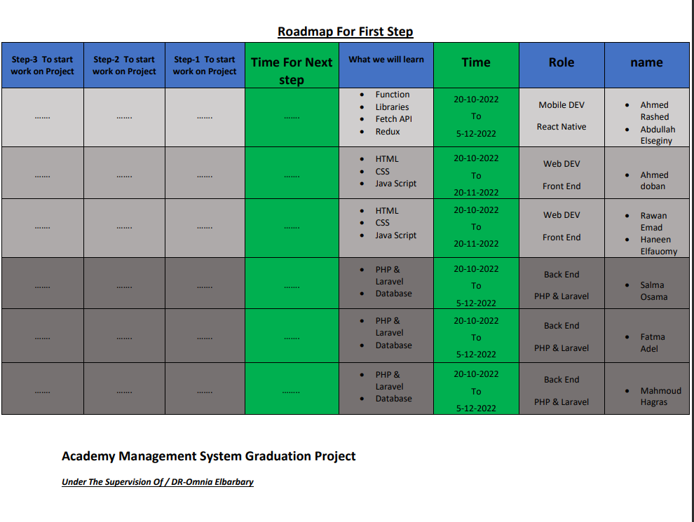Studying and preparing before starting implementation stage.
2. Starting implementation stage

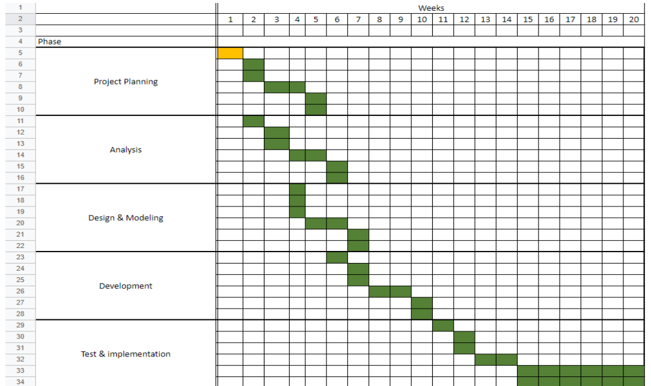

Chapter 2

Previous work

1. **introduction**

*ـــــــــــــــــــــــــــــــــــــــــ*

Academy management system Provides an integrated environment for distance learning and periodic follow-up of assignments and tasks for each of the student, teacher, and parent. It is a combination of several things needed by those in charge of the educational process combined in one program to facilitate all interactions between the student and the teacher.

We have developed and adapted the program to be compatible with the college system in an integrated experimental manner. So, it works smoothly for every student in the college with his national number and password. He can access everything he needs from any point in the world and any time he needs.

In this chapter, we provide a background about the tools and techniques needed to build our system. We also review the previous related work to our system, and the common technologies that are used. At the end of this chapter, we provide a comparison between the system we are going to build and the related systems.

1. **Background**

*ـــــــــــــــــــــــــــــــــــــــــ*

The system we are going to build depends on 3 directions:

mobile application, web application and back end for both.

1. Mobile app technology:

mobile application relies on react native cross platform that allows building mobile applications using only JavaScript. According to Stack Overflow’s 2020 Developer Survey, React Native beats other cross-platform frameworks such as Google's Flutter.

1. Web technology:

web application relies on react JS The React.js framework is an open-source JavaScript framework and library developed by Facebook. It’s used for building interactive user interfaces and web applications quickly and efficiently with significantly less code than you would with vanilla JavaScript. In React, you develop your applications by creating reusable components that you can think of as independent Lego blocks. These components are individual pieces of a final interface, which, when assembled, form the application’s entire user interface.

1. Back-end technology:

The back end is combination between php, and node JS integrated with herself to build our back to mobile application and web application. PHP stands for ‘PHP: Hypertext Preprocessor’, with the original PHP within this standing for ‘Personal Home Page’. The acronym has changed as the language developed since its launch in 1994 to reflect its nature more accurately. Data base by structured query language (SQL) is a programming language for storing and processing information in a relational database. A relational database stores information in tabular form, with rows and columns representing different data attributes and the various relationships between the data values. You can use SQL statements to store, update, remove, search, and retrieve information from the database. You can also use SQL to maintain and optimize database performance.

Structured query language (SQL) is a popular query language that is frequently used in all types of applications. Data analysts and developers learn and use SQL because it integrates well with different programming languages. For example, they can embed SQL queries with the Java programming language to build high-performing data processing applications with major SQL database systems such as Oracle or MS SQL Server. SQL is also easy to learn as it uses common English keywords in its statements

1. **Review of relevant work**

*ــــــــــــــــــــــــــــــــــــــــــــــ*

1. **Microsoft teams:**

Microsoft Teams is a proprietary business communication platform developed by Microsoft, as part of the Microsoft 365 family of products. Teams primarily compete with the similar service Slack, offering workspace chat and videoconferencing, file storage, and application integration. Teams replaced other Microsoft-operated business messaging and collaboration platforms, including Skype for Business and Microsoft Classroom. Throughout the COVID-19 pandemic, Teams, and other software such as Zoom and Google Meet, gained much interest as many meetings moved to a virtual environment.[9] As of January 2023, it has about 280 million monthly users. Teams allow users to communicate in two-way persistent chats with one or multiple participants. Participants can message using text, [emojis](https://en.wikipedia.org/wiki/Emoji), stickers and [gifs](https://en.wikipedia.org/wiki/GIF) as well as sharing links and files. Messages can be marked as urgent or important. Teams Live Events replaces [Skype Meeting Broadcast](https://en.wikipedia.org/wiki/Skype_for_Business) for users to broadcast to 10,000 participants on Teams, Yammer, or [Microsoft Stream](https://en.wikipedia.org/wiki/Microsoft_Stream)

Some screenshots from the application:

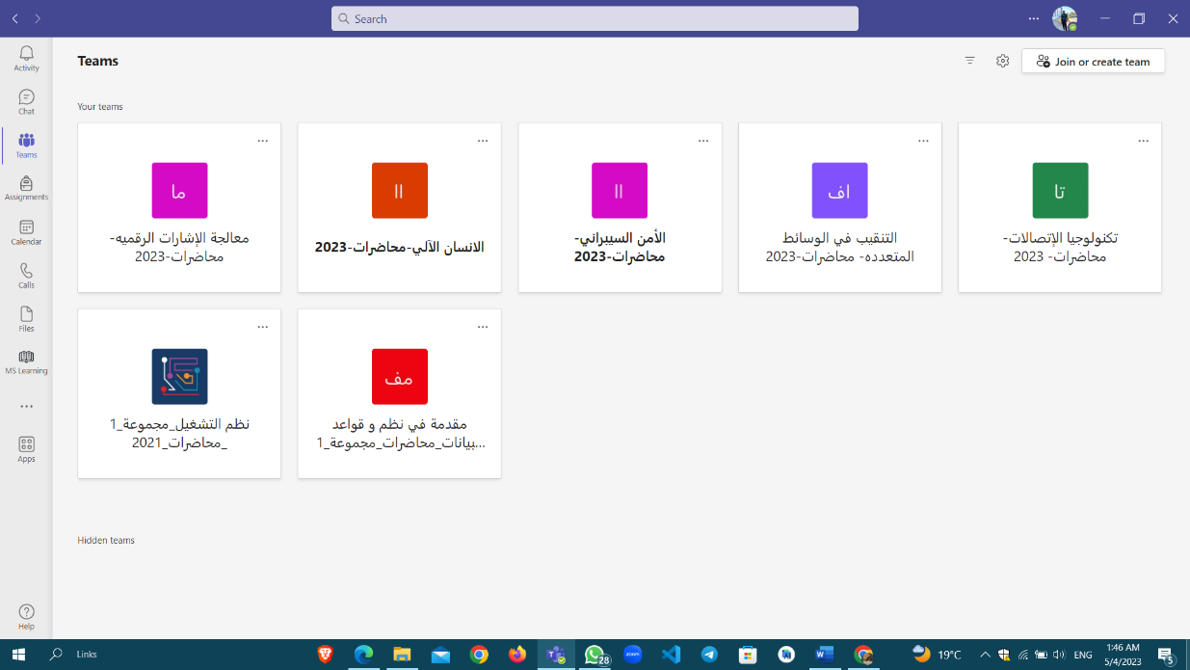

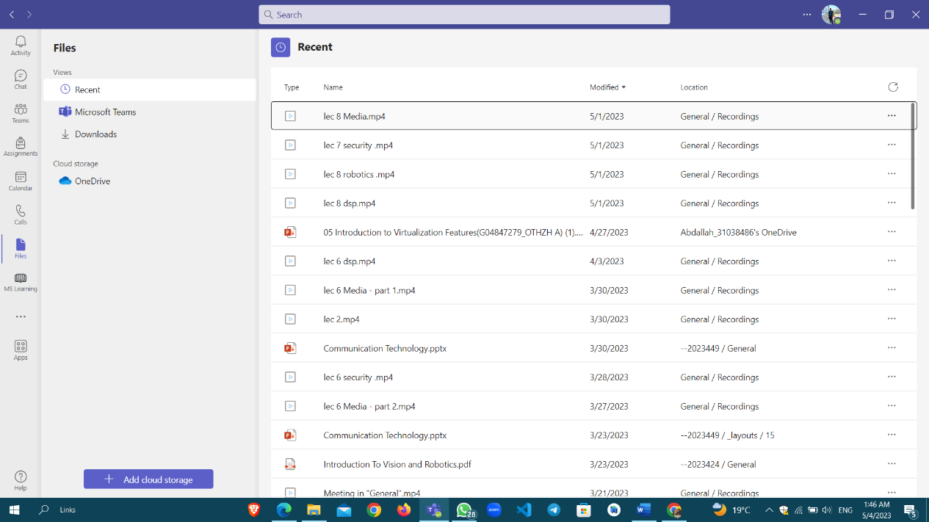

1. **Edmodo:**

An [educational technology](https://en.wikipedia.org/wiki/Educational_technology) platform for [K](https://en.wikipedia.org/wiki/K-12)–[12](https://en.wikipedia.org/wiki/K-12) schools and teachers. Edmodo enabled teachers to share content, distribute quizzes and assignments, and manage communication with students, colleagues, and parents. It is a free learning management platform that merges classroom content, safe communication, and assessment with social media savvy. Students and parents can get quick answers to questions as well as stay current on class assignments and happenings via the student planner and discussion threads. Teachers can set up classes for each in-school class or set up a large class and have all their students in one group. Edmodo makes it simple to track student progress. Grades can be stored and easily accessible through Edmodo. It also allows teachers to gather feedback from students on class discussions, assessments, and offer suggestions to students who are confused. It is your all-in-one line of communication, grade book, and assessment tracker.

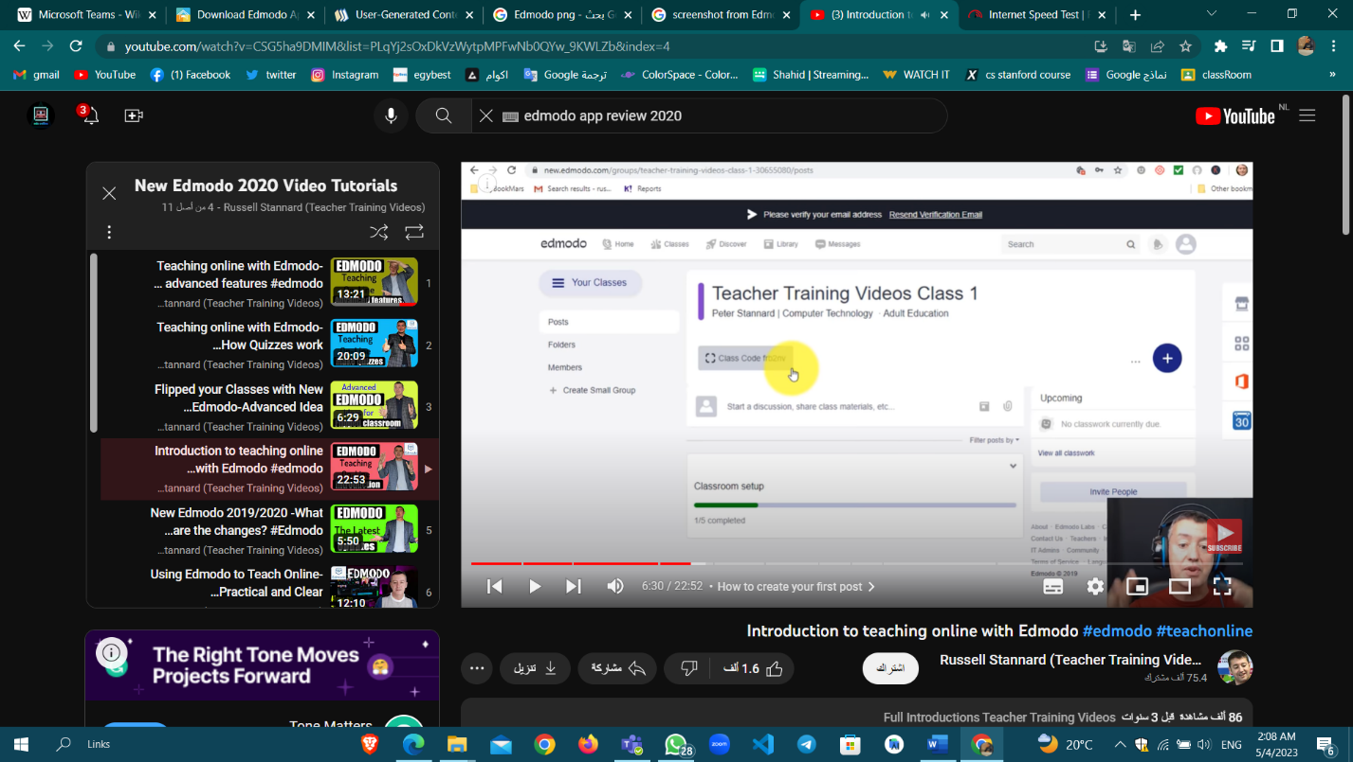Some screenshots from the website:

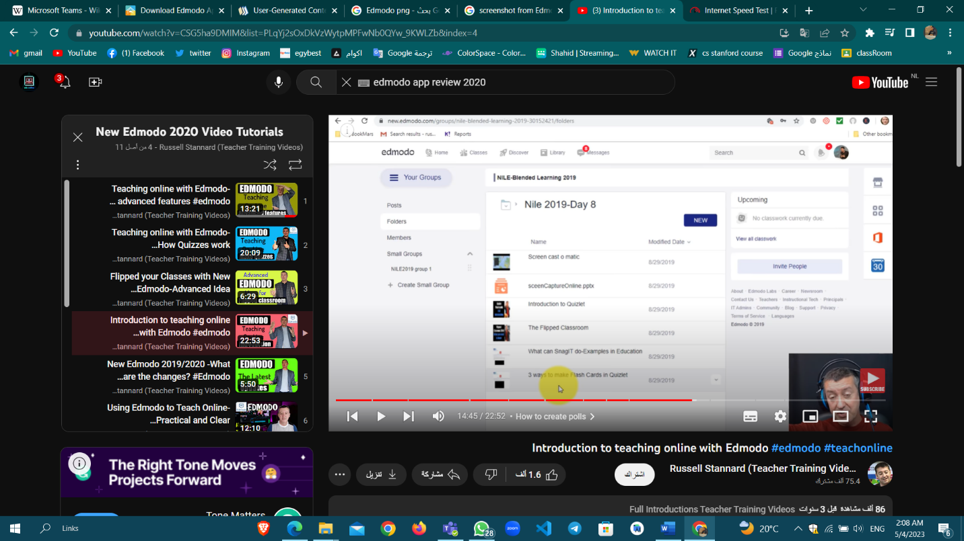

1. **Relationship between relevant work and our work**

*ــــــــــــــــــــــــــــــــــــــــــــــــــــــــــــــــــــــــــــــــــــــــــــــــــــــــــــــــــ*

There are some similarities between our project and Teams in terms of chat between students and teachers, asking questions and rooms for materials to upload all files and videos, but in a more user-friendly way. Also, there are similarities in the method of interaction between teachers and students in each room, where the teacher can make a meeting through the application or the website. But our application provides students with sending inquiries and responding to them by teachers, and it is possible for the teacher to send an answer to the inquiry to all students according to the importance of the inquiry. There is also a registration for the student's guardian through which the guardian can track the grades of his/her children through the application.

1. **Summary**

*ـــــــــــــــــــــــــــــ*

Academy management system Application is an educational application through which students learn remotely by watching recorded lectures, electronic exams, and assignments that the teacher creates for them. It Provides an integrated environment for distance learning and periodic follow-up of assignments and tasks for each of the student, teacher and parent. There is a similarity between it and other applications, but we have provided the service better and easier.

**Chapter 3**

**Theoretical considerations**

1. **Introduction**

*ـــــــــــــــــــــــــــــــــــــــــ*

In this chapter, we will provide a detailed explanation of our system by demonstrating the languages and tools that we used to build it, as well as discuss potential risks while using the system and how to avoid them. The most important aspect of this chapter is to define the system's functional and nonfunctional requirements.

1. **Development requirements**

*ـــــــــــــــــــــــــــــــــــــــــــــــــــــــــــــــــــــــــــ*

* + 1. **Designers and developers:**

1 UI&UX designer for mobile application and website, 2 web developers, 2 mobile developers, and 3 backend developers.

* + 1. **Languages:**
* **First Web Development**

1. ***HTML:***

The Hypertext Markup Language is the standard [markup language](https://en.wikipedia.org/wiki/Markup_language) for documents designed to be displayed in a [web browser](https://en.wikipedia.org/wiki/Web_browser).

1. ***CSS:***

Cascading Style Sheets (CSS) is a [style sheet language](https://en.wikipedia.org/wiki/Style_sheet_language) used for describing the [presentation](https://en.wikipedia.org/wiki/Presentation_semantics) of a document written in a [markup language](https://en.wikipedia.org/wiki/Markup_language) such as [HTML](https://en.wikipedia.org/wiki/HTML) or [XML](https://en.wikipedia.org/wiki/XML).

1. ***JS:***

JavaScript is a programming language, Websites use JavaScript to control webpage behavior, which frequently includes third-party libraries.

1. **React JS**

It is a React-popularized JavaScript syntax extension. React components are easier to create, maintain, and delete when JSX markup is close to related rendering logic.

We can use some libraries from react such as

AOS, axios, agora-rtc-sdk-ng, react-toastify, react-select, fort awesome, react-copy-to-clipboard, socket.io-client, react-toastify, react-to-print, sweetalert2, typewriter-effect, swiper, react-export-table-to-excel, react-router-dom.

* **second mobile Development:**

**React Native**

The open-source UI software framework React Native was developed by Meta Platforms, Inc. It enables developers to use the React framework along with native platform capabilities to create applications for Android, Android TV, iOS, macOS, tvOS, Web, Windows, and UWP. It is employed in the creation of Shopify, Microsoft, and Facebook's Android and iOS applications. At Oculus, it is also utilized to create virtual reality applications.

* **Third Backend:**

**PHP**

PHP is a server scripting language that can be used to create dynamic and interactive Web pages. PHP is a popular, open-source, and cost-effective alternative to competitors such as Microsoft's ASP.

* + 1. **Servers**

we used free online servers such as:

Github.com, vercel.com, 000Webhost.com

* + 1. **Tools and editors**

ـــــــــــــــــــــــــــــــــــــــــــــــــــــ

1. **XD**

[vector](https://en.wikipedia.org/wiki/Vector_graphics_editor) design tool for [web](https://en.wikipedia.org/wiki/Web_application) and [mobile applications](https://en.wikipedia.org/wiki/Mobile_app)

1. **Figma**

A [collaborative](https://en.wikipedia.org/wiki/Collaborative_software) [web application](https://en.wikipedia.org/wiki/Web_application) for [interface design](https://en.wikipedia.org/wiki/Interface_design), with additional offline features enabled by desktop applications for [macOS](https://en.wikipedia.org/wiki/MacOS) and [Windows](https://en.wikipedia.org/wiki/Microsoft_Windows).

1. **VS code:**

Visual Studio Code is a redesigned and optimized code editor for developing and debugging modern web and cloud applications. We used VS code in web development and back end.

1. **System requirements**

*ـــــــــــــــــــــــــــــــــــــــــــــــــــــــــــــ*

* + 1. **Functional requirements:**
* First for student:

1. Virtual classes
2. Online exam
3. Online lectures and recorded videos
4. Communication between all students or with doctors
5. Table of each student
6. Chat bot

* **second for doctor:**

1. create a new exam.
2. Edit or delete exam.
3. Upload videos and summarizations
4. Add or update students.

* **Third for parent**

1. following up student’s levels.
2. Know the results of his son.
3. Follow up GPA of his sons.
   * 1. Nonfunctional requirements:
4. Activity games like memory games and drawing game.
5. To do list
6. Notes
7. Library
8. **Cost and budget**

*ــــــــــــــــــــــــــــــــــــــــــــ*

No cost because academic management system is an online system consisting of website and mobile application designed to support teaching and learning in an educational setting.

1. **Risk List**

***ـــــــــــــــــــــــــــــــــــــــــ***

To have the authority to use this system, you must be registered with the foundation, company, or educational platform. They will give you a code that you will Sign in with it in addition to your national number, and in addition to accessing the system, you must have some capabilities, including you must have an Android phone or a device An Android tablet, or a computer to access the application must be downloaded from #LINK or via a browser via this link# .and you must have a connection to internet Without which you cannot enjoy the services of the institution so we can extract risk list as follows:

1. inability to buy android phone, tablet, or laptop to access the system.
2. Problems with server.
3. Inadequate internet access.
4. Can’t access the system because the user doesn’t have an account on the system.
5. Problems in logging onto the system.

Chapter 4

Practical work

1. **Introduction**

*ــــــــــــــــــــــــــــــــــــــــــــ*

In this chapter, we will discuss the system analysis of the project and we will present a detailed explanation about our application by using some figures such as: flow chart diagram in a way that supports reasoning about the structural properties of these objects, we also will discuss the implementation of the project.

1. **Flow chart**

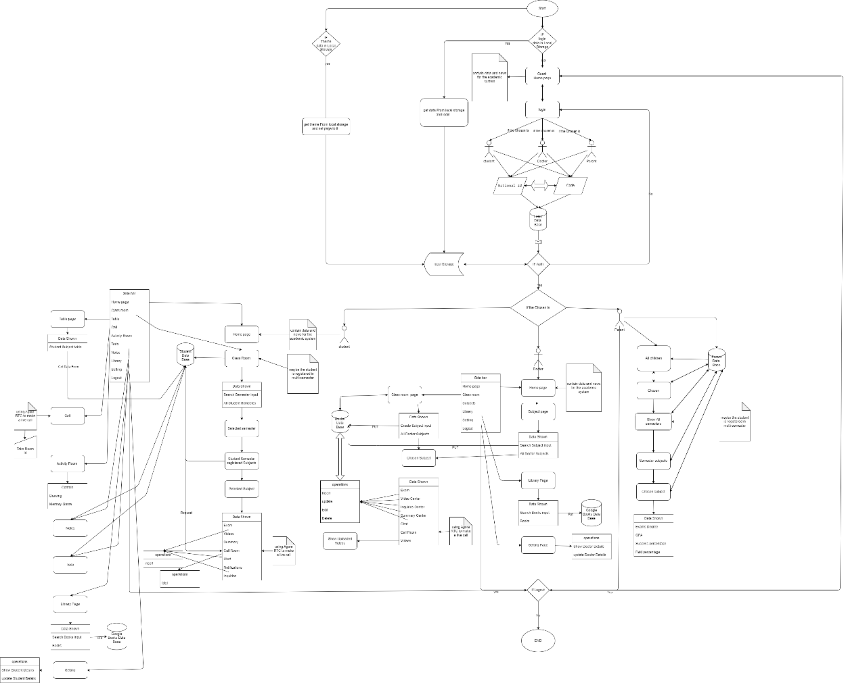*ــــــــــــــــــــــــــــــــــــــــــ*

1. **Website implementation**

*ـــــــــــــــــــــــــــــــــــــــــــــــــــــــــــــــــــــــــ*

* **App page**

1. Import necessary dependencies and components.
2. Define the App functional component.
3. Initialize state variables LogedIn and Type using the useState hook.
4. Define an array of options containing objects representing different user types (Student, Doctor, Parent) with their corresponding labels and URLs.
5. Implement the GetUser function to retrieve user information from local storage.
6. Use the useEffect hook to check if a user is already logged in based on the stored information.
7. If no user is logged in (! LogedIn), render the Gust component passing relevant props.
8. If a user is logged in, render the Auth component passing the SetLogedOn prop.
9. Export the App component as the default export.
   * + **Guest page**
10. Import necessary dependencies and components, including useEffect and useState from React, as well as Route and Routes from react-router-dom.
11. Import additional components such as NotFounded, Login, and Home.
12. Define the Gust functional component.
13. Initialize state variables Theme and Chek using the useState hook. The Theme variable stores the selected theme (defaulting to "light"), and Chek determines whether the theme switch is checked.
14. Implement the toggleTheme function to toggle between "light" and "dark" themes based on the current value of Theme.
15. Implement the HandleThemeChange function to update the theme state and toggle the theme switch.
16. Use the useEffect hook to store the selected theme in local storage and update the Chek variable based on the current theme. Also, call the CheckCurrentTheme function to apply the appropriate theme to the document.
17. Define the CheckCurrentTheme function to set CSS variables based on the selected theme.
18. Render the component's JSX elements, which include a theme switch input, routes, and corresponding components for different routes (Home, Login, NotFounded).
19. Export the Gust component as the default export.
20. Render the component's JSX elements, which include a theme switch input.

* **Auth page**

1. Import necessary dependencies and components, including React (assuming it's imported from the react package).
2. Import the components Student, Admin, Instructor, and Parent from their respective files.
3. Define the Auth functional component.
4. Check the user type stored in local storage using localStorage.getItem("Type").
5. If the user type is "Student", render the student component and pass the SetLogedOn prop to it.
6. If the user type is "Doctor", render the instructor component and pass the SetLogedOn prop to it.
7. If the user type is "Parent", render the Parent component and pass the SetLogedOn prop to it.
8. Export the Auth component as the default export.

* **About US section**

1. Import necessary dependencies and CSS styles from external files.
2. Define the AboutUs functional component.
3. Render the JSX elements for the about section/page.
4. The content includes a heading, a paragraph, and two container divs.
5. The first container div has two circles and a span for the main title, and a paragraph for additional information.
6. The second container div is divided into two sections: a left section and a right section.
7. The left section includes a heading, an image, and two paragraphs with descriptive text.
8. The right section includes a paragraph with more text, an unordered list with items, and another paragraph.
9. The right section also includes an image within an image container div.
10. The component is wrapped within a React.Fragment to avoid adding unnecessary HTML elements.
11. Export the AboutUs component as the default export.

* **Footer section**

1. Import necessary dependencies and CSS styles from external files.
2. Define the Footer functional component.
3. Render the JSX elements for the footer section.
4. The content includes SVG waves, a container div, and three boxes within the container.
5. Each box represents a different section of the footer.
6. Box 1 (contact class) includes the title "academic management system", a description, and social media icons (Facebook, Twitter, Instagram, WhatsApp, and Telegram).
7. Box 2 (contact class) includes the title "download App", a description, and app download options (Google Play and App Store) with icons.
8. Box 3 (contact class) includes the title "Find Us", a description, and a Google Maps iframe displaying a location.
9. The component utilizes various data-aos attributes for adding fade-down animations to the boxes.
10. The component is wrapped within a React.Fragment to avoid adding unnecessary HTML elements.
11. Export the Footer component as the default export.

* **Video call**

1. import necessary dependencies, CSS styles, and components from external files.
2. Define the VideoCall functional component, which represents a video call page.
3. Define the Videos component, which displays the local user's video and the videos of other users.
4. Define the Controls component, which includes buttons for controlling audio, video, screen sharing, and leaving the call.
5. Define the ChannelForm component, which displays a form for joining a call room.
6. Define the JoinRoom component, which handles the logic for joining a call and rendering the video call or channel form based on the call status.
7. Create a configuration object for the Agora client with the specified mode and codec.
8. Set the Agora app ID and token (currently set to null) for authentication and authorization.
9. Use hooks (useClient and useMicrophoneAndCameraTracks) to create the Agora client and microphone and camera tracks.
10. Use the useEffect hook to initialize the Agora client and join the call when the component mounts.
11. Render the video call page with the local user's video and other users' videos when the call starts.
12. Render the controls (audio, video, screen sharing, and leave call buttons) when the client is ready, and tracks are available.
13. Handle mute/unmute audio and video, screen sharing, and leaving the call events with appropriate callbacks.
14. Define the ChannelForm component to render a form for joining the call room with a channel name and subject name.
15. Use the useParams hook from react-router-dom to get the channel name and subject name from the URL parameters.
16. Set the channel name and subject name based on the URL parameters.
17. Handle the join call event and set the inCall state to true.
18. Render the video call page or the channel form based on the inCall state.

* **Sidebar**

The code looks fine. It defines a functional component called a SideBar that renders a sidebar with navigation links and various functionalities. It manages state using React hooks such as useState, useEffect, and useRef. It also makes use of external libraries like react-router-dom and axios for routing and making HTTP requests, respectively.

The SideBar component accepts props such as children and SetLogedOn. It renders a sidebar container with a toggle button, theme options, navigation links, and a logout link. It also includes event handlers for opening and closing the sidebar, fetching data from an API, logging out the user, and toggling the theme.

* **Not founded Page**

The code defines a functional component called `NotFounded` that renders a "Page Not Found" view. It imports the `Player` component from the `@lottiefiles/react-lottie-player` library and the `useNavigate` hook from `react-router-dom`. It also imports a CSS file for styling.

The `NotFounded` component renders a container with a Lottie animation, an error message, a suggestion to go back to the home page, and a "Go back" button. The Lottie animation is configured to autoplay and loop indefinitely. The `useNavigate` hook is used to navigate back to the home page when the button is clicked.

Overall, the code appears to be straightforward and easy to understand. It effectively displays a "Page Not Found" message with a visually appealing animation and a button to go back.

* **Library Page**

The code defines a functional component called `Library` that represents a library page. It imports various dependencies, components, and styles.

The component uses the `useState` and `useEffect` hooks from React to manage the state. It initializes state variables for `search`, `items`, `item`, and `Empty`. The `search` variable is used to store the search query entered by the user, `items` is an array that holds the fetched book data, `item` represents the selected book, and `Empty` is a flag to check if the library is empty.

The `getData` function is responsible for fetching book data from the Google Books API. It is called when the component mounts or when the search query changes. The fetched data is stored in the `items` state variable.

The `oneCall` function is used to call the `getData` function once the component is mounted to populate the library initially.

The `searchBox` function is triggered when the user presses the Enter key in the search input field. It calls the `getData` function with the search query entered by the user and clears the search input field.

The `searchButton` function is called when the user clicks the search button. It performs the same logic as the `searchBox` function.

The component renders a header section with a Lottie animation, a title, a welcome message, and a search input field. The `searchBox` and `searchButton` functions are used to handle the search functionality.

The component also renders a content section with a main title, Dots component, and routing configuration using `react-router-dom`. It sets up routes for displaying the book cards, book details, and a "Page Not Found" component.

Finally, the component renders a footer section and a `ToastContainer` from the `react-toastify` library for displaying notifications.

Overall, the code handles fetching book data, displaying it in a library layout, and providing search functionality. It also uses routing to navigate between different book pages and handles cases where the requested page is not found.

* **Student Page**

The code defines a functional component called `Student` that represents the main component for the student interface. It imports various dependencies, components, and styles.

The component uses the `useEffect`, `lazy`, `Suspense`, `useState`, `useRef`, and `useCallback` hooks from React.

The component sets up routing using `Routes`, `Route`, `Navigate`, and `Outlet` components from the `react-router-dom` library.

It imports and lazily loads different pages/components based on the routes.

The component renders a sidebar component called `SideBar` that contains navigation links for different sections of the student interface.

Inside the `content` div, the component uses `Suspense` to display a fallback loading UI while the lazily loaded components are being loaded.

The component defines different routes for various pages such as the home page, classroom page, table page, library page, activity page, todo page, notes page, setting page, student call page, and a not found page.

Each route is associated with a lazily loaded component and can have nested routes.

Overall, the code sets up the student interface by providing navigation, lazy loading of components, and handling different routes for various pages of the interface.

* **Parent Page**

The code defines a functional component called `Parent` that represents the main component for the parent interface. It imports various dependencies, components, and styles.

The component uses the `useEffect`, `lazy`, `Suspense`, and `useState` hooks from React.

The component sets up routing using `Routes`, `Route`, `Navigate`, and `Outlet` components from the `react-router-dom` library.

It imports and lazily loads different pages/components based on the routes.

The component renders a custom component called `Mountain` that provides a mountain-themed background and displays a header with navigation links.

Inside the `data` div, the component displays the current title and a toggle switch for changing the theme.

The component defines different routes for various pages such as the students page and a not found page.

Each route is associated with a lazily loaded component and can have nested routes.

The component also provides a fallback loading UI while the lazily loaded components are being loaded.

Overall, the code sets up the parent interface by providing navigation, lazy loading of components, handling different routes for various pages of the interface, and theme switching functionality.

* **Instructor (Doctor) Page**

The code defines a functional component called `Instructor` that represents the main component for the instructor interface. It imports various dependencies, components, and styles.

The component uses the `useEffect`, `lazy`, `Suspense`, `useState`, `useRef`, and `useCallback` hooks from React.

The component sets up routing using `Routes`, `Route`, `Navigate`, `NavLink`, and `Outlet` components from the `react-router-dom` library.

It imports and lazily loads different pages/components based on the routes.

The component renders a custom component called `SideBar` that provides a sidebar navigation menu.

Inside the `content` div, the component displays a loader while the lazily loaded components are being loaded.

The component defines different routes for various pages such as the home page, class page, subjects page, video center page, summary center page, library page, and setting page.

Each route is associated with a lazily loaded component and can have nested routes.

The component also provides a fallback loading UI while the lazily loaded components are being loaded.

Overall, the code sets up the instructor interface by providing navigation, lazy loading of components, handling different routes for various pages of the interface, and displaying content based on the selected route.

* **Student Page content**
  + **Student Classes Page:**

The code provided is a React functional component called `Courses`. It imports various dependencies from different libraries, including React, react-router-dom, and axios.

Within the component, there are several state variables defined using the `useState` hook. These variables include `visible`, `show`, `student_id`, `Classes`, `loading`, and `Search`.

The `Courses` component renders a JSX fragment containing React Router's `Routes` component. Inside the `Routes`, there are two `Route` components. The first `Route` is for the root path ("/") and renders a component called `Select_Sub_generation` with various props passed to it. The second `Route` is for a dynamic path (“generation_id") and renders a component called `Select_Sub_generationSubjects`.

The `Select_Sub_generation` component is defined as a separate functional component. It receives props such as `Search`, `setSearch`, `loading`, `Classes`, `show`, `showMore`, and `style`. It conditionally renders either a loading indicator (`LodingFeachData`) or a container with a header, input field, and a list of classes based on the props and the state variables.

The `Select_Sub_generationSubjects` component is also a separate functional component. It uses the `useParams` hook from react-router-dom to get the `generation_id` parameter from the URL. It fetches data based on the `generation_id` and renders a container with the generation's name and a list of subjects.

Overall, the code handles the rendering of courses and subjects based on the URL path and user interactions. It fetches data from an API using axios and updates the component state accordingly.

* + **Student Subject Page:**

The code provided is a React functional component called `SubjectData`. It imports dependencies such as React, `Player` from `@lottiefiles/react-lottie-player`, and `Link`, `useParams` from `react-router-dom`.

The `SubjectData` component renders a JSX fragment containing a `Mountain` component, which is presumably a decorative component. Inside the `Mountain` component, there is a `div` element with the class name "data" and a heading element (`<h1>`) displaying the value of `params.SubjectName`.

After the `Mountain` component, there is another `div` element with the class name "SubjectData". Inside this div, there is a `container` div that contains a series of `Link` components representing different cards for various subjects related to the current subject data.

Each `Link` component represents a different feature related to the subject. They have a common structure with a heading (`<h1>`) representing the feature's name and a `Player` component rendering an animated icon using LottieFiles. The `to` prop of each `Link` component is set with different paths based on the `params.subject_id` and the specific feature.

The rendered component provides users with different options related to the subject, such as exams, videos, summaries, video calls, chats, notifications, and inquiries. Each option is represented by a clickable card with an animated icon and a descriptive heading.

Overall, the `SubjectData` component is responsible for rendering the subject-specific data and providing links to different features or functionalities related to that subject.

* + **Student Inquiries Page:**

The code provided is a React functional component called `Inquiries`. It imports dependencies such as React, `Player` from `@lottiefiles/react-lottie-player`, `useParams` from `react-router-dom`, axios, `Mountain` component, and `ToastContainer`, `toast` from "react-toastify".

The `Inquiries` component renders a JSX fragment containing a `Mountain` component. Inside the `Mountain` component, there is a `div` element with the class name "data" and a heading element (`<h1>`) displaying the text "Inquiries". Additionally, there is a `div` element with the class name "card" that contains an icon and an input field for adding new inquiries. Clicking on the icon triggers the `HandleTextFeild` function, and the input field is controlled by the `TextFeild` state variable.

Below the `Mountain` component, there is a conditional rendering based on the length of the `Inquiries` state array. If the array has elements (`Inquiries.length > 0`), a `div` element with the class name "Inquiries" is rendered. Inside this div, there is a `container` div that maps over the `Inquiries` array and renders a `card` for each inquiry. Each card has a `data` div containing the inquiry's title and answer (if available). If an answer exists, it is displayed with a check icon; otherwise, a message indicating no response is shown.

If the `Inquiries` array is empty, a `div` element with the class name "No_Inquiries" is rendered instead. It displays a `Player` component that plays an animated icon, a paragraph element with the text "There is No Inquiries".

The `Inquiries` component includes some state variables such as `Inquiries`, `student_id`, and `TextFeild`, which are initialized using the `useState` hook. The component also uses the `useEffect` hook to fetch data and update the component when necessary. The `fetchData` function is responsible for making an API call using the `axios` library to retrieve inquiries based on the `params.subject_id` value. The `GetID` function retrieves the `student_id` from local storage. The `HandleTextFeild` function is triggered when adding a new inquiry, and it makes a POST request to the API to add the inquiry.

Overall, the `Inquiries` component displays a list of inquiries related to a specific subject. It allows users to add new inquiries and provides visual feedback through animations and toast notifications.

* + **Student Exam Page:**

The code provided is a React functional component called `ExamPage`. It imports dependencies such as React, `useEffect`, `useState`, `useParams`, `useNavigate` from `react-router-dom`, axios, `ToastContainer`, `toast` from "react-toastify", and `Mountain` component.

The `ExamPage` component renders a JSX fragment containing a `Mountain` component. Inside the `Mountain` component, there is a `div` element with the class name "data" and a heading element (`<h1>`) displaying the text "Exam" followed by the name of the exam fetched from the API. Additionally, there is a `button` element with the class name "FinshExam" that triggers the `HandleFinish` function when clicked.

Below the `Mountain` component, there is a `div` element with the class name "ExamPage" that contains a `container` div and a menu with two options: "PDF Data" and "Answers". The active option is controlled by the `Togle` state variable. If "PDF Data" is active, an `iframe` element with the `src` attribute set to the `Exams.papel_link` value is rendered. If "Answers" is active, a list of questions is displayed. Each question is rendered as a `card` element containing the question text and a set of answer options. The answer options are rendered using the `Answers` component.

The component includes some state variables such as `Exams`, `student_id`, `Question`, `Togle`, and `Score`, which are initialized using the `useState` hook. The `GetID` function retrieves the `student_id` from local storage.

The component uses the `useEffect` hook to fetch exam data and question data from the API. Two separates `fetchData` functions are defined to make POST requests using the `axios` library. The first `fetchData` function retrieves exam data based on the `params.subject_id` and `student_id` values. The second `fetchData` function retrieves question data based on the `params.Exam_id` value.

The `HandleFinish` function is triggered when the "Finish" button is clicked. It calculates the score by checking each question's chosen answer against the valid answer and increments the `Score` state variable accordingly. Then, it makes a POST request to the API to upload the score, along with the exam ID, student ID, and all questions. Upon a successful response, a success toast notification is displayed, and the user is navigated back.

Overall, the `ExamPage` component displays an exam page with the exam name, PDF data, and answer options for each question. It allows the user to select answers and submit them to calculate the score. Toast notifications are used to provide feedback, and the `Mountain` component is used for the page layout.

* + **Student Chat Page:**

The code provided is a React functional component called `Chat`. It imports dependencies such as React, `useState`, `useEffect`, `useCallback` from "react", "./Chat.css", `Blobs` component, `useParams` from "react-router-dom", `ToastContainer`, `toast` from "react-toastify", axios, and `GetUser` component.

The `Chat` component renders a JSX fragment. Inside the fragment, there is a `Blobs` component for visual decoration. Inside the `Chat` component's div with the class name "Chat", there are two main sections: "messages" and "SendMessage".

The "messages" section displays a list of messages. Each message is rendered as a `div` element with the class name "messages-data" and contains a heading element (`<h1>`) displaying the message text. Additionally, there is a `p` element displaying the username of the student who sent the message. The username is obtained by passing the `student_id` to the `GetUser` component.

The "SendMessage" section consists of an `input` element of type "text" that allows the user to type a message. The value of the input is controlled by the `TextFeild` state variable. When the input value changes, the `SetTextField` function is called to update the state. There is also a `button` element with the class name "SendMessage-button" that triggers the `HandleTextFeild` function when clicked. The `HandleTextFeild` function sends a POST request to the API to add a new message. If the request is successful, it calls the `fetchData` function to fetch the updated message list and clears the input field by setting the `TextFeild` state variable to an empty string. If the input field is empty, a warning toast notification is displayed.

The component includes the `fetchData` function, which makes a POST request to the API to fetch the message data based on the `params.subject_id` value. The fetched data is stored in the `Chat` state variable using the `SetChat` function.

The `useEffect` hook is used to fetch the message data from the API when the component mounts or when the `params.subject_id` value changes.

Overall, the `Chat` component displays a chat interface where messages can be sent and received. The messages are fetched from the API and displayed in a list. Users can enter new messages, and the component sends them to the API to be stored. Toast notifications are used to provide feedback, and the `Blobs` component is used for visual decoration.

* + **Student Summary Page:**

The code provided is a React functional component called `Summary`. It imports dependencies such as React, `useState`, `useEffect`, `Player` from "@lottiefiles/react-lottie-player", `Link`, `useParams` from "react-router-dom", `axios`, and "./Summary.css". It also imports the `Mountain` component.

The `Summary` component renders a JSX fragment. Inside the fragment, there is a `Mountain` component that displays a mountain template with the heading "Summary".

The component uses the `useParams` hook from react-router-dom to get the parameters from the URL. It stores the parameters in the `params` variable.

The component defines a state variable `Summary` using the `useState` hook, initialized as an empty array.

The `useEffect` hook is used to fetch summary data from an API endpoint. It makes an asynchronous request to the API using the `axios` library. The URL is constructed using `process.env.REACT_APP_API` and the "/select_summary.php" endpoint. The request is made with the `params.subject_id` as the request payload. If the response is successful and the status is "success", the summary data is stored in the `Summary` state variable using the `SetSummary` function.

The component conditionally renders content based on the length of the `Summary` array. If the length is greater than 0, it renders a `div` element with the class name "Summary". Inside this div, there is a `div` element with the class name "container". For each `pdf` in the `Summary` array, a `Link` component is rendered with a `card` class. The `to` attribute of the `Link` component is set to `pdf.summary_link`, and the `key` attribute is set to `pdf.summary_id`. Inside the `Link` component, a `Player` component from `@lottiefiles/react-lottie-player` is rendered. It has various props such as `autoplay`, `loop`, `controls`, `src`, and `className`. The `src` prop is set to a JSON file URL for displaying animation. Below the `Player` component, an `h1` element displays the `pdf.summary_name`.

If the length of the `Summary` array is 0, it renders a `div` element with the class name "No_Summary". Inside this div, a `Player` component is rendered to display an animation. The `src` prop of the `Player` component is set to another JSON file URL for the animation. Below the `Player` component, a `p` element displays the text "There is No Summary".

Overall, the `Summary` component fetches summary data from an API based on the provided subject ID. It displays the summary data as cards with animation using the `Player` component. If there are no summaries available, it displays a different animation and a message indicating the absence of summaries.

* + **Student Subject Notification Page:**

The code provided is a React functional component called `SubjectNotification`. It imports dependencies such as React, `useState`, `useEffect`, `Player` from "@lottiefiles/react-lottie-player", `Link`, `useParams` from "react-router-dom", `axios`, and "./SubjectNotification.css". It also imports the `Mountain` component.

The `SubjectNotification` component renders a JSX fragment. Inside the fragment, there is a `Mountain` component that displays a mountain template with the heading "Notification".

The component uses the `useParams` hook from react-router-dom to get the parameters from the URL. It stores the parameters in the `params` variable.

The component defines state variables `student_id` and `Notification` using the `useState` hook. `student_id` is initialized as an empty array, and `Notification` is initialized as an empty array.

The `GetID` function is defined to retrieve the student ID from local storage using `localStorage.getItem("User")`. The retrieved data is parsed as JSON and stored in the `response` variable. The `student_id` state variable is updated with the value of `response.student_id`.

The `useEffect` hook is used to fetch notification data from an API endpoint. It makes an asynchronous request to the API using the `axios` library. The URL is constructed using `process.env.REACT_APP_API` and the "/select_notification.php" endpoint. The request is made with the `params.subject_id` as the request payload and the `student_id` as an additional dependency. If the response is successful and the status is "success", the notification data is stored in the `Notification` state variable using the `SetNotification` function.

The component conditionally renders content based on the length of the `Notification` array. If the length is greater than 0, it renders a `div` element with the class name "Notification". Inside this div, there is a `div` element with the class name "container". However, the content inside this container is commented out.

If the length of the `Notification` array is 0, it renders a `div` element with the class name "No_Notification". Inside this div, a `Player` component is rendered to display an animation. The `src` prop of the `Player` component is set to a JSON file URL for the animation. Below the `Player` component, a `p` element displays the text "There are No Notifications".

Overall, the `SubjectNotification` component fetches notification data from an API based on the provided subject ID and student ID. It currently does not render any notifications but displays a placeholder animation if there are no notifications available.

* + **Student Activity Room Page:**

The code provided is a React functional component called `ActivityRoom`. It imports dependencies such as React, `Link` from "react-router-dom", `Blobs` component, `CardBlur` component, and "./ActivityRoom.css". It also imports `Mountain` component, `CardBlur` component, and some image assets.

The `ActivityRoom` component renders a JSX fragment. Inside the fragment, there is a `Mountain` component that serves as a template for the header section. It contains a `div` element with the class name "data" and displays the heading "Welcome to Activity Room".

Below the `Mountain` component, there is a `div` element with the class name "ActivityRoom". Inside this div, there is a `Blobs` component that serves as a visual decoration. Inside the `ActivityRoom` div, there is another `div` element with the class name "container". Inside this container, there is a `div` element with the class name "activity-container".

Inside the "activity-container", there are two `Link` components wrapped in `box` div elements. These `Link` components are used for navigation to different activity pages. Each `Link` component contains a `CardBlur` component. The `CardBlur` component displays an image related to the activity (drawing or memory game) and a caption for the activity.

The first `Link` component is linked to the "drawing" route and displays an image of a color palette. The caption for the activity is "Drawing". The second `Link` component is linked to the "memory-game" route and displays an image of card games. The caption for the activity is "Memory Game".

Overall, the `ActivityRoom` component represents a page that serves as a hub for different activities. It displays a header, visual decoration, and two activity cards. Each activity card is a link that navigates the user to a specific activity page.

* + **Memory Game Page:**

The code provided is a React functional component called `MemoryGame`. It imports dependencies such as React, `useState`, `CardBlur` component, `Blobs` component, and "./MemoryGame.css".

The `MemoryGame` component renders a JSX fragment. Inside the fragment, there is a `Blobs` component that serves as a visual decoration. Inside the `MemoryGame` div, there is a `div` element with the class name "container". Inside this container, there is an `h1` element with the class name "main-title-2" that displays the heading "Memory Game".

Below the heading, there is another `div` element with the class name "MemoryGame-container". Inside this div, there is a mapping of the `items` state using the `map` function. Each item represents a card in the memory game. The `CardBlur` component is used to display each card. The `active` prop is passed to the `CardBlur` component based on the `state` property of the corresponding item.

Each card has two sides, represented by the `div` elements with the classes’ "front" and "back". The "front" side is initially empty and has an `onClick` event listener that calls the `HandleClick` function passing the index of the clicked card. The "back" side contains an icon rendered using the `className` property of the corresponding item.

At the bottom of the container, there is an `input` element of type "button" with the class name "Reset-Game". This button is used to reset the game. It has an `onClick` event listener that calls the `ResetGameHandler` function.

The `MemoryGame` component utilizes the `useState` hook to manage the `items` state, which represents the cards in the memory game, and the `prev` state, which keeps track of the previously clicked card.

The `HandleCheckElle` function is called when two cards are clicked consecutively. It checks if the two cards have the same `id`. If they do, their `state` is set to "correct". Otherwise, their `state` is set to "wrong" temporarily, and then after a delay, their `state` is reset to an empty string.

The `HandleClick` function is called when a card is clicked. It checks if a previous card has been clicked. If not, it sets the clicked card's `state` to "active" and updates the `prev` state. If a previous card has been clicked, it calls the `HandleCheckElle` function passing the index of the clicked card.

The `ResetGameHandeler` function is called when the "Reset Game" button is clicked. It resets the `state` of all cards to "active", shuffles the `items` array, and after a delay, resets the `state` of all cards to an empty string.

Overall, the `MemoryGame` component represents a memory game where the user needs to match pairs of cards with the same icon. The game provides visual feedback for correct and incorrect matches and allows the user to reset the game.

* + **Drawing Page:**

The code provided is a React functional component called `Drawing`. It imports dependencies such as React, `useRef`, `useEffect`, `useState`, `useCallback`, and "./drawing.css". It also imports the `DrawingOptions` component.

The `Drawing` component renders a JSX fragment. Inside the fragment, there is a `div` element with the class name "drawing". Inside this div, there is a `canvas` element with various event listeners such as `onMouseDown`, `onMouseUp`, `onMouseMove`, `onTouchStart`, `onTouchEnd`, and `onTouchMove`. The `ref` attribute is set to `canvasRef` to reference the canvas element.

Below the canvas, the `DrawingOptions` component is rendered. It receives several props, including `handleDownload`, `dateUrl`, `handleClear`, `color`, `setColor`, `Erasing`, `DrawingAgin`, `size`, and `setSize`. These props are used to control various drawing options such as downloading the drawing, clearing the canvas, setting the drawing color and size, and toggling between drawing and erasing modes.

The `useRef` hook is used to create two references: `canvasRef` and `contextRef`. The `canvasRef` reference points to the `canvas` element, while the `contextRef` reference is used to store the canvas context.

The `useState` hook is used to manage the state of `isDrawing`, which determines whether the user is currently drawing or not. It is initially set to be `false`. The `color` and `size` states manage the current drawing color and size, respectively, and are initially set to "#000" and 10.

The `useEffect` hook is used to perform setup logic when the component mounts. It sets the width and height of the canvas to match the window dimensions and sets the canvas context in the `contextRef` reference.

Several event handler functions are defined within the component. These include `startDrawing`, `touchstart`, `finishDrawing`, `Drawing`, `DrawingMob`, `Erasing`, and `DrawingAgain`. These functions handle the various stages of drawing, such as starting, finishing, and updating the drawing based on mouse and touch events. They use the `contextRef` to access the canvas context and modify the drawing accordingly.

The `handleDownload` function uses the `toDataURL` method of the canvas to generate a data URL representing the current drawing. It updates the `dateUrl` state with the generated URL. This function is wrapped in `useCallback` to memorize the function and prevent unnecessary re-renders.

The `handleClear` function clears the canvas by calling the `clearRect` method on the canvas context. It sets the `color` state to the specified color, and the `size` state to the specified size.

Overall, the `Drawing` component represents a drawing area where users can draw on a canvas using a mouse or touch events. It provides options for changing the drawing color and size, erasing, downloading the drawing, and clearing the canvas.

* + **Table Page:**

The `StudentTable` component is a class-based component that renders a table. The table contains rows and columns with data. Each row represents a day of the week, and each column represents a time slot. The table cells contain placeholder text.

The `StudentTablePage` component is a functional component that wraps the `StudentTable` component. It also imports and utilizes two custom hooks: `useReactToPrint` and `useDownloadExcel`.

Inside the `StudentTablePage` component, there is a `Mountain` component that displays a mountain template with the heading "Student table". Below the heading, there is a `div` with the class name "card" that contains two buttons: one for printing the table and another for downloading the table as an Excel file.

The `StudentTable` component is rendered inside the `StudentTablePage` component using the `ref` attribute to access the component instance. This allows the `useReactToPrint` and `useDownloadExcel` hooks to access the table component.

Overall, the `StudentTablePage` component displays a table of student data and provides options for printing and downloading the table.

* + **TODO Page:**
  1. The component imports necessary dependencies from external libraries, such as React, react-toastify, and CSS styles.
  2. Inside the component, several state variables are declared using the `useState` hook. These variables are used to manage the state of the todo list:
     1. `textField`: Represents the input value of the text field for adding new todos.
     2. `todos`: Stores the array of todo objects. The initial value is retrieved from the local storage if it exists; otherwise, it is set to an empty array.
     3. `checkAll`: Represents the state of the "Select All" checkbox.
     4. `viewedTodos`: Stores a filtered view of the todos based on the selected filter (All, Active, or Completed).
  3. The component defines an effect using the `useEffect` hook. This effect is triggered whenever the `todos` state variable changes. It updates the local storage with the new todo list, updates the `viewedTodos` state variable to match the current filter, and updates the `checkAll` state variable if all todos are completed.
  4. The component defines various event handlers and utility functions:
     1. `handelFilter`: Handles the filter buttons (All, Active, Completed) and updates the `viewedTodos` state variable based on the selected filter.
     2. `handelCompleated`: Toggles the completion status of a todo item.
     3. `HandleDelete`: Deletes a todo item from the list.
     4. `HandleTextFeild`: Adds a new todo item to the list based on the value in the `textField` state variable.
     5. `TextBox`: Handles the Enter key press event in the text field and calls `HandleTextFeild` to add a new todo item.
     6. `HandleCheckALl`: Toggles the completion status of all todo items and updates the `checkAll` state variable accordingly.
     7. `dragStart`: Stores the index of the dragged todo item during drag and drop.
     8. `dragEnter`: Stores the index of the target position during drag and drop.
     9. `drop`: Reorders the todo items based on the drag and drop operation.
  5. The component's render method returns JSX code that represents the todo list UI:
     1. It includes a title, an input field for adding new todos, and various UI elements for filtering and managing the todo list.
     2. The `ViewedTodo` array is mapped to create individual todo items with checkboxes, labels, and delete buttons.
     3. The todo items are also made draggable using the HTML5 `draggable` attribute and drag events.
  6. The `ToastContainer` component from the `react-toastify` library is rendered to display toast notifications for errors or other messages.
  7. Finally, the `StudentTodo` component is exported as the default export of the module, making it available for use in other parts of the application.
* **Parent Page content**
  + **Students Data:**

1. The component imports necessary dependencies from external libraries, such as React, react-router-dom, axios, and a lottie animation player.
2. Inside the component, the `useParams` hook from react-router-dom is used to extract the parameters from the URL.
3. The component declares state variables using the `useState` hook:
4. `select_solved`: Represents the fetched student data.
5. `loading`: Indicates whether the data is being loaded or not.
6. The `url` variable is assigned the API endpoint URL.
7. The `FeatchData` function is defined as an asynchronous function. It sends a POST request to the API endpoint using axios to fetch the student data for the specified student ID. Upon a successful response, it updates the `select_solved` state variable with the received data. Finally, it sets the `loading` state variable to `false`.
8. The `useEffect` hook is used to call the `FeatchData` function when the component mounts.
9. The component's render method returns JSX code that represents the student data UI:
10. If `loading` is `true`, it renders a loading spinner component (`LodingFeachData`).
11. If `select_solved` length is greater than 0, it maps over the student data and creates links for each subject, displaying the subject generation name and a lottie animation player.
12. If `select_solved` length is 0, it displays a message and a lottie animation indicating that the student doesn't have any subjects.
13. Finally, the `StudentData` component is exported as the default export of the module, making it available for use in other parts of the application.
    * **Students Subject Data:**
14. The component imports necessary dependencies from external libraries, such as React, react-router-dom, axios, and a lottie animation player.
15. Inside the component, the `useParams` hook from react-router-dom is used to extract the parameters from the URL.
16. The component declares state variables using the `useState` hook:
17. `select_solved`: Represents the selected solved subject data.
18. `loading`: Indicates whether the data is being loaded or not.
19. The `url` variable is assigned the API endpoint URL.
20. The `FeatchData` function is defined as an asynchronous function. It sends a POST request to the API endpoint using axios to fetch the subject data. Upon a successful response, it updates the `select_solved` state variable with the filtered subject data corresponding to the specified student ID and generation ID. Finally, it sets the `loading` state variable to `false`. The `useEffect` hook is used to call the `FeatchData` function when the `url` dependency changes.
21. The component's render method returns JSX code that represents the subject data UI:
22. It conditionally renders a loading spinner component (`LodingFeachData`) if the `loading` state variable is `true`.
23. If `select_solved.subjects` exists, it maps over the subjects and creates links for each subject, displaying the subject name and a lottie animation player.
24. If `select_solved.subjects` does not exist, it displays a message and a lottie animation indicating that the student hasn't taken any exams yet.
25. Finally, the `SubjectData` component is exported as the default export of the module, making it available for use in other parts of the application.
    * **Students Subject Exams:**
26. The component imports necessary dependencies from external libraries, such as React, react-router-dom, axios, a lottie animation player, and a circular progress bar component.
27. Inside the component, the `useParams` hook from react-router-dom is used to extract the parameters from the URL.
28. The component declares state variables using the `useState` hook:
29. `Data`: Represents the fetched exam data for the subject.
30. `Success`: Represents the percentage of successful exams.
31. `Faild`: Represents the percentage of failed exams.
32. `Gpa`: Represents the GPA (Grade Point Average) calculated based on the exam scores.
33. `loading`: Indicates whether the data is being loaded or not.
34. The `url` variable is assigned the API endpoint URL.
35. The `FeatchData` function is defined as an asynchronous function. It sends a POST request to the API endpoint using axios to fetch the exam data for the specified student ID and subject ID. Upon a successful response, it updates the state variables (`Data`, `Success`, `Faild`, `Gpa`) based on the received data. Finally, it sets the `loading` state variable to `false`.
36. The `useEffect` hook is used to call the `FeatchData` function when the component mounts.
37. The component's render method returns JSX code that represents the subject exams UI:
38. If `loading` is `true` or `Data` length is less than or equal to 0, it renders `null`.
39. If `loading` is `false` and `Data` length is greater than 0, it renders the circular progress bar components (`CircularProgressbarWithChildren`) representing the GPA, success percentage, and failure percentage.
40. If `loading` is `true`, it renders a loading spinner component (`LodingFeachData`).
41. If `Data` length is greater than 0, it maps over the exams and creates links for each exam, displaying the exam name, solved exam score, and a lottie animation player.
42. If `Data` length is 0, it displays a message and a lottie animation indicating that the student hasn't taken any exams yet.
43. Finally, the `SubjectExams` component is exported as the default export of the module, making it available for use in other parts of the application.

* **Doctor Page content**
  + **Classes:**

1. The component imports necessary dependencies from external libraries, such as React, axios, and a lottie animation player. It also imports the `Link` component from react-router-dom.
2. Inside the component, the `useState` and `useEffect` hooks are used to declare state variables and perform side effects.
3. The component declares state variables using the `useState` hook:
4. `TextFeild`: Represents the input value for creating a new class.
5. `Doctor_id`: Represents the ID of the doctor fetched from local storage.
6. `Classes`: Represents the fetched classes for the doctor.
7. `loading`: Indicates whether the data is being loaded or not.
8. The `HandleTextFeild` function is currently empty and doesn't have any implementation.
9. The `GetID` function is defined as an asynchronous function. It retrieves the doctor ID from local storage and updates the `Doctor_id` state variable with the retrieved value.
10. The `url` variable is assigned the API endpoint URL.
11. The `useEffect` hook is used to call the `fetchData` function when the component mounts or when the `url` and `Doctor_id` variables change. The `fetchData` function sends a POST request to the API endpoint using axios to fetch the classes for the specified doctor ID. Upon a successful response, it updates the `Classes` state variable with the received data. Finally, it sets the `loading` state variable to `false`.
12. The component's render method returns JSX code that represents the class room UI:
13. It displays a mountain template with a heading and an input field for creating a new class.
14. If `loading` is `true`, it renders a loading spinner component (`LodingFeachData`).
15. If `loading` is `false`, it maps over the `Classes` array and creates links for each class, displaying the class name and a lottie animation player.
16. Finally, the `Class` component is exported as the default export of the module, making it available for use in other parts of the application.
    * **Video Center:**
17. The component imports necessary dependencies from external libraries, such as React, `lazy` from React, and various components from `react-router-dom` (e.g., `useParams`, `NavLink`, `Routes`, `Route`, `Navigate`).
18. Inside the component, the `lazy` function is used to define lazy-loaded imports for different video-related components (`NewVideo`, `DeleteVideo`, `EditVideo`, `ShowVideo`). Lazy loading allows the components to be loaded asynchronously when needed.
19. The `useParams` hook is used to get the parameters from the current URL.
20. The component's render method returns JSX code that represents the video center UI:
21. It displays a mountain template with a heading that shows the value of `params.SubjectName`.
22. It renders a menu with different options (Add, Delete, Edit, Show) using `NavLink` components.
23. It uses the `Routes` component to define the routes for the different video-related components.
24. Each `Route` component specifies a `path` and an `element` prop, which renders the corresponding lazy-loaded component.
25. Finally, the `VideoCenter` component is exported as the default export of the module, making it available for use in other parts of the application.
26. **Show Video:**
27. The component imports necessary dependencies from external libraries, such as React, `useState`, `useCallback`, `useEffect` from React, `useParams` from `react-router-dom`, and `axios` for making HTTP requests. It also imports `Swal` from the `sweetalert2` library for displaying alert messages.
28. Inside the component, it uses the `useParams` hook to get the parameters from the current URL.
29. The component defines a state variable `Videos` using the `useState` hook, which represents the list of videos.
30. The `url` variable is constructed using the `REACT_APP_API` environment variable and a relative path.
31. The `fetchData` function is defined using the `useCallback` hook. It makes an HTTP POST request to fetch the videos based on the `subject_id` parameter. The response data is then used to update the `Videos` state.
32. The `useEffect` hook is used to fetch the data when the component mounts or when the `url` or `params.subject_id` dependencies change.
33. The component defines two functions: `handleShowvideo` and `handleHidevideo`. These functions show confirmation dialogs using `Swal.fire` and make HTTP POST requests to update the `hide` value of a video to show or hide it. After a successful response, the `fetchData` function is called to refresh the video list.
34. The component's render method returns JSX code that represents the UI:
35. It maps over the `Videos` array and renders a card for each video. The card displays the video title and a controller icon (eye icon) that allows the user to show or hide the video.
36. Depending on the value of `Vi.hide`, either the eye-slash icon or the eye icon is displayed.
37. Finally, the `ShowVideo` component is exported as the default export of the module, making it available for use in other parts of the application.
38. **New Video:**
    1. The component imports necessary dependencies from external libraries, such as React, `useState`, `useCallback` from React, `useParams`, `useNavigate` from `react-router-dom`, `axios` for making HTTP requests, and `ToastContainer`, `toast` from `react-toastify` for displaying toast notifications.
    2. Inside the component, it uses the `useParams` hook to get the parameters from the current URL, and the `useNavigate` hook for programmatic navigation.
    3. The component defines a state variable `data` using the `useState` hook, which represents the form data for the new video. The initial state includes the `video_title`, `description`, `video_link`, and `subject_id` (obtained from the URL parameter).
    4. The `HandeChange` function is defined using the `useCallback` hook. It updates the `data` state when the input fields' values change.
    5. The `HandleUpLoadVideo` function is defined, which makes an HTTP POST request to add the new video using the `axios` library. The `data` state is sent as the request payload. Depending on the response from the server, a success or warning toast notification is displayed using `toast.success` or `toast.warn`, respectively. After a successful response, the page is navigated back using `navigate (-1) `.
    6. The component's render method returns JSX code that represents the UI:
39. It includes input fields for video title, description, and video link.
40. here is a submit button that triggers the `HandleUpLoadVideo` function when clicked.
41. The submit button also includes a Lottie animation (a looping arrow) using the `Player` component from the `@lottiefiles/react-lottie-player` library.
    1. The `NewVideo` component is exported as the default export of the module, making it available for use in other parts of the application.
42. **Edit Video:**
    1. The component imports necessary dependencies from external libraries, such as React, `useState` from React, `useParams` from `react-router-dom`, `axios` for making HTTP requests, `ToastContainer`, `toast` from `react-toastify` for displaying toast notifications, and `Player` from `@lottiefiles/react-lottie-player` for rendering Lottie animations.
    2. Inside the component, it uses the `useParams` hook to get the parameters from the current URL.
    3. The component defines several state variables using the `useState` hook, including `Videos` (to store the list of videos), `video_title`, `video_description`, `video_link`, `video_id`, and `ValidData` (to manage the state of editing a video or showing the list of videos).
    4. The `fetchData` function is defined, which makes an HTTP POST request to fetch the videos data using the `axios` library. The response data is stored in the `Videos` state variable.
    5. The `useEffect` hook is used to fetch the data when the component mounts or when the URL parameters change.
    6. The `HandleUpLoadVideo` function is defined, which makes an HTTP POST request to update the video data using the `axios` library. The request payload includes the updated video title, description, link, and ID. Depending on the response from the server, a success or warning toast notification is displayed, and the page is navigated back, and the data is refetched.
    7. The `HandleEditVideo` function is defined, which sets the state variables with the values of the video being edited and sets `ValidData` to true to switch to the edit form.
    8. The `HandleBack` function is defined, which sets `ValidData` to false to switch back to the list of videos.
    9. The component's render method returns JSX code that represents the UI:
43. If `ValidData` is true, it renders the edit form with input fields for video title, description, and link. It includes buttons to go back and update the video. Each button also includes a Lottie animation.
44. If `ValidData` is false, it renders the list of videos. Each video is displayed in a card with the video title and an edit icon. Clicking on the edit icon triggers the `HandleEditVideo` function.
45. The `ToastContainer` component is used to display toast notifications.

* 1. The `EditVideo` component is exported as the default export of the module, making it available for use in other parts of the application.

1. **Delete Video**
   1. The component imports necessary dependencies from external libraries, such as React, `useState` from React, `useParams` from `react-router-dom`, `axios` for making HTTP requests, and `Swal` for displaying confirmation dialogs.
   2. Inside the component, it uses the `useParams` hook to get the parameters from the current URL.
   3. The component defines a state variable called `Videos` using the `useState` hook to store the list of videos.
   4. The `fetchData` function is defined, which makes an HTTP POST request to fetch the videos data using the `axios` library. The response data is stored in the `Videos` state variable.
   5. The `useEffect` hook is used to fetch the data when the component mounts or when the URL parameters change.
   6. The `handleDeletevideo` function is defined, which displays a confirmation dialog using `Swal.fire`. If the user confirms the deletion, an HTTP POST request is made to delete the video using the `axios` library. Depending on the response from the server, a success message is displayed using `Swal.fire` and the data is refetched.
   7. The component's render method returns JSX code that represents the UI:
2. It renders a list of videos, where each video is displayed in a card with the video title and a delete icon. Clicking on the delete icon triggers the `handleDeletevideo` function.
3. The cards are animated using the `data-aos` attribute.
   1. The `DeleteVideo` component is exported as the default export of the module, making it available for use in other parts of the application.
   * **Exams Page:**
4. The component imports necessary dependencies from external libraries, such as React, `useState`, `useEffect` from React, `axios` for making HTTP requests, `Mountain` component from a custom component file, `Player` component from `@lottiefiles/react-lottie-player`, and `Link` and `useParams` from `react-router-dom`. It also imports a custom loading component called `LodingFeachData`.
5. Inside the component, it uses the `useParams` hook to get the parameters from the current URL.
6. The component defines a state variable called `Doctor_id` using the `useState` hook to store the doctor's ID.
7. The `GetID` function is defined, which retrieves the doctor's ID from the local storage and updates the `Doctor_id` state variable.
8. The component defines a state variable called `Exams` using the `useState` hook to store the list of exams, and a state variable called `loading` to indicate whether data is being fetched.
9. The `url` variable is defined to hold the URL for the exams API.
10. The `useEffect` hook is used to fetch the data when the component mounts or when the `url` or `Doctor_id` changes. It makes an HTTP POST request to fetch the exams data using the `axios` library. The response data is stored in the `Exams` state variable. The `loading` state variable is set to `true` while the data is being fetched and set to `false` when the fetching is complete.
11. The `compareDates` function is defined to compare the date and time of an exam with the current date and time. It returns `1` if the exam is in the future, `-1` if it's in the past, and `0` if it's the current time.
12. The component's render method returns JSX code that represents the UI:
13. It renders a component called `Mountain` that displays a background image and some content.
14. Inside `Mountain`, it renders the subject name and a button to create a new exam.
15. It then renders the list of exams. If `loading` is `true`, it displays the `LodingFeachData` component.
16. If `Exams` has items, it renders a container with a list of exam cards. Each card displays the exam name, a play icon, the exam status, and a link to edit the exam.
17. If `Exams` is empty, it displays a message and a lottie animation indicating that there are no exams.
18. The `Exams` component is exported as the default export of the module, making it available for use in other parts of the application.
    1. **New Exam Page**
    2. The component imports necessary dependencies from external libraries, such as React, `useState` and `useParams` from `react-router-dom`, `axios` for making HTTP requests, `Mountain` component from a custom component file, and `useNavigate` from `react-router-dom`. It also imports `ToastContainer` component from a library for displaying toast notifications.
    3. Inside the component, it uses the `useParams` hook to get the parameters from the current URL, and the `useNavigate` hook to get a navigation function.
    4. The component defines a state variable called `DataForm` using the `useState` hook to store the form data for creating an exam. It initializes the state with an object that contains properties for `exam_name`, `exam_time`, `exam_date`, `exam_start`, and `exam_end`. The `subject_id` property is obtained from the `params` object.
    5. The `ChangeHandler` function is defined to handle changes in the input fields. It extracts the `name` and `value` from the event target and updates the `DataForm` state using the spread operator.
    6. The `HandleCreateExam` function is defined to handle the creation of a new exam. It makes an HTTP POST request to the specified API endpoint with the `DataForm` data. If the request is successful (status is "success"), it displays a success toast notification and navigates back to the previous page using the `navigate` function.
    7. The component's render method returns JSX code that represents the UI:
19. It renders a component called `Mountain` that displays a background image and the subject name.
20. Inside `Mountain`, it renders a container with input fields for the exam name, exam time (using a range input), exam date, exam start time, and exam end time.
21. It also renders a button to create the exam.
22. The `ChangeHandler` function is assigned to the `onChange` event of the input fields to handle changes in their values.
23. The `HandleCreateExam` function is assigned to the `onClick` event of the create button to handle the creation of the exam.
24. It also renders a `ToastContainer` component for displaying toast notifications.
    1. The `NewExam` component is exported as the default export of the module, making it available for use in other parts of the application.
    2. **Edit Exam Page**
25. The component imports necessary dependencies from external libraries, such as React, `useState` from `react`, `axios` for making HTTP requests, `Mountain` component from a custom component file, `Player` component from the `@lottiefiles/react-lottie-player` library, `Link` and `useParams` from `react-router-dom`, and `ToastContainer` and `toast` from the `react-toastify` library. It also imports a CSS file.
    1. Inside the component, it uses the `useParams` hook to get the parameters from the current URL.
    2. The component defines state variables using the `useState` hook. The `file_attachment` variable is used to store the selected file for uploading, and the `progress` variable is used to track the upload progress.
    3. The `HandleUploadPDF` function is defined to handle the upload of a PDF file. It creates a `FormData` object and appends the selected file and the exam ID to it. It then makes an HTTP POST request to the specified API endpoint with the `formData`. The request includes headers for accepting JSON and specifying the content type as `multipart/form-data`. It also includes an `onUploadProgress` callback to update the `progress` state based on the upload progress. If the request is successful (status is "success"), it displays a success toast notification and resets the `file_attachment` state to null.
    4. The component's render method returns JSX code that represents the UI.
26. It renders a component called `Mountain` that displays a background image and the exam name.
27. Inside `Mountain`, it renders a container with several cards representing different actions related to the exam.
28. The first card is a link to edit the exam. It uses the `params.exam_id` to create the link URL.
29. The second card is a link to add a new question to the exam.
30. The third card represents the option to edit the PDF file. It shows a different face depending on whether a file is selected or not. If a file is selected, it displays an input field and a button to upload the file. The progress of the upload is shown using a progress bar.
31. The fourth card represents the option to delete the exam.
32. the `HandleUploadPDF` function is assigned to the `onClick` event of the upload button to handle the file upload.
33. It also renders a `ToastContainer` component for displaying toast notifications.
    1. The `EditExam` component is exported as the default export of the module, making it available for use in other parts of the application.
    2. **Edit Selected Exam Page**
34. The component imports necessary dependencies from external libraries, such as React, `useState` and `useEffect` from `react`, `axios` for making HTTP requests, `Mountain` component from a custom component file, `LodingFeachData` component from an unknown source, `Player` component from the `@lottiefiles/react-lottie-player` library, `Dropdown` component from an unknown source, and `ToastContainer` and `toast` from the `react-toastify` library. It also imports a CSS file.
35. Inside the component, it uses the `useParams` hook to get the parameters from the current URL.
36. The component defines state variables using the `useState` hook. The `Exams` variable is used to store an array of exam data, `Doctor_id` is used to store the doctor's ID, `loading` is used to track the loading state, and `ShowenEditExam` is used to store the currently shown exam for editing.
37. The `url` constant is set to the value of `process.env.REACT_APP_API`.
38. The `GetID` function is defined to get the doctor's ID from the local storage. It parses the value stored in the "User" key and sets the `Doctor_id` state variable accordingly.
39. The `HandleShowExam` function is defined to fetch and set the currently shown exam for editing. It makes an HTTP POST request to the specified API endpoint with the `doctor_id` and `subject_id` as parameters. It then sets the `ShowenEditExam` state variable to the first exam in the response data that matches the `params.exam_id`.
40. The component uses the `useEffect` hook to fetch the data and perform necessary actions when the component mounts or when the `url` or `params` values change. It calls the `GetID` function, and then makes an HTTP POST request to fetch the questions for the selected exam using the `params.exam_id`. It sets the `Exams` state variable with the fetched data and sets the `loading` state variable accordingly. It is also called the `HandleShowExam` function.
41. The component defines several helper functions to handle user interactions:
42. `question_textHandelar` updates the `question_text` property of a question in the `Exams` state variable based on user input.
43. -`question_valid_answerHandelar` updates the `question_valid_answer` property of a question in the `Exams` state variable based on user input.
44. HandelUpdateChanges` updates the questions for the selected exam by making an HTTP POST request with the updated `Exams` data. It then calls the `HandleShowExam` function to refresh the displayed exam data.
45. ‘HandelUpdateShow` updates the visibility of the selected exam by making an HTTP POST request to the specified API endpoint. It toggles the value of the `ShowenEditExam.show` property between "0" and "1". It displays success or error toast notifications based on the response data, and then calls the `HandleShowExam` function to refresh the displayed exam data.
46. The component's render method returns JSX code that represents the UI:
47. It renders a component called `Mountain` that displays a background image and the exam name.
48. Inside `Mountain`, it renders a container that conditionally renders either a loading indicator (`LodingFeachData`) or the exam editing interface.
49. If `loading` is true, the loading indicator is rendered.
50. If `loading` is false and there are questions (`Exams.length > 0`), the exam editing interface is rendered.
51. The exam editing interface renders a card for each question in the `Exams` array.
52. Each card contains input fields for editing the question text, displaying the valid answer, and selecting a new valid answer using the `Dropdown` component.
53. The interface also includes buttons for updating the changes and toggling the visibility of the exam. These buttons display animated icons using the `Player` component from LottieFiles.
54. The `question_textHandelar`, `question_valid_answerHandelar`, `HandelUpdateChanges`, and `HandelUpdateShow` functions are assigned to the respective `onChange` and `onClick` events of the UI elements.
55. If there are no questions (`Exams.length === 0`), a message is displayed indicating that no questions exist, and the user should create a question first.
56. The `ToastContainer` component is rendered for displaying toast notifications.
57. The `EditSelectedExam` component is exported as the default export of the module, making it available for use in other parts of the application.
    1. **Add new Question Page**
58. The component imports necessary dependencies from external libraries, such as React, `useState`, and `useEffect` from `react`, `axios` for making HTTP requests, `Mountain` component from a custom component file, `useParams` from `react-router-dom`, `ToastContainer` and `toast` from the `react-toastify` library, `Dropdown` component from an unknown source, and a CSS file.
59. Inside the component, it uses the `useParams` hook to get the parameters from the current URL.
60. The component defines state variables using the `useState` hook. The `question_text` variable is used to store the text of the new question, `question_answers` is used to store an array of answers for the new question, `question_answersField` is used to store the value of the input field for entering an answer, `question_valid_answer` is used to store the selected valid answer from the dropdown, and `Answers` is used to store the formatted answers for the dropdown options.
    1. The component uses the `useEffect` hook to perform necessary actions when the `question_answers` and `Answers` values change. Currently, the effect is empty.
    2. The `AddAnswer` function is defined to add a new answer to the `question_answers` state variable and update the `Answers` state variable. It checks if the `question_answersField` is not empty and if the answer is not already included in the `Answers` array. If these conditions are met, it adds the new answer to `question_answers` with a delimiter and updates the `Answers` state variable by joining `question_answers` and splitting it based on the delimiter.
    3. The `HandleQuestionValidAnswer` function is defined to handle the selection of the valid answer from the dropdown. It updates the `question_valid_answer` state variable with the selected value.
    4. The `add_ques` function is defined to submit the new question to the server. It makes an HTTP POST request to the specified API endpoint with the relevant data, including the `question_text`, `question_answers`, `question_valid_answer`, and `question_exam_quiz_id`. It displays a success toast notification if the response status is "success" and resets the state variables related to the new question.
61. The component's render method returns JSX code that represents the UI:
62. It renders a component called `Mountain` that displays a background image and the exam name obtained from the URL parameters.
63. Inside `Mountain`, it renders a container with the class "addQu".
64. Inside the container, it renders input fields for entering the question text and answers.
65. It conditionally renders the answer input fields, dropdown for selecting the valid answer, and submit button based on the values of the `question_text`, `question_answers`, and `question_valid_answer` state variables.
66. The `AddAnswer`, `HandleQuestionValidAnswer`, and `add_ques` functions are assigned to the respective `onClick` events of the UI elements.
67. The `ToastContainer` component is rendered for displaying toast notifications.
    1. The `AddNewQu` component is exported as the default export of the module, making it available for use in other parts of the application.
68. **Inquiries Page:**
69. The component imports necessary dependencies from external libraries, such as React, `useState`, `useEffect` from `react`, `Player` from `@lottiefiles/react-lottie-player`, `useParams` from `react-router-dom`, `axios` for making HTTP requests, and `ToastContainer` and `toast` from the `react-toastify` library. It also imports a CSS file.
70. Inside the component, it uses the `useParams` hook to get the parameters from the current URL.
71. The component defines a state variable called `Inquiries` using the `useState` hook to store the list of inquiries.
72. It defines a `url` variable that holds the API endpoint URL for fetching inquiries.
73. The `fetchData` function is defined as an asynchronous function to fetch the inquiries from the server. It makes an HTTP POST request to the `url` endpoint with the `subject_id` parameter obtained from the URL. It updates the `Inquiries` state variable with the response data if the status is "success".
74. The `useEffect` hook is used to call the `fetchData` function when the component mounts or when the `url` or `params.subject_id` values change.
75. The component's render method returns JSX code that represents the UI:
76. If there are inquiries available (`Inquiries.length > 0`), it renders a container with the class "AllInquiries" and iterates over the `Inquiries` array to render individual inquiry cards.
77. Each card displays the inquiry title and its answer (if available) or a message indicating that there is no answer.
78. If there are no inquiries available, it renders a container with the class "No_Inquiries" that displays a Lottie animation and a message indicating that there are no inquiries.
79. The `ToastContainer` component is rendered for displaying toast notifications.
80. The `AllInquiries` component is exported as the default export of the module, making it available for use in other parts of the application.
    1. **Answer Inquiries Page**
81. The component imports necessary dependencies from external libraries, such as React, `useState`, `useEffect` from `react`, `Player` from `@lottiefiles/react-lottie-player`, `useParams` from `react-router-dom`, `axios` for making HTTP requests, and a CSS file.
82. Inside the component, it uses the `useParams` hook to get the parameters from the current URL.
83. The component defines state variables `Inquiries` and `doctor_id` using the `useState` hook to store the list of inquiries and the doctor's ID, respectively.
84. The `GetID` function is defined as an asynchronous function to retrieve the doctor's ID from the local storage. It parses the stored user object and updates the `doctor_id` state variable.
85. The `url` variable holds the API endpoint URL for fetching inquiries.
86. The `fetchData` function is defined as an asynchronous function to fetch the inquiries from the server. It calls the `GetID` function to retrieve the doctor's ID, then makes an HTTP POST request to the `url` endpoint with the `subject_id` parameter obtained from the URL. It updates the `Inquiries` state variable with the response data if the status is "success".
87. The `useEffect` hook is used to call the `fetchData` function when the component mounts or when the `url` or `params.subject_id` values change.
88. The component's render method returns JSX code that represents the UI:
89. If there are inquiries available (`Inquiries.length > 0`), it renders a container with the class "AnswerInquiries" and iterates over the `Inquiries` array to render individual inquiry cards.
90. Each card displays the inquiry title, its answer, and an `AnswerInQuiriesInput` component for providing an answer to the inquiry.
91. The `AnswerInQuiriesInput` component is passed the `Inquirie` object, `doctor_id`, and `fetchData` function as props.
92. If there are no inquiries available, it renders a container with the class "No_Inquiries" that displays a Lottie animation and a message indicating that there are no inquiries.
93. The `AnswerInquiries` component is exported as the default export of the module, making it available for use in other parts of the application.
    1. **Delete Inquiries**
94. The component imports necessary dependencies from external libraries, such as React, `useState`, `useEffect` from `react`, `Player` from `@lottiefiles/react-lottie-player`, `useParams` from `react-router-dom`, `axios` for making HTTP requests, a CSS file, and `Swal` from the "sweetalert2" library.
95. Inside the component, it uses the `useParams` hook to get the parameters from the current URL.
96. The component defines a state variable `Inquiries` using the `useState` hook to store the list of inquiries.
97. The `url` variable holds the API endpoint URL for fetching inquiries.
98. The `fetchData` function is defined as an asynchronous function to fetch the inquiries from the server. It makes an HTTP POST request to the `url` endpoint with the `subject_id` parameter obtained from the URL. It updates the `Inquiries` state variable with the response data if the status is "success".
99. The `useEffect` hook is used to call the `fetchData` function when the component mounts or when the `url` or `params.subject_id` values change.
100. The `DeleteInquiriesHandelar` function is defined to handle the deletion of an inquiry. It shows a confirmation dialog using `Swal.fire` from the "sweetalert2" library. If the user confirms the deletion, it makes an HTTP POST request to the delete inquiry endpoint with the `question_id` parameter and updates the `Inquiries` state variable with the updated list of inquiries.
101. The component's render method returns JSX code that represents the UI:
102. If there are inquiries available (`Inquiries.length > 0`), it renders a container with the class "DeleteInquiries" and iterates over the `Inquiries` array to render individual inquiry cards.
103. Each card displays the inquiry title, its answer, and a trash icon that triggers the `DeleteInquiriesHandelar` function when clicked.
104. If there are no inquiries available, it renders a container with the class "No_Inquiries" that displays a Lottie animation and a message indicating that there are no inquiries.
105. The `DeleteInquiries` component is exported as the default export of the module, making it available for use in other parts of the application.
     1. **Subject Summary**

This code defines a React functional component called `AllSubjectSammary` that fetches and displays a list of subject summaries. Each summary is represented as a card with a title and a link to a PDF file.

1. The component imports necessary dependencies from external libraries, such as React, `useState`, `useEffect` from `react`, `Player` from `@lottiefiles/react-lottie-player`, `Link` and `useParams` from `react-router-dom`, `axios` for making HTTP requests, and a CSS file.
2. Inside the component, it uses the `useParams` hook to get the parameters from the current URL.
3. The component defines a state variable `Summary` using the `useState` hook to store the list of subject summaries.
4. The `url` variable holds the API endpoint URL for fetching subject summaries.
5. The `useEffect` hook is used to call the `fetchData` function when the component mounts or when the `url` value changes. Inside the `useEffect` hook, the `fetchData` function is defined as an asynchronous function to fetch the subject summaries from the server. It makes an HTTP POST request to the `url` endpoint with the `subject_id` parameter obtained from the URL. It updates the `Summary` state variable with the response data if the status is "success".
6. The component's render method returns JSX code that represents the UI:
   1. If there are subject summaries available (`Summary.length > 0`), it renders a container with the class "allSubjectSammary" and iterates over the `Summary` array to render individual summary cards.
   2. Each card is wrapped in a `Link` component that points to the summary's link (`pdf.summary_link`).
   3. Each card displays the summary's name as a heading and a Lottie animation representing a PDF viewer.
   4. If there are no subject summaries available, it renders a container with the class "No_Summary" that displays a different Lottie animation and a message indicating that there are no summaries.
7. The `AllSubjectSammary` component is exported as the default export of the module, making it available for use in other parts of the application.
   1. **Delete Summary:**

* The component imports necessary dependencies from external libraries, such as React, `useState`, `useEffect` from `react`, `Player` from `@lottiefiles/react-lottie-player`, `useParams` from `react-router-dom`, `axios` for making HTTP requests, `Swal` for displaying confirmation dialogs, and a CSS file.
* Inside the component, it uses the `useParams` hook to get the parameters from the current URL.
* The component defines a state variable `Summary` using the `useState` hook to store the list of subject summaries.
* The `url` variable holds the API endpoint URL for fetching subject summaries.
* The `fetchData` function is defined as an asynchronous function that fetches the subject summaries from the server. It makes an HTTP POST request to the `url` endpoint with the `subject_id` parameter obtained from the URL. It updates the `Summary` state variable with the response data if the status is "success".
* The `useEffect` hook is used to call the `fetchData` function when the component mounts or when the `url` value changes.
* The `HandleDeleteSammary` function is called when a summary delete button is clicked. It displays a confirmation dialog using `Swal.fire`. If the user confirms the deletion, it makes an HTTP POST request to the delete endpoint with the `summary_id` and `subject_id` parameters. If the deletion is successful, it displays a success message and calls the `fetchData` function to refresh the list of summaries. If there is an error, it displays an error message.
* The component's render method returns JSX code that represents the UI:

1. If there are subject summaries available (`Summary.length > 0`), it renders a container with the class "DeleteSammary" and iterates over the `Summary` array to render individual summary cards.
2. Each card displays the summary's name as a heading and a delete button represented by the trash icon. Clicking on the delete button triggers the `HandleDeleteSammary` function with the corresponding summary data.
3. If there are no subject summaries available, it renders a container with the class "No_Summary" that displays a Lottie animation and a message indicating that there are no summaries.

* The `DeleteSammary` component is exported as the default export of the module, making it available for use in other parts of the application.
  + **Upload Summary**

1. The component imports necessary dependencies from external libraries, such as React, `useState`, `useEffect` from `react`, `axios` for making HTTP requests, `Player` from `@lottiefiles/react-lottie-player`, `Link` and `useParams` from `react-router-dom`, `ToastContainer` and `toast` from `react-toastify`, and a CSS file.
2. Inside the component, it uses the `useParams` hook to get the parameters from the current URL.
3. The component defines state variables `file_attachment` to store the uploaded file, `summery_name` to store the summary title, and `progress` to track the upload progress.
4. The `HandleUploadPDF` function is called when the user clicks on the upload button. It prevents the default form submission behavior, creates a new `FormData` object, appends the uploaded file, summary title, and subject ID to the form data, and makes an HTTP POST request to the upload endpoint. It also sets up an `onUploadProgress` callback to track the upload progress and updates the `progress` state variable accordingly. After the request is completed, it displays a success or warning toast message based on the response data and resets the `file_attachment` state variable.
5. The component's render method returns JSX code that represents the UI:
   1. It renders a container with the class "uploadsammary".
   2. Inside the container, there is a card for entering the summary title. The value of the input field is bound to the `summery_name` state variable, and the `onChange` event updates the state variable.
   3. Below the card, there is another card that flips to reveal the upload functionality. The card displays a Lottie animation and a text indicating that the user needs to choose a PDF file.
   4. When the user selects a file, the card flips to reveal the upload button and progress bar. The `onChange` event updates the `file_attachment` state variable with the selected file.
   5. Clicking on the upload button triggers the `HandleUploadPDF` function.
   6. The progress bar width is determined by the `progress` state variable.
   7. Finally, a `ToastContainer` component is rendered to display toast messages.
6. The `UploadSammary` component is exported as the default export of the module, making it available for use in other parts of the application.
   1. **Mobile implementation**

*ــــــــــــــــــــــــــــــــــــــــــــــــــــ*

* **Auth page**

1. Import necessary dependencies and components, including React (assuming it's imported from the react package).
2. Import the components Student, Admin, Instructor, and Parent from their respective files.
3. Define the Auth functional component.
4. Check the user type stored in local storage using localStorage.getItem("Type").
5. If the user type is "Student", render the Student component and pass the SetLogedOn prop to it.
6. If the user type is "Doctor", render the Instructor component and pass the SetLogedOn prop to it.
7. If the user type is "Parent", render the Parent component and pass the SetLogedOn prop to it.
8. Export the Auth component as the default export.

* **Setting profile page**

1. In the settings page, we call the necessary libraries, such as: 'react-redux' 'react-native'
2. On the page, he finds the name of the doctor or the name of the dog, if the registration was as a student, and the code of the student or doctor, which is called ~ from the back-end files.

* **Live streaming**

1- import necessary dependencies, react component styles, and components from external files.

2- Define the VideoCall functional component, which represents a video call page.

3- Define the Videos component, which displays the local user's video and the videos of other users.

4- Define the Controls component, which includes buttons for controlling audio, video, screen sharing, and leaving the call.

5- Define the ChannelForm component, which displays a form for joining a call room.

6- Define the JoinRoom component, which handles the logic for joining a call and rendering the video call or channel form based on the call status.

7- Create a configuration object for the Agora client with the specified mode and codec.

8- Set the Agora app ID and token (currently set to null) for authentication and authorization.

9- Use hooks (useClient and useMicrophoneAndCameraTracks) to create the Agora client and microphone and camera tracks.

10- Use the useEffect hook to initialize the Agora client and join the call when the component mounts.

11- Render the video call page with the local user's video and other users' videos when the call starts.

12- Render the controls (audio, video, screen sharing, and leave call buttons) when the client is ready and tracks are available.

13- Handle mute/unmute audio and video, screen sharing, and leaving the call events with appropriate callbacks.

14- Define the ChannelForm component to render a form for joining the call room with a channel name and subject name.

15- Use the useParams hook from react-router-dom to get the channel name and subject name from the URL parameters.

16- Set the channel name and subject name based on the URL parameters.

17- Handle the join call event and set the inCall state to true.

18- Render the video call page or the channel form based on the inCall state.

* **Parent page**

The code defines a functional component called `Parent` that represents the main component for the parent interface. It imports various dependencies, components, and styles.

The component uses the `useEffect`, `lazy`, `Suspense`, and `useState` hooks from React.

The component sets up routing using `Routes`, `Route`, `Navigate`, and `Outlet` components from the `react-router-dom` library.

It imports and lazily loads different pages/components based on the routes.

The component renders a custom component called `Mountain` that provides a mountain-themed background and displays a header with navigation links.

Inside the `data` div, the component displays the current title and a toggle switch for changing the theme.

The component defines different routes for various pages such as the students page and a not found page.

Each route is associated with a lazily loaded component and can have nested routes.

The component also provides a fallback loading UI while the lazily loaded components are being loaded.

Overall, the code sets up the parent interface by providing navigation, lazy loading of components, handling different routes for various pages of the interface, and theme switching functionality.

* 1. **Backend implementation**

*ـــــــــــــــــــــــــــــــــــــــــــــــــــــــ*

* **Student API**

There are many functions for student to be done in our system as (log in, adding inquiry, message a doctor…etc.) we will discuss some of these functions and how they work in this part of our chapter. We will start with the basic functions.

1. **log in:**

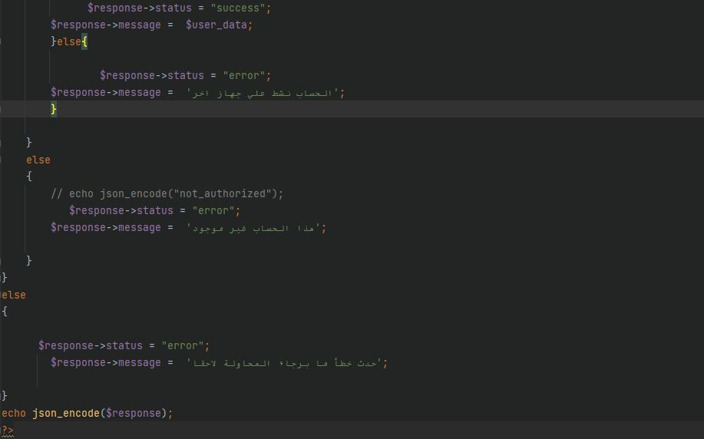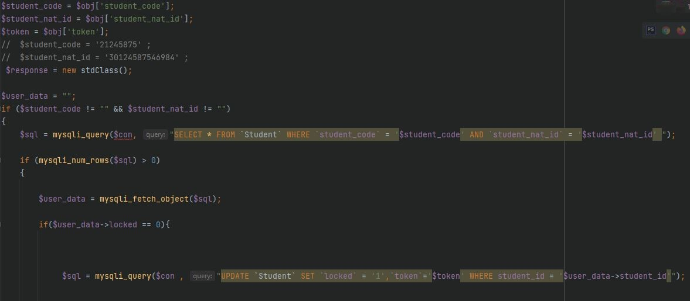This function takes the student ID and his code to check them in the students table in system database to make sure he/she is the valid user. Then it will make another check the ‘locked’ parameter value if its zero this means that student account is not opened in another device and if its value is one this mean the account is active in another device.

1. **Log out:**

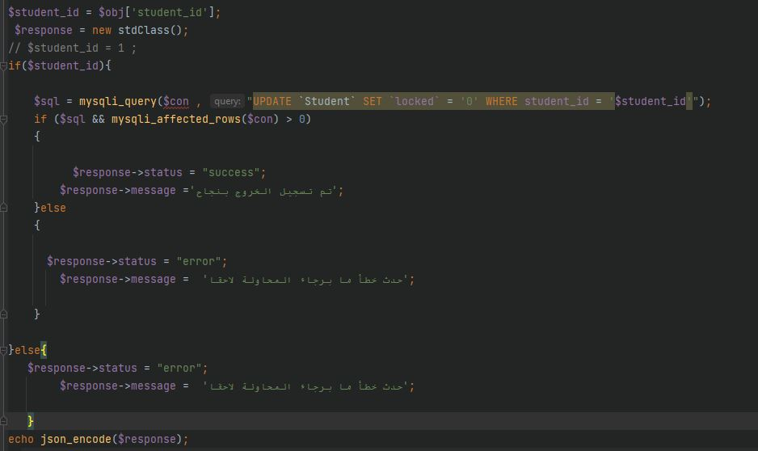This function will simply update the ‘locked ‘parameter for current student from one value to zero this means that the account is not active on this device.

1. **Display profile information:**

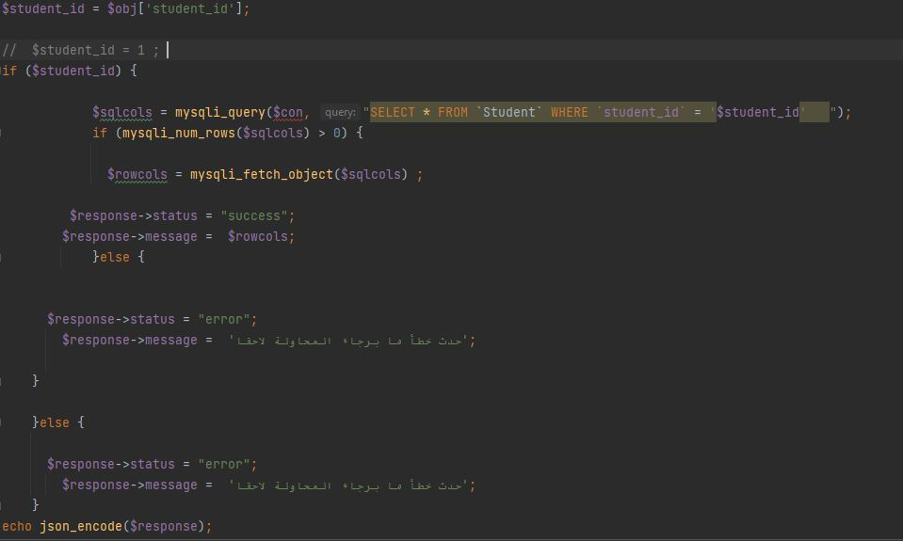This function will select all student information from students table in the system database and display it to student screen.

1. **Meeting:**

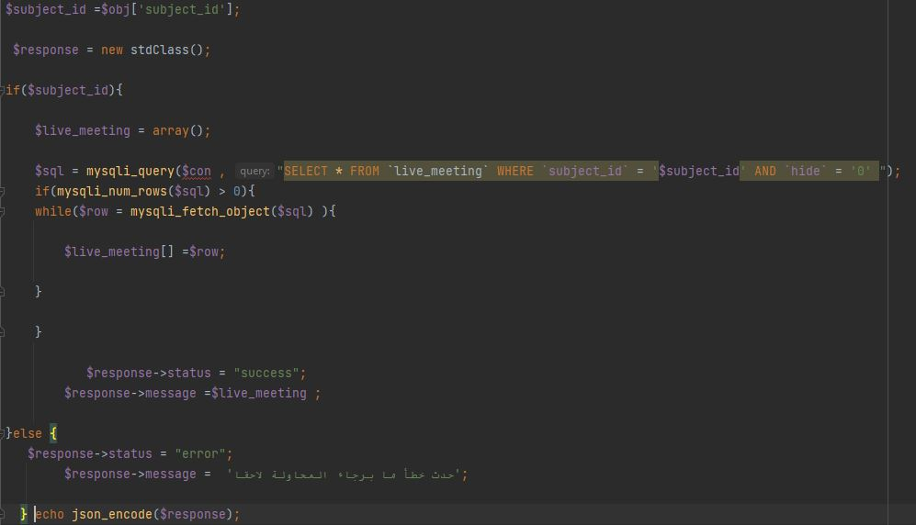This function allows the student to see the current meeting in a subject he/she is studying in his/her current year so the student can attend this meeting.

1. **Video:**

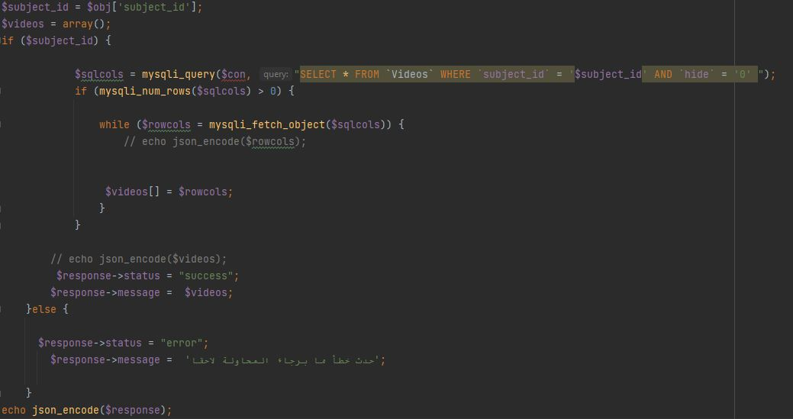This function displays videos of each subject student have in his/her current year by selecting videos associated with the subject from the videos table in system database.

1. **Adding Inquiry:**

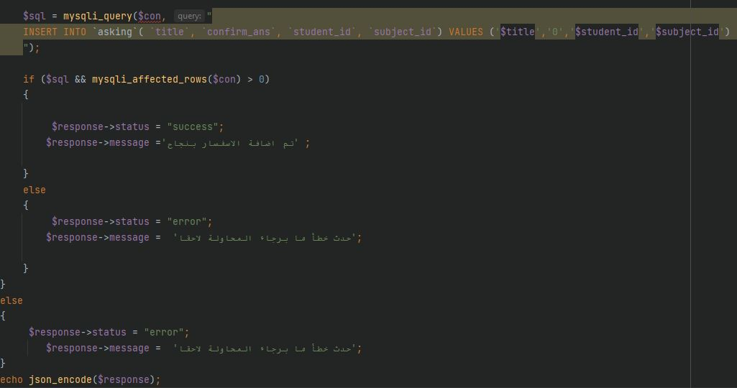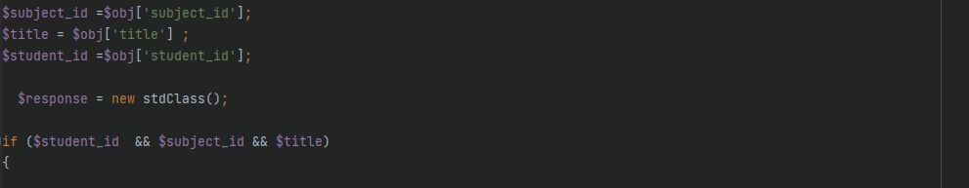Using this function, students can ask any question about any topic in any subject he/she has. This function takes the question, student ID and subject ID then stores them into asking table to be answered by subject doctor.

1. **Display summary:**

This function helps students in finding summary for each subject he/she has. By taking the subject ID and display associated summary for this subject.

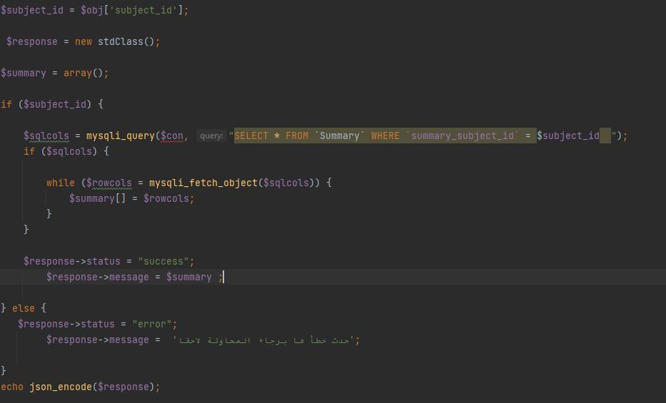

1. **Exam:**

This function after identifying the date and time displays student exam in each subject by taking student ID then search for any exam associated with the subject which student has and displays its questions.

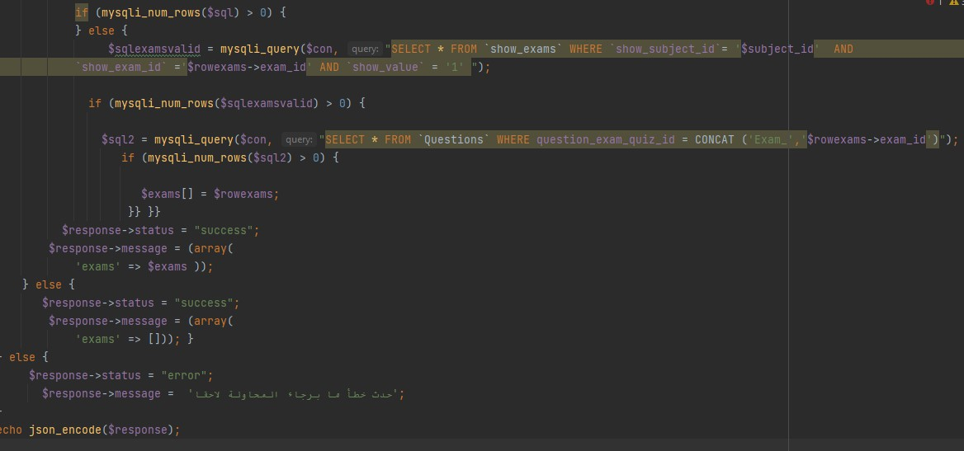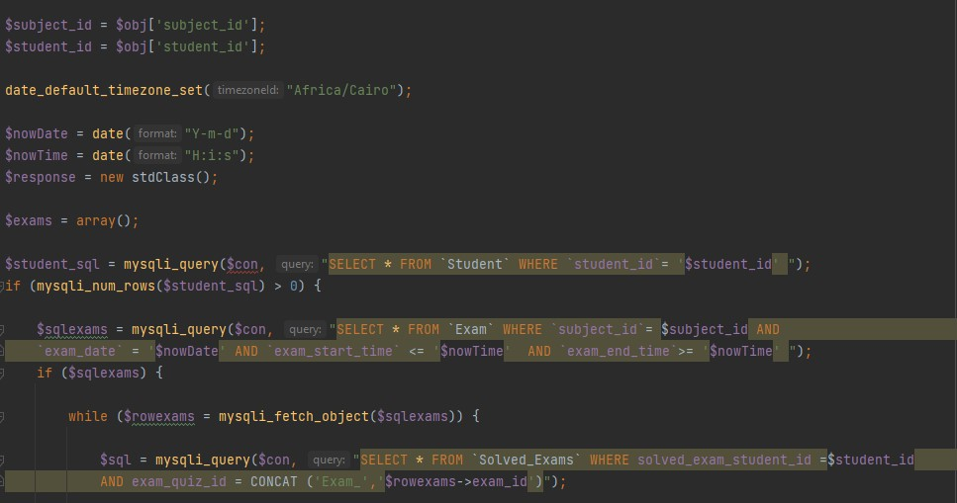

* **Admin API:**

There are many functions for admin to be done in our system. We will discuss some of these functions and how they work in this part of our chapter.

1. **Logout student:**

This function mainly gives permission for the admin to check if a specific student is logged in using its id and this student (He/She) will be logged out from the system.

**Explaining The Code:**

* The script includes a database connection file using the "include" statement.
* The script reads the JSON payload from the request body using the "file_get_contents" function and decodes it into an associative array using the "json_decode" function.
* The script extracts the "student_id" field from the decoded JSON payload.
* The script checks if a valid "student_id" is provided. If not, it returns an error message as a JSON-encoded string.
* The script queries the database to retrieve the "student_logged_in" field value for the provided "student_id".
* If the "student_logged_in" field is already set to "0", the script returns an "already_logged_out" message as a JSON-encoded string.
* If the "student_logged_in" field is not set to "0", the script updates the "student_logged_in" and "student_serial" fields to "0" and "null", respectively, for the provided "student_id".
* If the update query is successful, the script returns a "success" message as a JSON-encoded string. Otherwise, it returns an "error" message as a JSON-encoded string.

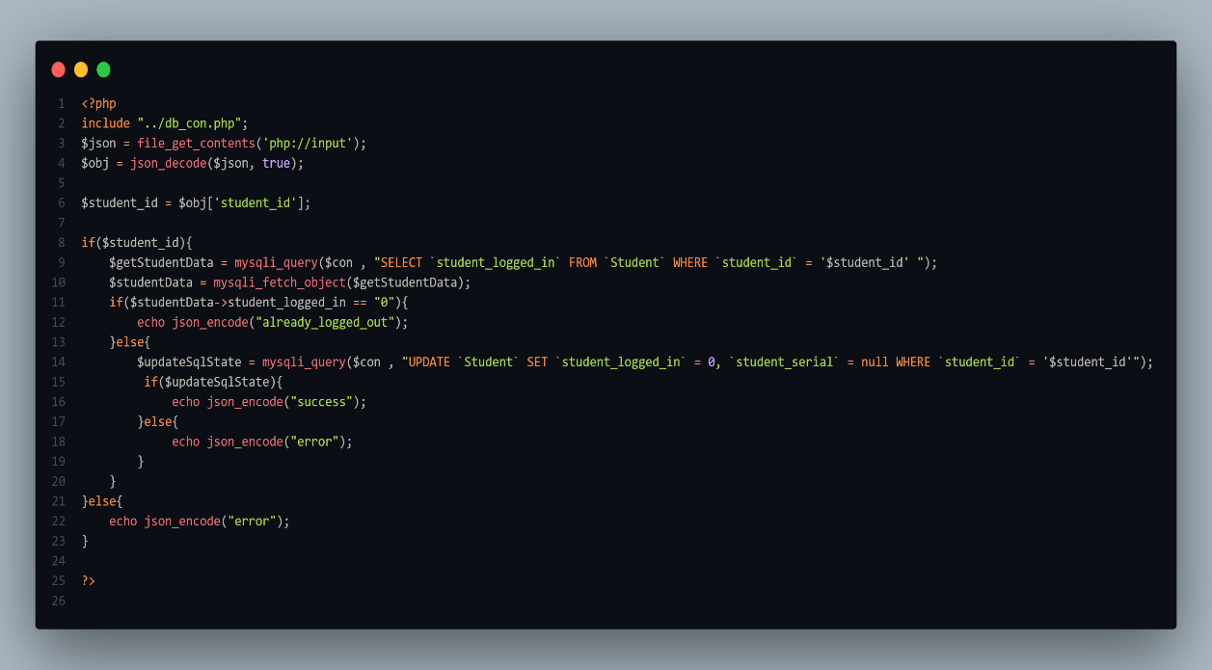

1. **Select custom student:**

This is a PHP script that retrieves data from the "Student", "Generations", and "Collections" tables of a database based on a provided "status" value. The script expects a JSON payload in the request body that contains a "status" field.

**Explaining The Code :**

* The script includes a database connection file using the "include" statement.
* The script reads the JSON payload from the request body using the "file_get_contents" function and decodes it into an associative array using the "json_decode" function.
* The script extracts the "status" field from the decoded JSON payload.
* The script checks if a valid "status" value is provided. If not, it returns an error message as a JSON-encoded string.
* The script creates an empty array called "students" and an empty string called "sqlstudents".
* The script queries the database to retrieve data from the "Student", "Generations", and "Collections" tables based on the provided "status" value. The query joins the "Student" table with the "Generations" and "Collections" tables based on the "student_generation_id" and "student_collection_id" fields, respectively. The query orders the results by the "student_name" field.
* If the query returns one or more rows, the script enters a loop that fetches each row as an object and queries the database to calculate the sum of the "view_count" field in the "my_videos" table for the current student. The query uses the "student_id" field of the current row as a filter.
* If the "view_count" sum query returns one or more rows, the script fetches the first row as an object, and assigns the "sum" value to the "view_count" field of the current student object. If the query returns no rows, the script assigns 0 to the "view_count" field of the current student object.
* The script adds the current student object to the "students" array.
* After all rows have been processed, the script returns the "students" array as a JSON-encoded string. If the initial query returns no rows, the script returns an "error" message as a JSON-encoded string. If the provided "status" value is invalid, the script also returns an "error" message as a JSON-encoded string.

1. **Update student name:**

This is a PHP script that updates the "student_name" field for a specific student in the "Student" table of a database. The script expects a JSON payload in the request body that contains a "student_id" field and a "student_name" field.

**Explaining The Code:**

* The script includes a database connection file using the "include" statement.
* The script reads the JSON payload from the request body using the "file_get_contents" function and decodes it into an associative array using the "json_decode" function.
* The script extracts the "student_id" and "student_name" fields from the decoded JSON payload.
* The script queries the database to update the "student_name" field for the provided "student_id".
* If the update query is successful and at least one row is affected, the script returns a "success" message as a JSON-encoded string.
* 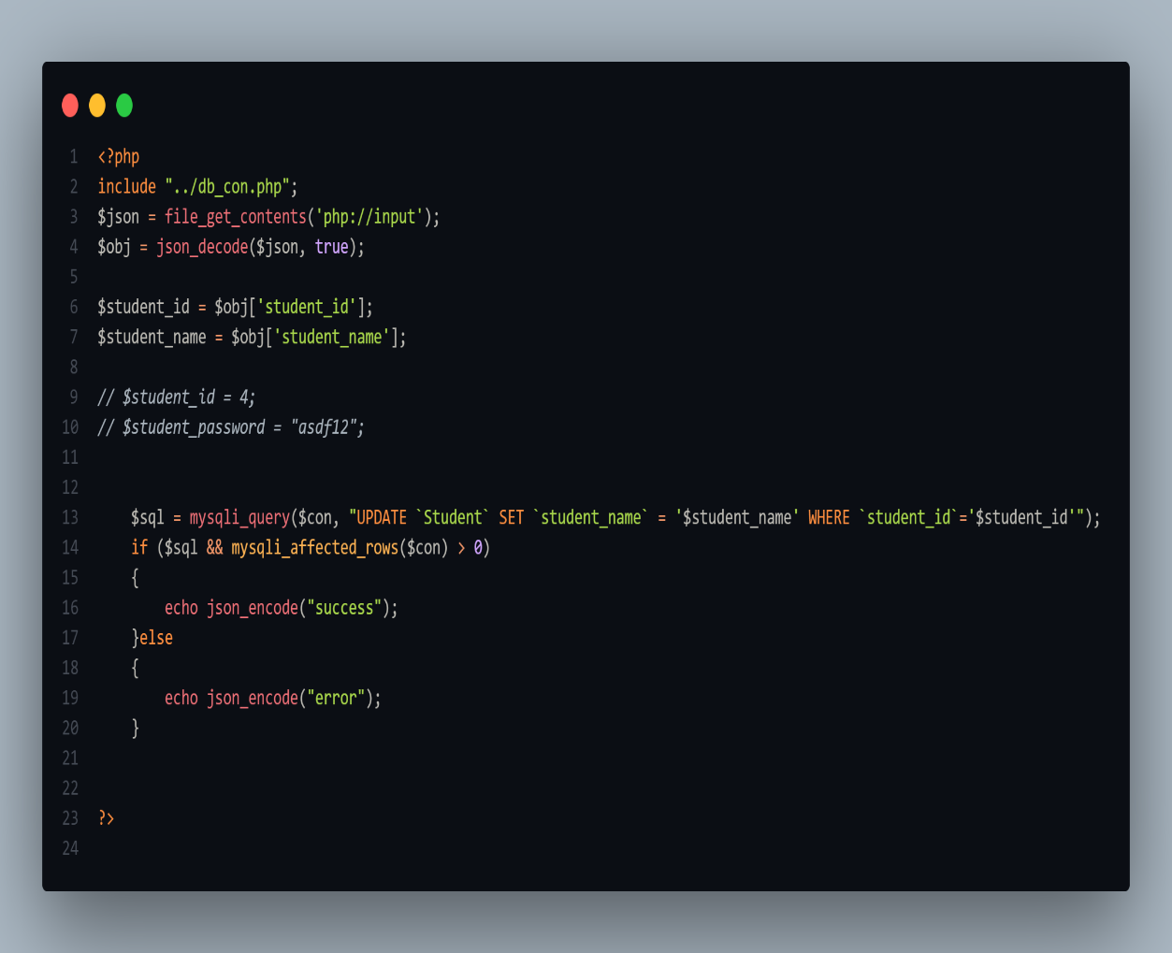If the update query fails or no rows are affected, the script returns an "error" message as a JSON-encoded string.

1. **Update student password:**

This is a PHP script that updates the "student_password" field for a specific student in the "Student" table of a database. The script expects a JSON payload in the request body that contains a "student_id" field and a "student_password" field.

**Explanation of the code:**

* The script includes a database connection file using the "include" statement.
* The script reads the JSON payload from the request body using the "file_get_contents" function and decodes it into an associative array using the "json_decode" function.
* The script extracts the "student_id" and "student_password" fields from the decoded JSON payload.
* The script queries the database to update the "student_password" field for the provided "student_id".
* If the update query is successful and at least one row is affected, the script returns a "success" message as a JSON-encoded string.
* 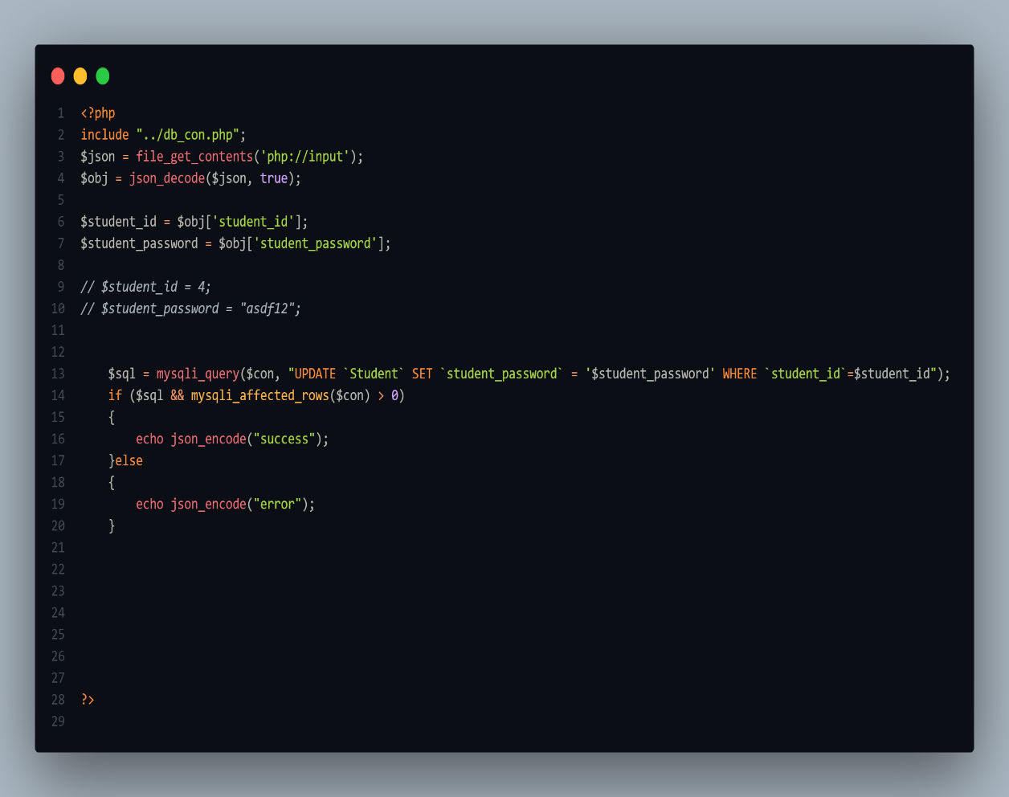If the update query fails or no rows are affected, the script returns an "error" message as a JSON-encoded string.

1. **Add exam:**

This is a PHP script that inserts a new exam record in the "Exam" table of a database and creates corresponding records in the "show_exams" table based on the provided "exam_name", "exam_date", "exam_start", "exam_end", and "exam_generation_id" fields. The script expects a JSON payload in the request body that contains several fields related to exam creation.

**Explaining The Code:**

* The script includes a database connection file using the "include" statement.
* The script reads the JSON payload from the request body using the "file_get_contents" function and decodes it into an associative array using the "json_decode" function.
* The script extracts several fields related to exam creation from the decoded JSON payload, such as "exam_name", "page_type", "time_type", "solution_type", "all_type", "exam_time", "exam_date", "exam_start", "exam_end", and "exam_generation_id".
* The script checks if the required fields ("exam_name", "exam_date", "exam_start", "exam_generation_id", and "exam_end") are not empty. If any of these fields are empty, the script returns an error message as a JSON-encoded string.
* The script queries the database to insert a new exam record in the "Exam" table based on the provided fields. The query uses the "INSERT INTO" statement to insert a new row into the "Exam" table with the provided values.
* If the insert query is successful and at least one row is affected, the script retrieves the new exam ID using the "mysqli_insert_id" function.
* The script queries the database to retrieve all collections that belong to the provided generation ID.
* If at least one collection is found, the script enters a loop that creates a new record in the "show_exams" table for each collection. The new record includes the newly created exam ID, the provided generation ID, and the ID of the current collection.
* If the loop completes successfully and at least one row is affected for each collection, the script returns a "success" message as a JSON-encoded string.
* If any query fails or no rows are affected, the script returns an "error" message as a JSON-encoded string.

1. **Update exam:**

This is a PHP script that updates an existing exam record in the "Exam" table of a database based on the provided "exam_id", "exam_name", "exam_date", "exam_start", "exam_end", and other related fields. The script expects a JSON payload in the request body that contains several fields related to exam update.

**Explaining The Code:**

* The script includes a database connection file using the "include" statement.
* The script reads the JSON payload from the request body using the "file_get_contents" function and decodes it into an associative array using the "json_decode" function.
* The script extracts several fields related to exam update from the decoded JSON payload, such as "exam_id", "exam_name", "page_type", "time_type", "solution_type", "all_type", "exam_time", "exam_date", "exam_start", and "exam_end".
* The script checks if the required fields ("exam_name", "exam_date", "exam_start", "exam_end", and "exam_id") are not empty. If any of these fields are empty, the script returns an error message as a JSON-encoded string.
* The script queries the database to update the existing exam record in the "Exam" table based on the provided fields. The query uses the "UPDATE" statement to update the row in the "Exam" table with the provided values.
* If the update query is successful and at least one row is affected, the script returns a "success" message as a JSON-encoded string.
* If the update query fails or no rows are affected, the script returns an "error" message as a JSON-encoded string.

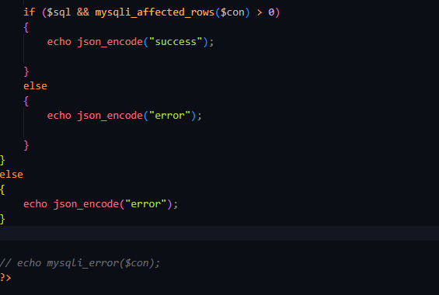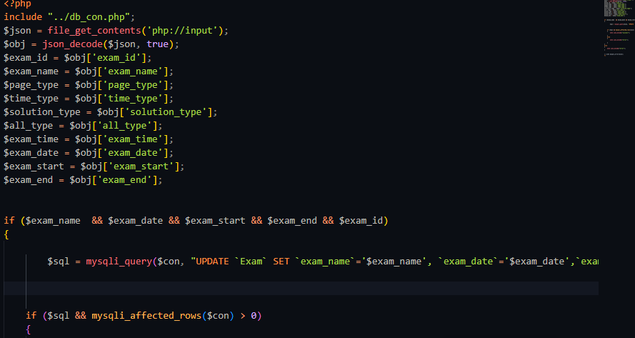

1. **Delete exam:**

This is a PHP script that deletes an existing exam record from the "Exam" table of a database based on the provided "exam_id". The script expects a JSON payload in the request body that contains the "exam_id" field.

**Explanation if the code:**

* The script includes a database connection file using the "include" statement.
* The script reads the JSON payload from the request body using the "file_get_contents" function and decodes it into an associative array using the "json_decode" function.
* The script extracts the "exam_id" field from the decoded JSON payload.
* The script queries the database to delete the existing exam record from the "Exam" table based on the provided "exam_id". The query uses the "DELETE FROM" statement to remove the corresponding row from the "Exam" table.
* If the delete query is successful and at least one row is affected, the script retrieves the exam ID and uses it to delete all related records from the "Questions", "Solved_Exams", and "show_exams" tables.
* If all related records are successfully deleted and at least one row is affected, the script returns a "success" message as a JSON-encoded string.
* 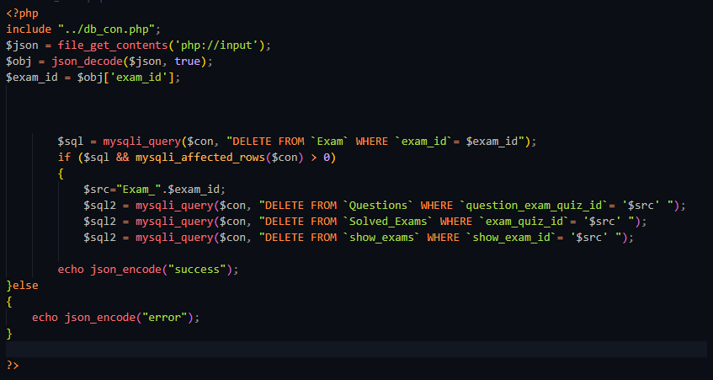If the delete query fails or no rows are affected, the script returns an "error" message as a JSON-encoded string.

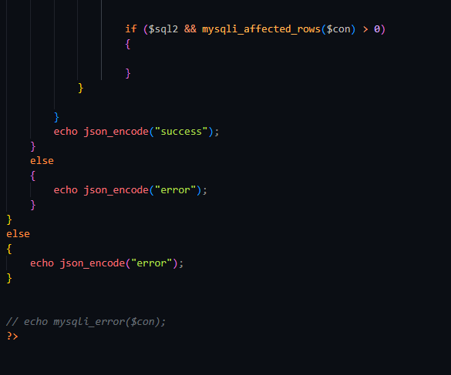

1. **Add quiz:**

This is a PHP script that adds a new quiz record to the "Qiuz" table of a database based on the provided quiz details. The script expects a JSON payload in the request body that contains several fields related to quiz creation.

**Explaining The Code:**

* The script includes a database connection file using the "include" statement.
* The script reads the JSON payload from the request body using the "file_get_contents" function and decodes it into an associative array using the "json_decode" function.
* The script extracts several fields related to quiz creation from the decoded JSON payload, such as "quiz_name", "page_type", "time_type", "solution_type", "all_type", "quiz_time", "quiz_date", and "quiz_generation_id".
* The script checks if the required fields ("quiz_name", "quiz_date", and "quiz_generation_id") are not empty. If any of these fields are empty, the script returns an error message as a JSON-encoded string.
* The script queries the database to insert a new quiz record into the "Qiuz" table based on the provided fields. The query uses the "INSERT INTO" statement to add a new row to the "Qiuz" table with the provided values.
* If the insert query is successful and at least one row is affected, the script retrieves the newly-generated quiz ID using the "mysqli_insert_id" function.
* The script then queries the "Collections" table to retrieve all collections associated with the provided "quiz_generation_id".
* For each collection retrieved, the script generates a new "show_exams" record with the quiz ID, the quiz generation ID, and the collection.
* If all "show_exams" records are successfully inserted and at least one row is affected, the script returns a "success" message as a JSON-encoded string.
* If the insert query fails or no rows are affected, the script returns an "error" message as a JSON-encoded string.

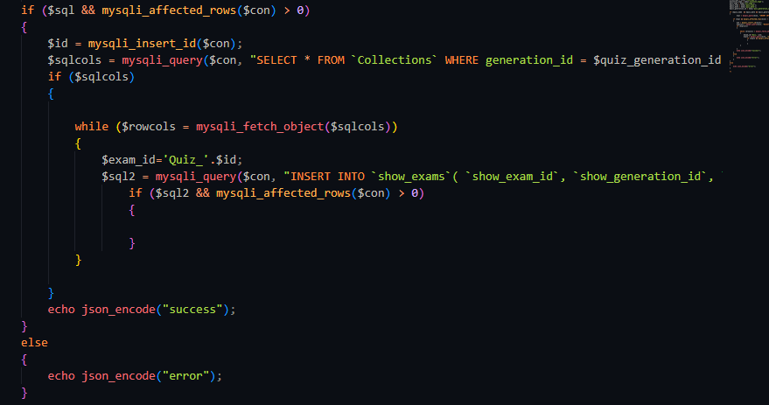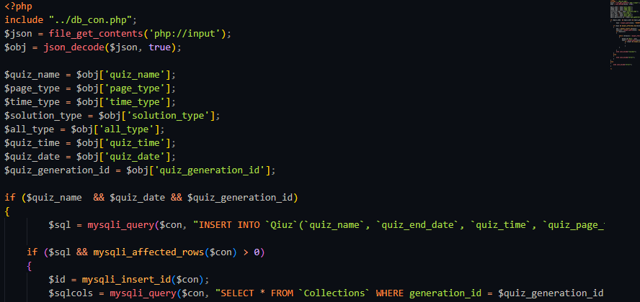

1. **Delete quiz:**

This is a PHP script that deletes an existing quiz record from the "Quiz" table of a database based on the provided "quiz_id". The script expects a JSON payload in the request body that contains the "quiz_id" field.

**Explaining The Code:**

* The script includes a database connection file using the "include" statement.
* The script reads the JSON payload from the request body using the "file_get_contents" function and decodes it into an associative array using the "json_decode" function.
* The script extracts the "quiz_id" field from the decoded JSON payload.
* The script queries the database to delete the existing quiz record from the "Quiz" table based on the provided "quiz_id". The query uses the "DELETE FROM" statement to remove the corresponding row from the "Quiz" table.
* If the delete query is successful and at least one row is affected, the script retrieves the quiz ID and uses it to delete all related records from the "Questions", "Solved_Exams", and "show_exams" tables.
* If all related records are successfully deleted and at least one row is affected, the script returns a "success" message as a JSON-encoded string.
* 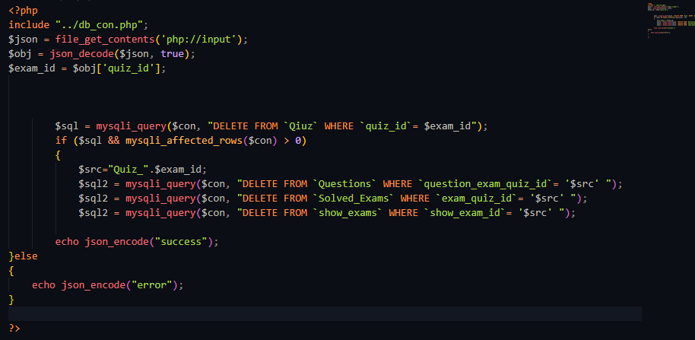If the delete query fails or no rows are affected, the script returns an "error" message as a JSON-encoded string.

1. **Update quiz:**

This is a PHP script that updates an existing quiz record in the "Qiuz" table of a database based on the provided quiz details and quiz ID. The script expects a JSON payload in the request body that contains several fields related to quiz update.

**Explaining The Code :**

* The script includes a database connection file using the "include" statement.
* The script reads the JSON payload from the request body using the "file_get_contents" function and decodes it into an associative array using the "json_decode" function.
* The script extracts several fields related to quiz update from the decoded JSON payload, such as "quiz_name", "page_type", "time_type", "solution_type", "all_type", "quiz_time", "quiz_date", and "quiz_id".
* The script checks if the required fields ("quiz_name", "quiz_date", and "quiz_id") are not empty. If any of these fields are empty, the script returns an error message as a JSON-encoded string.
* The script queries the database to update the existing quiz record in the "Qiuz" table based on the provided fields and quiz ID. The query uses the "UPDATE" statement to update the row in the "Qiuz" table with the provided values.
* If the update query is successful and at least one row is affected, the script returns a "success" message as a JSON-encoded string.
* 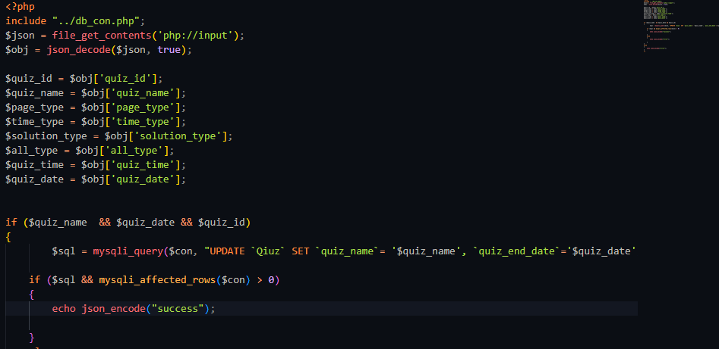If the update query fails or no rows are affected, the script returns an "error" message as a JSON-encoded string.

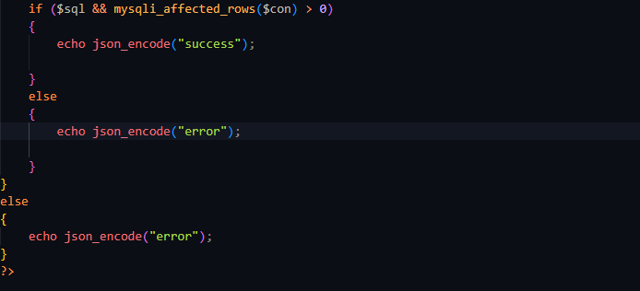

1. **Add question:**

This is a PHP script that adds a new question record to the "Questions" table of a database based on the provided question details. The script expects the question details to be submitted via a form using the POST method.

**Explaining The Code :**

* The script includes a database connection file using the "include" statement.
* The script retrieves the question details from the POST parameters, such as "question_text", "question_answers", "question_image", "question_valid_answer", and "question_exam_quiz_id".
* The script checks if the required fields ("question_text", "question_answers", "question_valid_answer", and "question_exam_quiz_id") are not empty. If any of these fields are empty, the script returns an error message as a JSON-encoded string.
* If the "question_image" field is not empty, the script includes the "item_img_uploader.php" file to upload the question image and retrieve its URL.
* The script queries the database to insert a new question record into the "Questions" table based on the provided fields. The query uses the "INSERT INTO" statement to add a new row to the "Questions" table with the provided values.
* If the insert query is successful and at least one row is affected, the script returns a "success" message as a JSON-encoded string.
* If the insert query fails or no rows are affected, the script returns an "error" message as a JSON-encoded string.

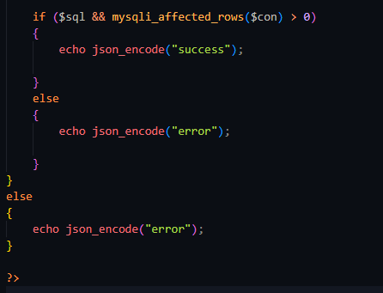

1. **Delete question:**

This is a PHP script that deletes an existing question record from the "Questions" table of a database based on the provided "question_id". The script expects a JSON payload in the request body that contains the "question_id" field.

**Explaining The Code :**

* The script includes a database connection file using the "include" statement.
* The script reads the JSON payload from the request body using the "file_get_contents" function and decodes it into an associative array using the "json_decode" function.
* The script extracts the "question_id" field from the decoded JSON payload.
* The script queries the database to delete the existing question record from the "Questions" table based on the provided "question_id". The query uses the "DELETE FROM" statement to remove the corresponding row from the "Questions" table.
* If the delete query is successful and at least one row is affected, the script returns a "success" message as a JSON-encoded string.
* 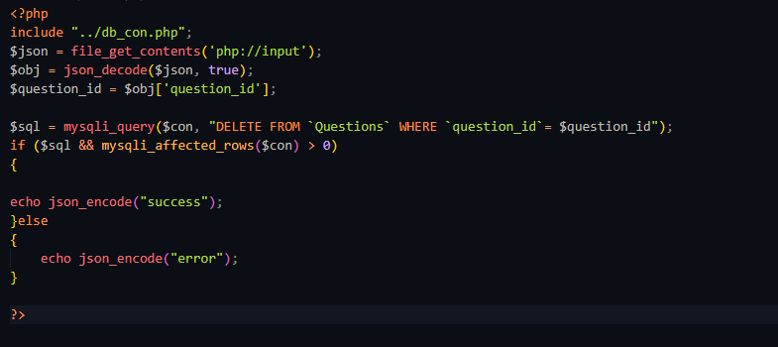If the delete query fails or no rows are affected, the script returns an "error" message as a JSON-encoded string.

1. **Edit question:**

This is a PHP script that updates an existing question record in the "Questions" table of a database based on the provided question details and question ID. The script expects the question details to be submitted via a form using the POST method.

**Explaining The Code :**

* The script includes a database connection file using the "include" statement.
* The script retrieves the question details from the POST parameters, such as "question_id", "question_text", "question_answers", "question_image", "question_valid_answer", and "question_exam_quiz_id".
* The script checks if the required fields ("question_text", "question_answers", "question_valid_answer", "question_exam_quiz_id", and "question_id") are not empty. If any of these fields are empty, the script returns an error message as a JSON-encoded string.
* If the "question_image" field is not empty, the script includes the "item_img_uploader.php" file to upload the question image and retrieve its URL.
* The script queries the database to update the existing question record in the "Questions" table based on the provided fields and question ID. The query uses the "UPDATE" statement to modify the corresponding row in the "Questions" table with the provided values.
* If the update query is successful and at least one row is affected, the script returns a "success" message as a JSON-encoded string.
* 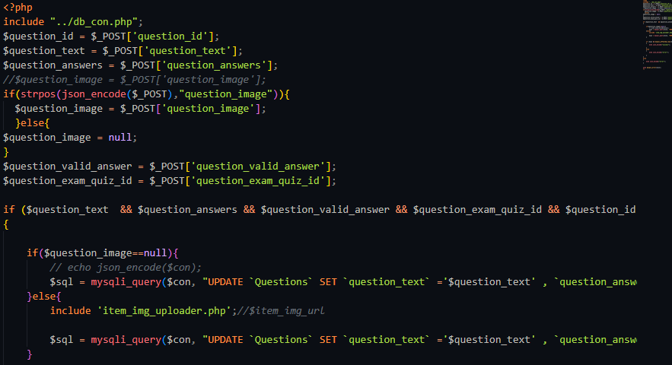If the update query fails or no rows are affected, the script returns an "error" message as a JSON-encoded string.
* 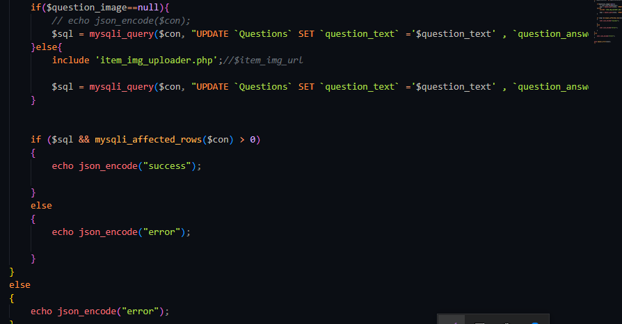The script also outputs any error message that occurs during the execution of the query using the "mysqli_error" function, which can be helpful for debugging purposes.

1. **Insert collection:**

This is a PHP script that creates a new collection record in the "Collections" table of a database based on the provided collection details and generation ID. The script expects the collection details to be submitted via a JSON payload using the POST method.

**Explaining The Code :**

* The script includes a database connection file using the "include" statement.
* The script reads the JSON payload from the request body using the "file_get_contents" function and decodes it into an associative array using the "json_decode" function.
* The script extracts the collection details from the decoded JSON payload, such as "generation_id", "collection_name", "collection_start_time", "collection_end_time", "collection_limit", and "collection_day".
* The script checks if the required fields ("collection_name" and "generation_id") are not empty. If any of these fields are empty, the script returns an error message as a JSON-encoded string.
* The script queries the database to check if a collection with the same "collection_name" already exists for the given "generation_id". If a collection with the same name exists, the script returns a "name_found" message as a JSON-encoded string.
* If a collection with the same name does not exist, the script queries the database to insert a new collection record into the "Collections" table based on the provided fields. The query uses the "INSERT INTO" statement to add a new row to the "Collections" table with the provided values.
* If the insert query is successful and at least one row is affected, the script retrieves the newly inserted collection ID using the "mysqli_insert_id" function.
* 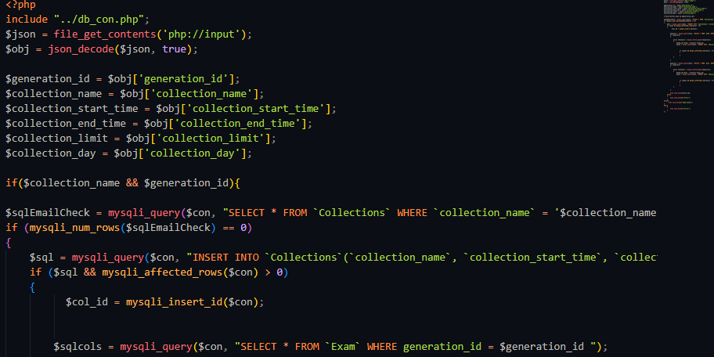The script queries the database to populate the "show_exams" table with the exams and quizzes associated with the given "generation_id". The query uses the "SELECT" statement to retrieve the exams and quizzes associated with the given "generation_id", and the "INSERT INTO" statement to add a new row to the "show_exams" table for each exam and quiz.
* If both the insert queries are successful and at least one row is affected, the script returns the newly inserted collection ID as a JSON-encoded string.
* If any of the insert queries fail or no rows are affected, the script returns an "error" message as a JSON-encoded string.

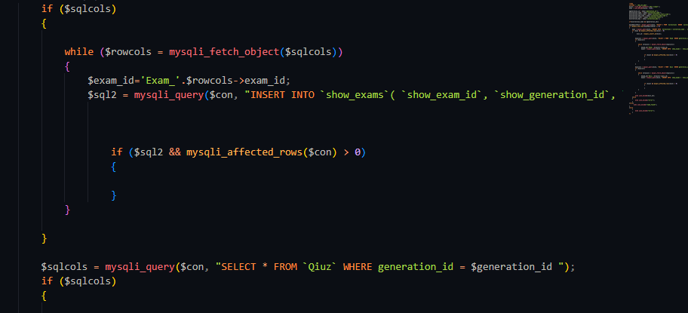

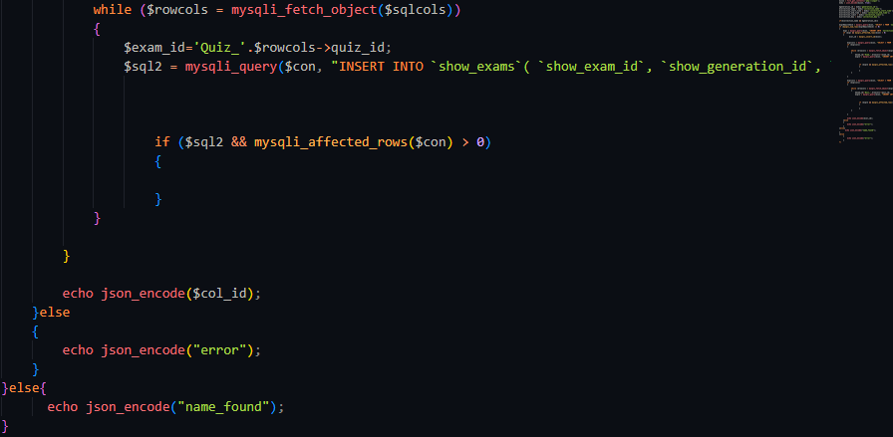

1. **Insert generation:**

This is a PHP script that creates a new generation record in the "Generations" table of a database based on the provided generation name. The script expects the generation name to be submitted via a JSON payload using the POST method.

**Explaining The Code :**

* The script includes a database connection file using the "include" statement.
* The script reads the JSON payload from the request body using the "file_get_contents" function and decodes it into an associative array using the "json_decode" function.
* The script extracts the generation name from the decoded JSON payload.
* The script checks if the required field ("generation_name") is not empty. If this field is empty, the script returns an error message as a JSON-encoded string.
* The script queries the database to check if a generation with the same "generation_name" already exists. If a generation with the same name exists, the script returns a "name_found" message as a JSON-encoded string.
* If a generation with the same name does not exist, the script queries the database to insert a new generation record into the "Generations" table based on the provided generation name. The query uses the "INSERT INTO" statement to add a new row to the "Generations" table with the provided values.
* If the insert query is successful and at least one row is affected, the script retrieves the newly inserted generation ID using the "mysqli_insert_id" function.
* If both the insert query is successful and at least one row is affected, the script returns the newly inserted generation ID as a JSON-encoded string.
* If the insert query fails or no rows are affected, the script returns an "error" message as a JSON-encoded string.

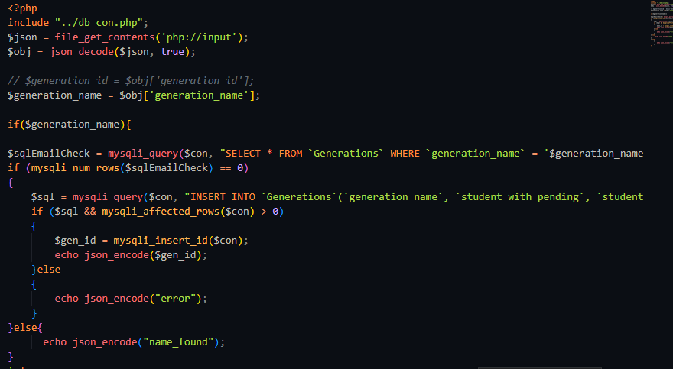

1. **Select question:**

This is a PHP script that retrieves the questions and exam information for a given exam or quiz ID from the "Questions" and "Exam" tables of a database. The script expects the exam or quiz ID to be submitted via a JSON payload using the POST method.

**Explaining The Code :**

* The script includes a database connection file using the "include" statement.
* The script reads the JSON payload from the request body using the "file_get_contents" function and decodes it into an associative array using the "json_decode" function.
* The script extracts the exam or quiz ID from the decoded JSON payload.
* The script checks if the required field ("id") is not empty. If this field is empty, the script returns an error message.
* The script queries the database to retrieve all the questions associated with the given exam or quiz ID from the "Questions" table. The query uses the "SELECT" statement to retrieve all the rows in the "Questions" table with the matching "question_exam_quiz_id" value.
* If the question query is successful, the script queries the database to retrieve the exam name and paper link associated with the given exam ID from the "Exam" table. The query uses the "SELECT" statement to retrieve the row in the "Exam" table with the matching "exam_id" value.
* The script loops through all the retrieved questions and creates an array of question objects that contain the question information, the answer options, and the correct answer. It also checks if each question is found in the test bank and sets a flag accordingly.
* The script creates a new object and assigns the array of questions and exam information to it.
* The script returns the newly created object as a JSON-encoded string.
* 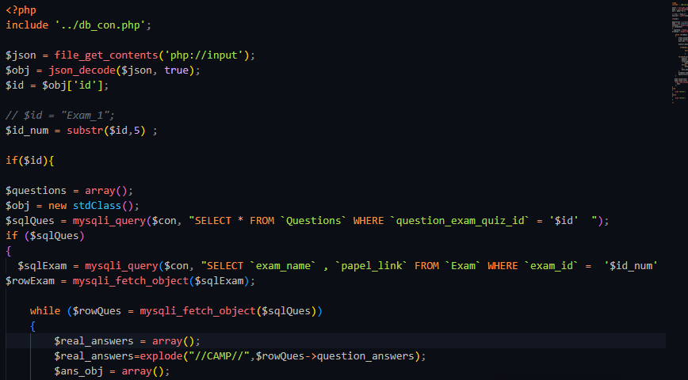If the question query fails or no rows are affected, the script returns an "error" message.

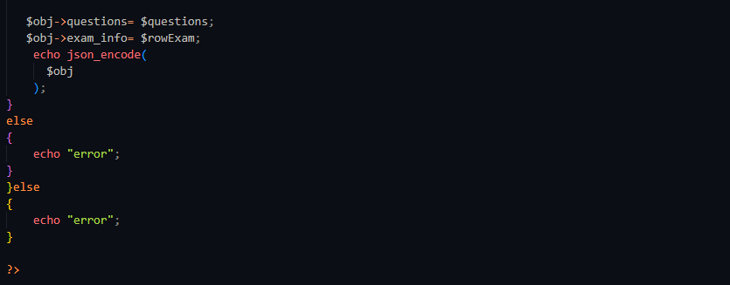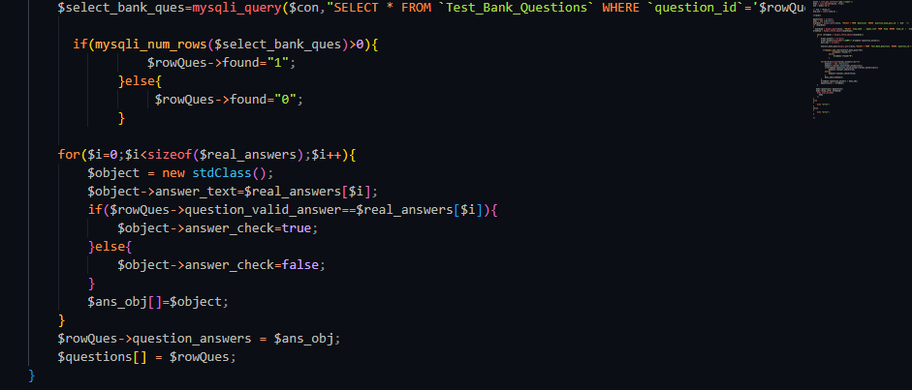

1. **Upload video data:**

This is a PHP script that creates a new video record in the "Videos" table of a database based on the provided video details and generation ID. The script expects the video details to be submitted via a JSON payload using the POST method.

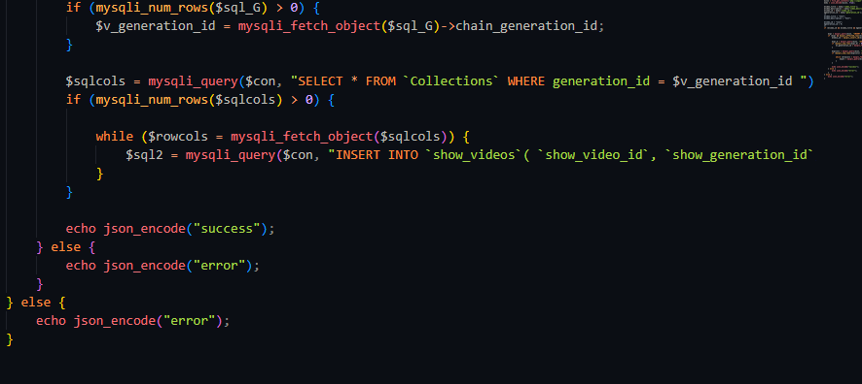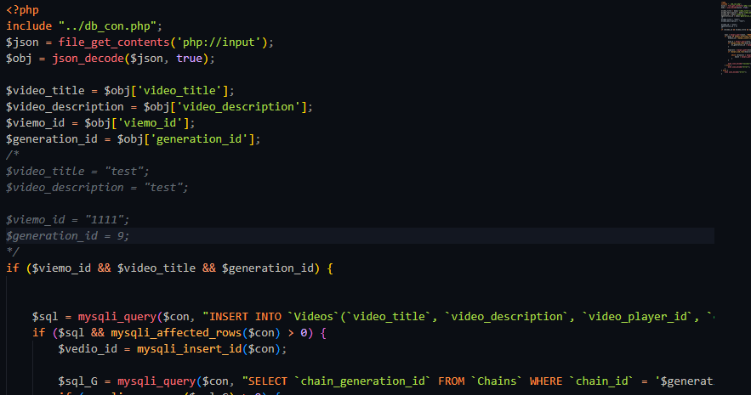

1. **Upload question from excel file:**

This is a PHP script that reads data from an Excel file and inserts new question records into the "Questions" table of a database. The script expects the path of the Excel file to be assigned to the $path variable.

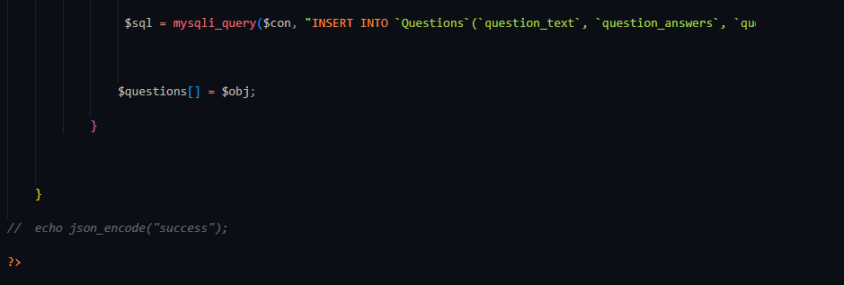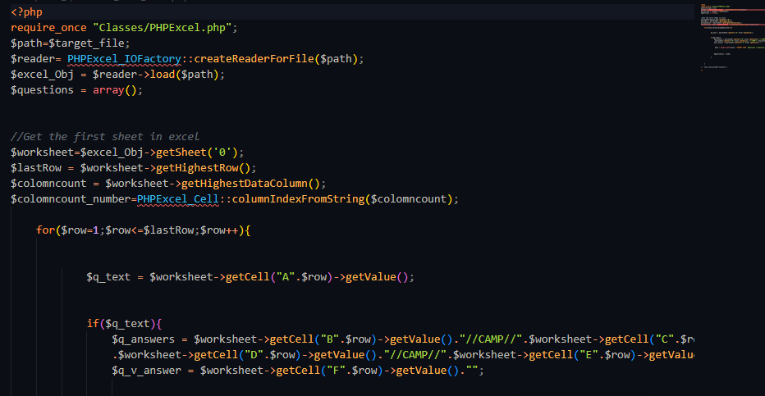

1. **Update video:**

This is a PHP script that updates an existing video recorder in the "Videos" table of a database based on the provided video details and video ID. The script expects the video details and video ID to be submitted via a JSON payload using the POST method.

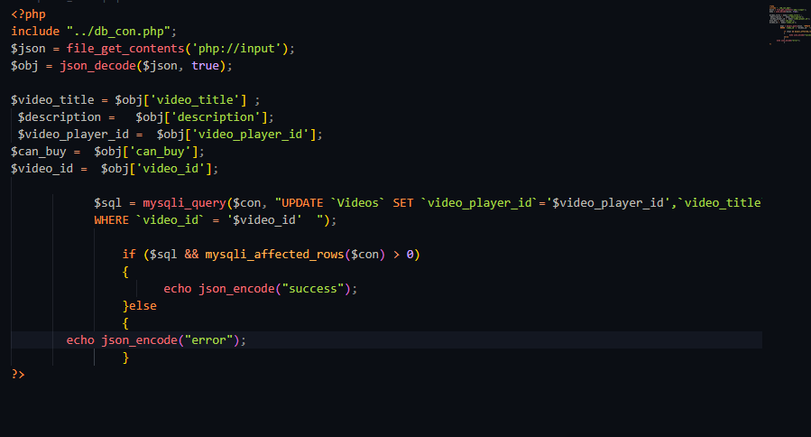

1. **Select viedos:**

This is a PHP script that retrieves a list of videos associated with a particular "generation" or "chain" from the "Videos" and "my_videos" tables of a database. The script expects the generation ID to be submitted via a JSON payload using the POST.

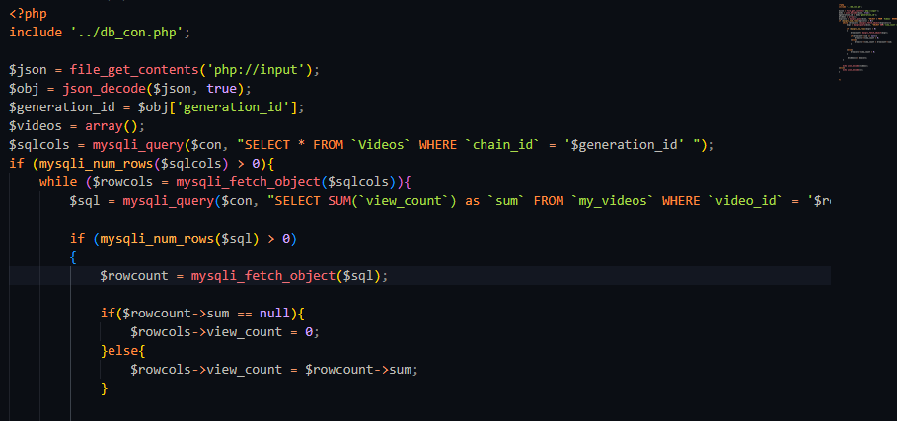

* **Doctor API**

There are many functions for doctor to be done in our system as (log in, adding inquiry, message a doctor…etc.) we will discuss some of these functions and how they work in this part of our chapter. We will start with the basic functions.

1. **Add and delete exams:**

The doctor has a lot of permissions in our application, one of them is adding and deleting exams for students.

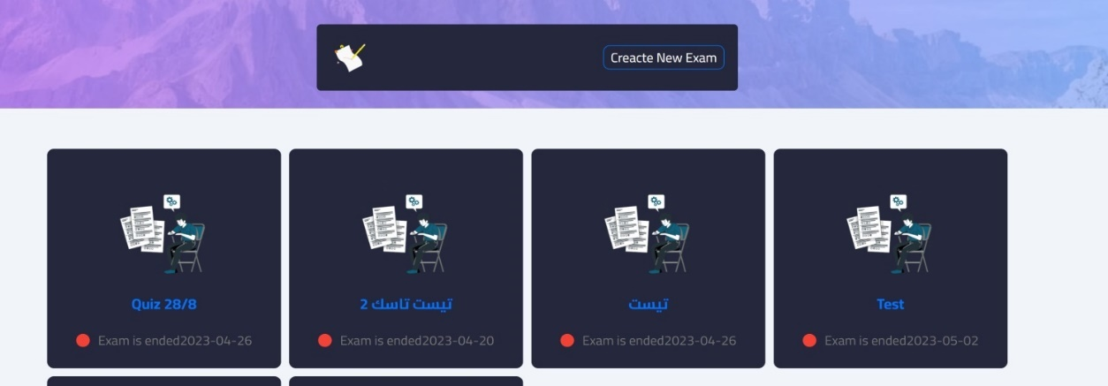**Design of add and delete exams:**

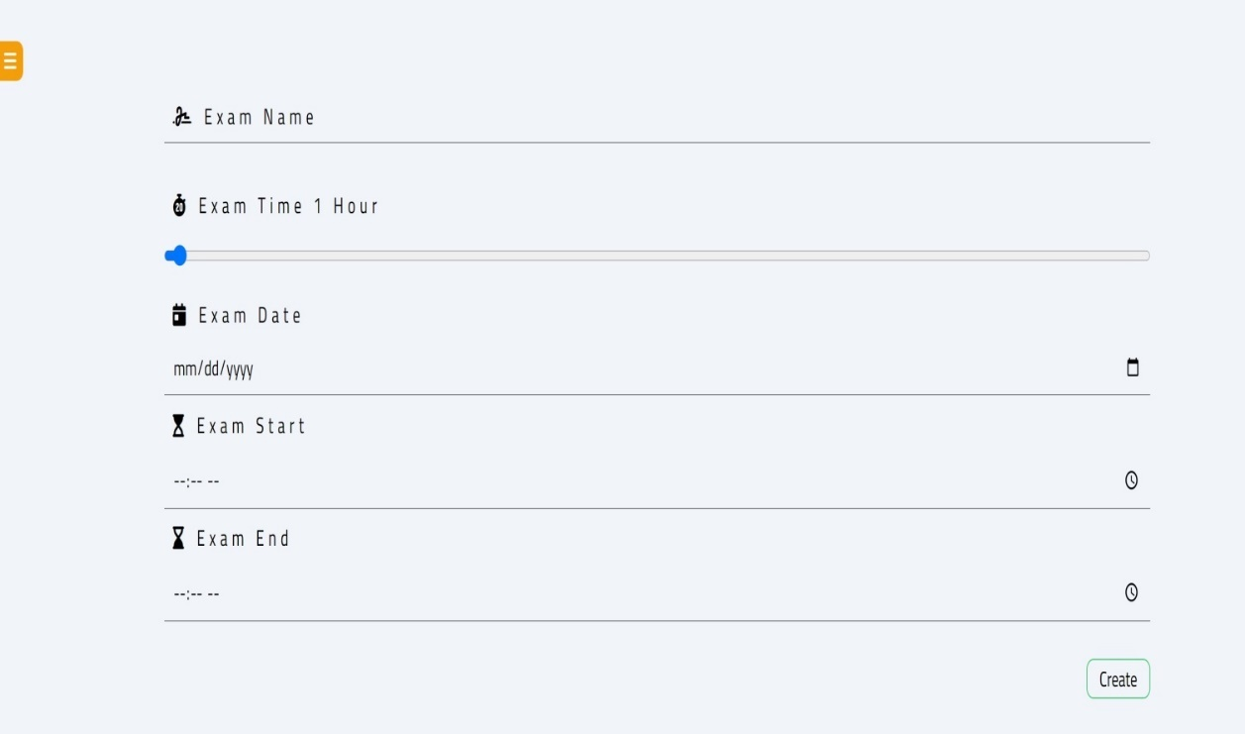

**Code of add and delete exams:**

First things first the access was given to the database and the elements:

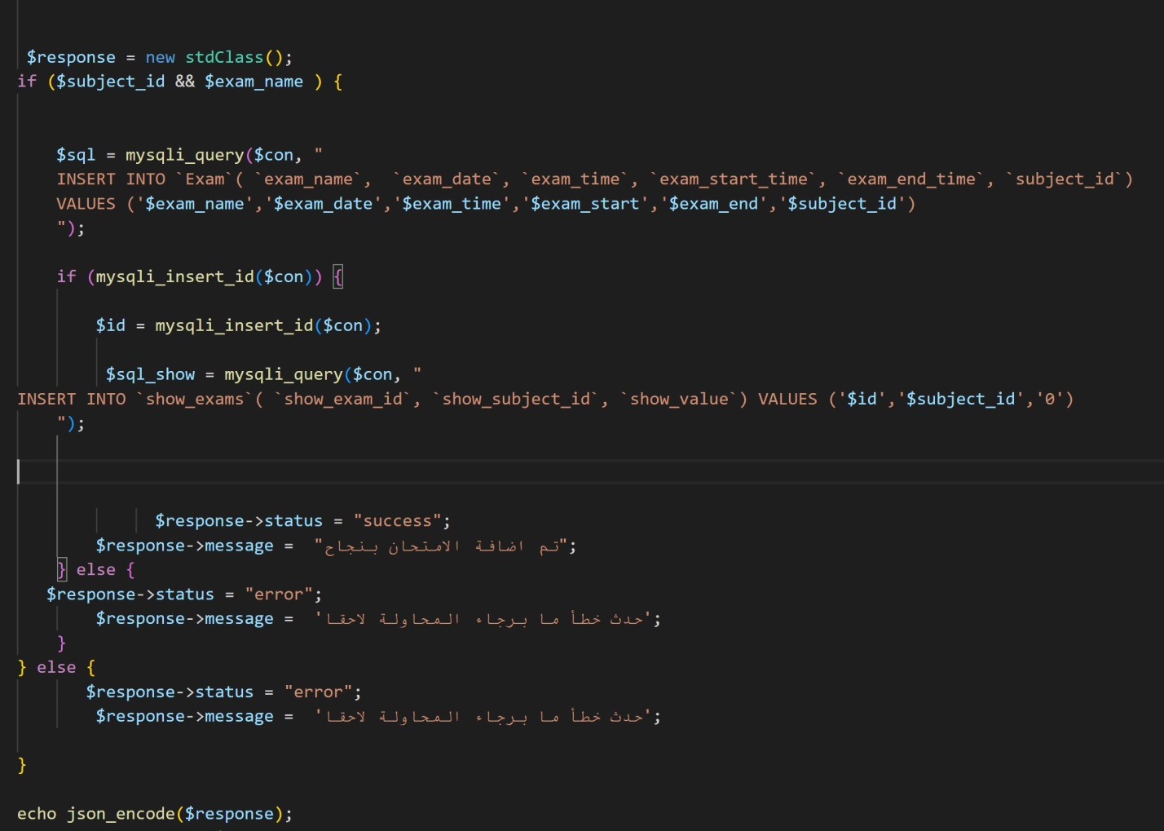Exam_name, exam_date, exam_time, exam_start_time, exam_end_time, subject_id was added to the table Exam to allow storing and putting name and time for the exam that the doctor adds. Then after clicking Create if all the steps were done correctly the exam will be added and shown if not an error message will appear to try again later.

1. **Adding questions and answers:**

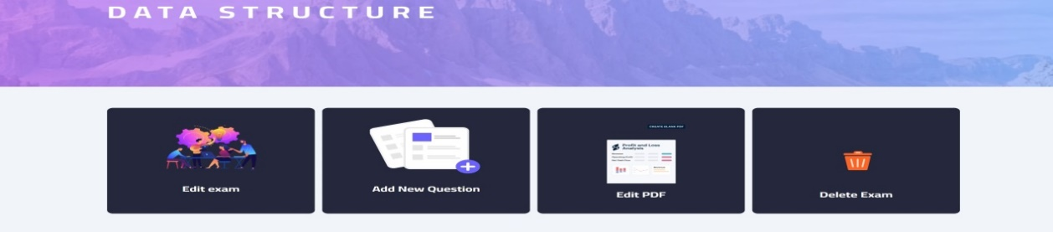**Design of adding questions and answers:**

**Code of adding questions and answers:**

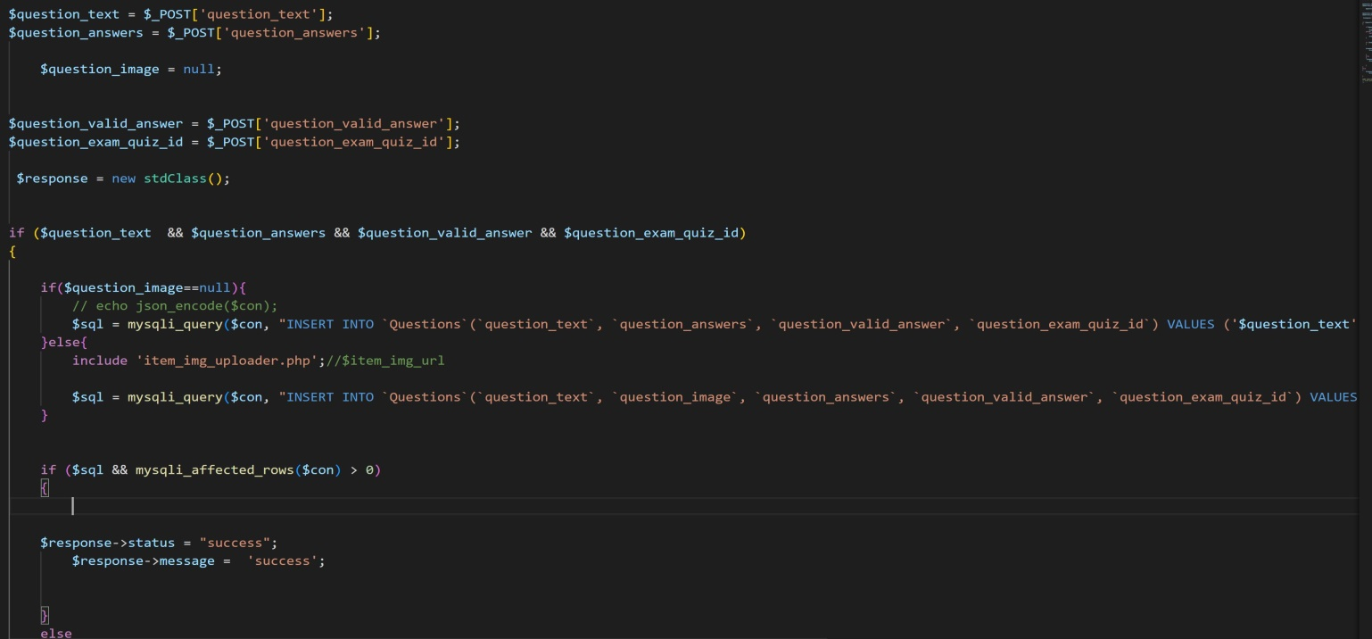Here, the doctor has the access to add text or image questions to the exam after creating it and also, he adds the possible answers to the question and if something wrong happens an error message will appear to try again.

1. **Edit exams:**

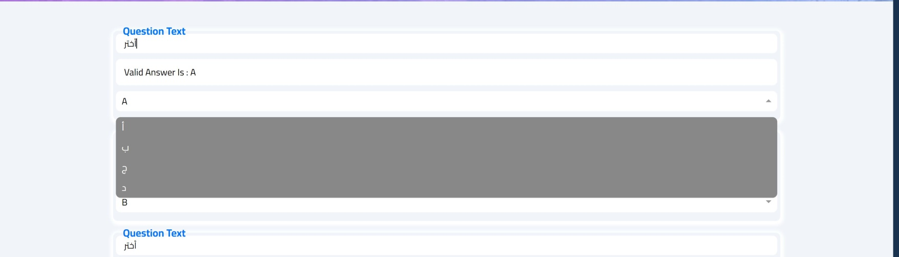**Design of editing exams:**

**Code of editing exams:**

Here, The doctor has the access to edit any question or answer in the exam that he added if no errors appeared the editing will be successful and a success message will appear after clicking the button update changes if not an error message will appear to try again.

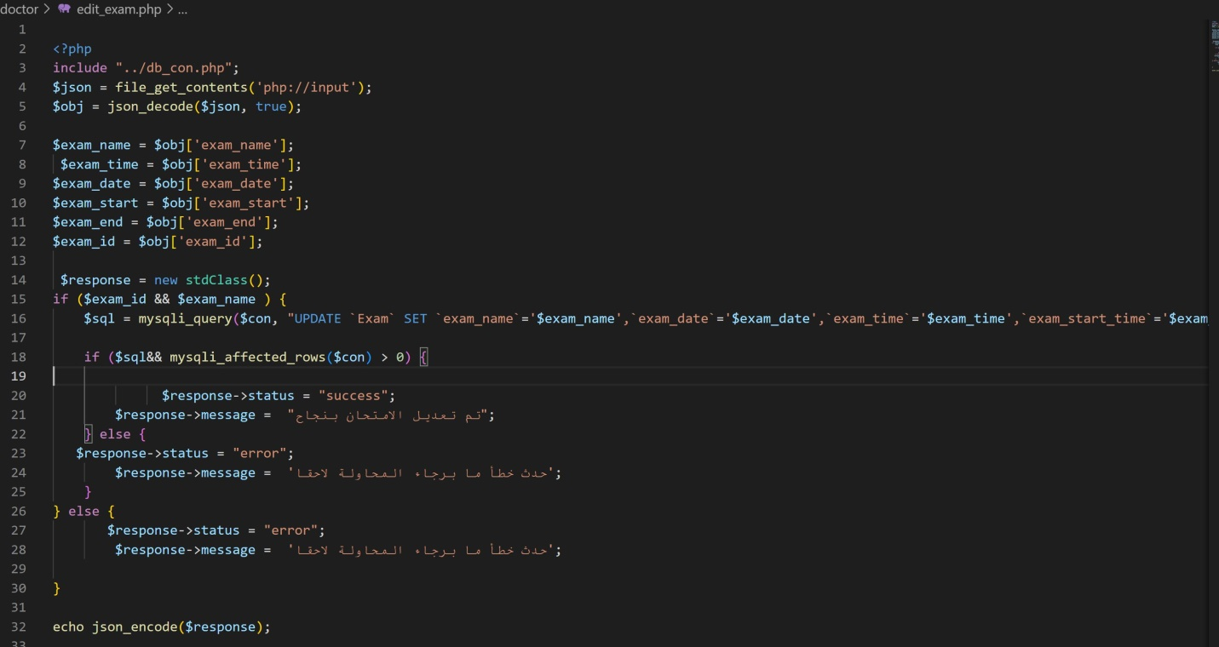

1. **Delete exam:**

**Design of deleting existing exam:**

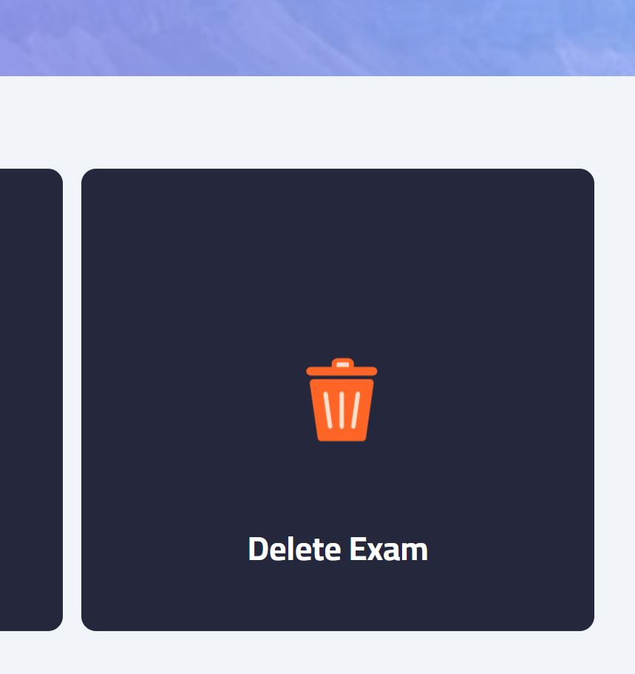

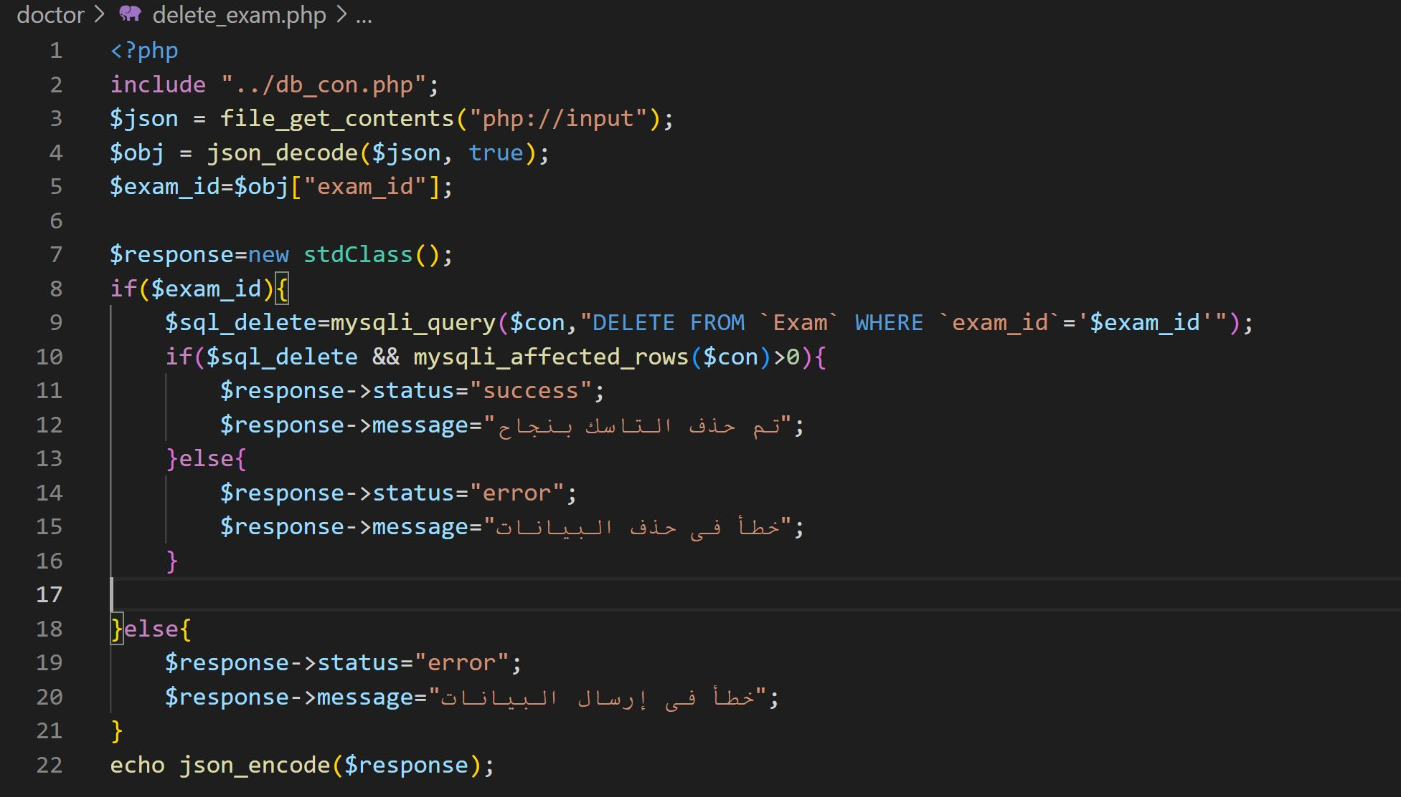**Code of deleting existing exam:**

1. **Select exam:**

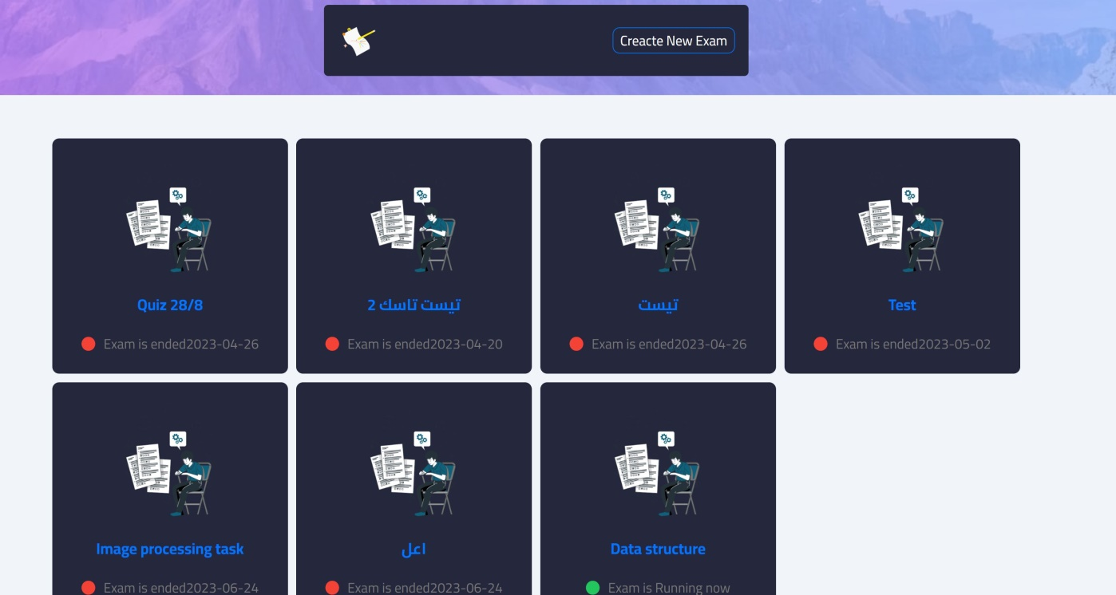**Design of selecting existing exam:**

**code of selecting existing exam:**

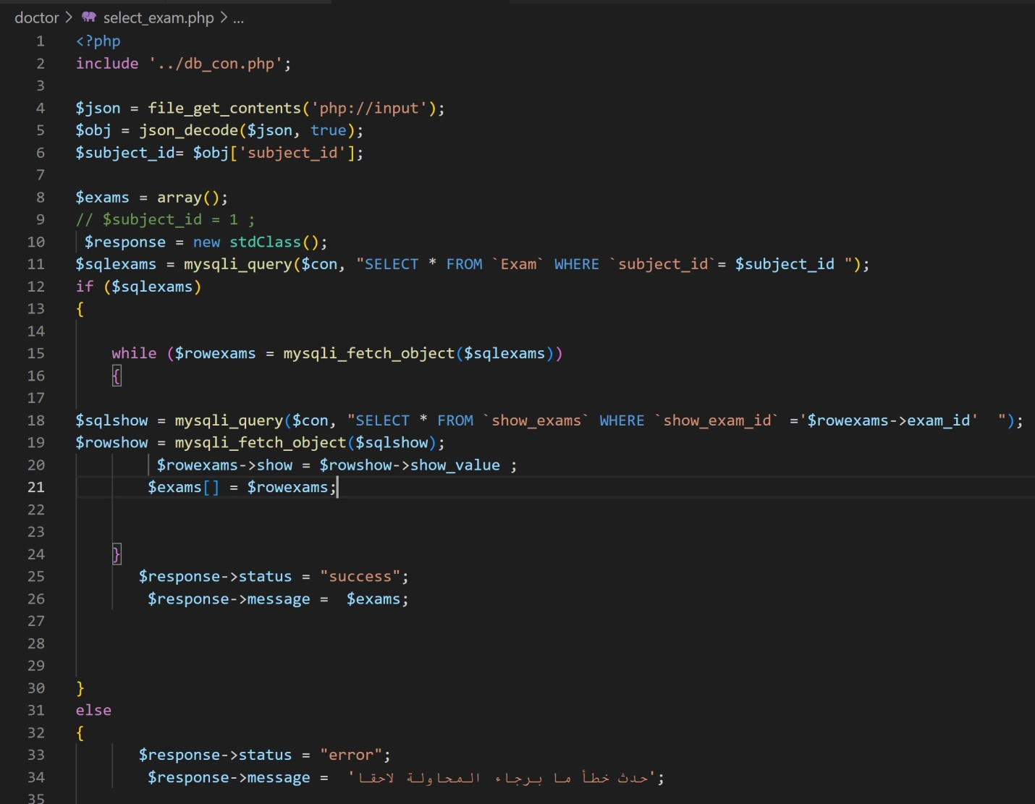All the Exams are shown to the doctor using show functions and he can select the exam that he wants by clicking it and all the options mentined before will appear to him as editing, deleting, adding ….etc.

1. **Add viedos:**

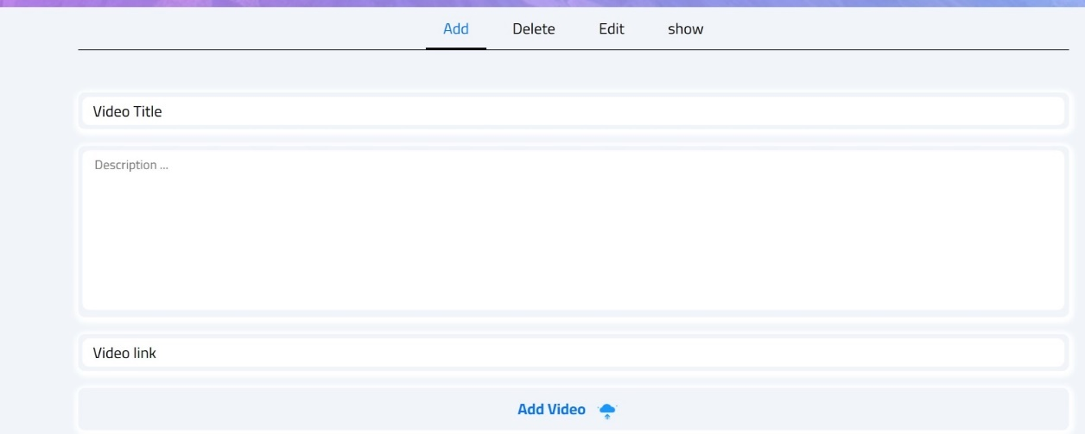**Deign of adding a new viedo:**

**Code of adding a new viedo:**

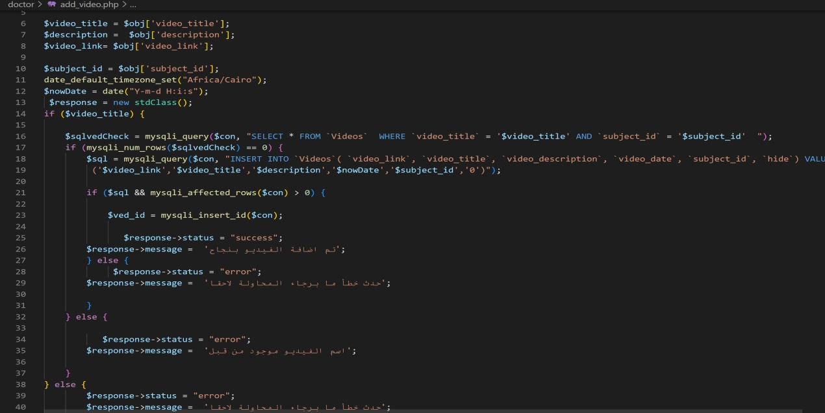The doctor can Add any vedio by adding name, description and link then clicking add vedio .. if the name is repeated an error message will appear to rewrite the name if not the vedio will be added successfully and a message will appear saying that also.

1. **edit viedo:**

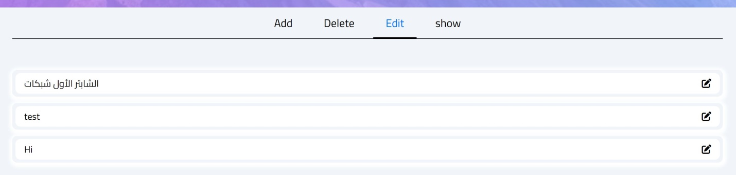**Design of editing existing viedo:**

**Code of editing existing viedo:**

The information of any vedio can be edited and updated by the doctor and a success message will appear if there aren’t any errors.

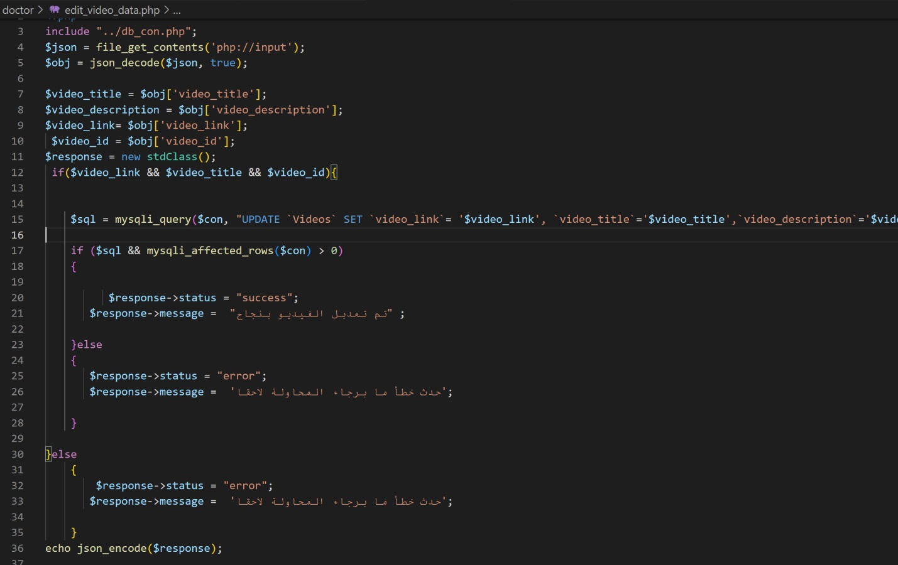

1. **Show viedo:**

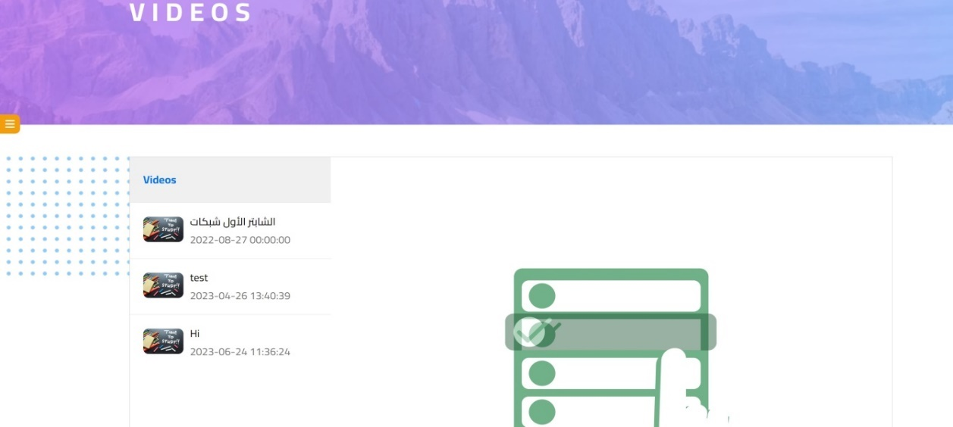**Design of showing viedos:**

**Code of showing viedos:**

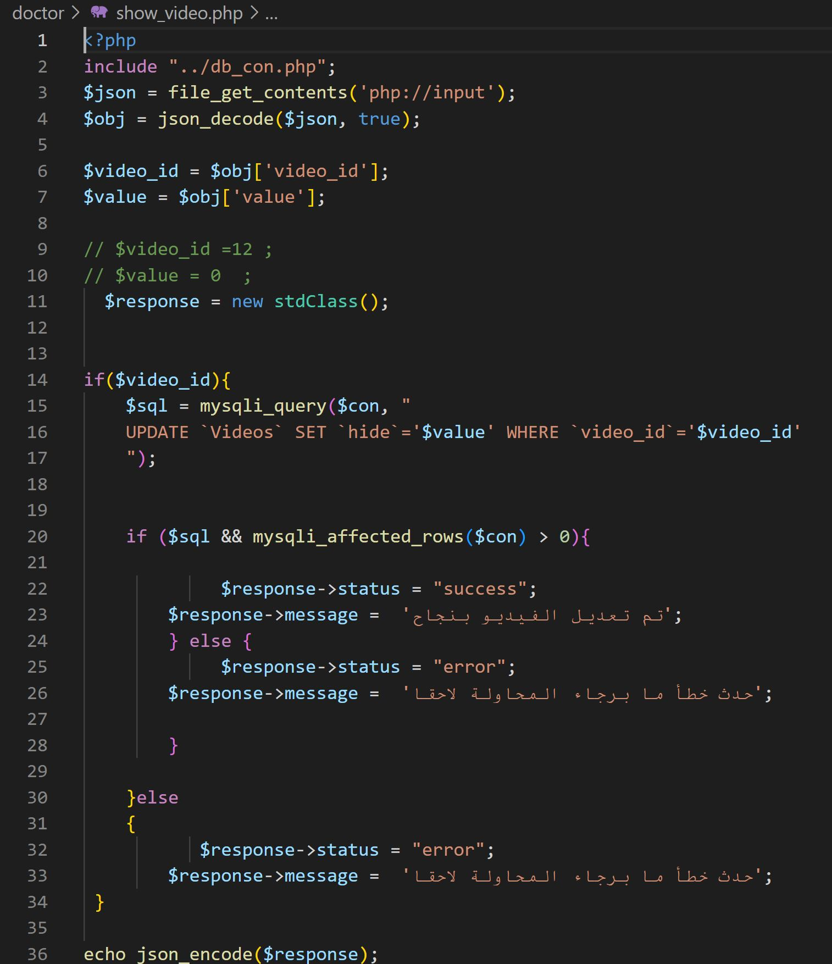The vedios will be shown after updating and the doctor can see all the vedios on the application.

1. **Login:**

**Design of logging into the system:**

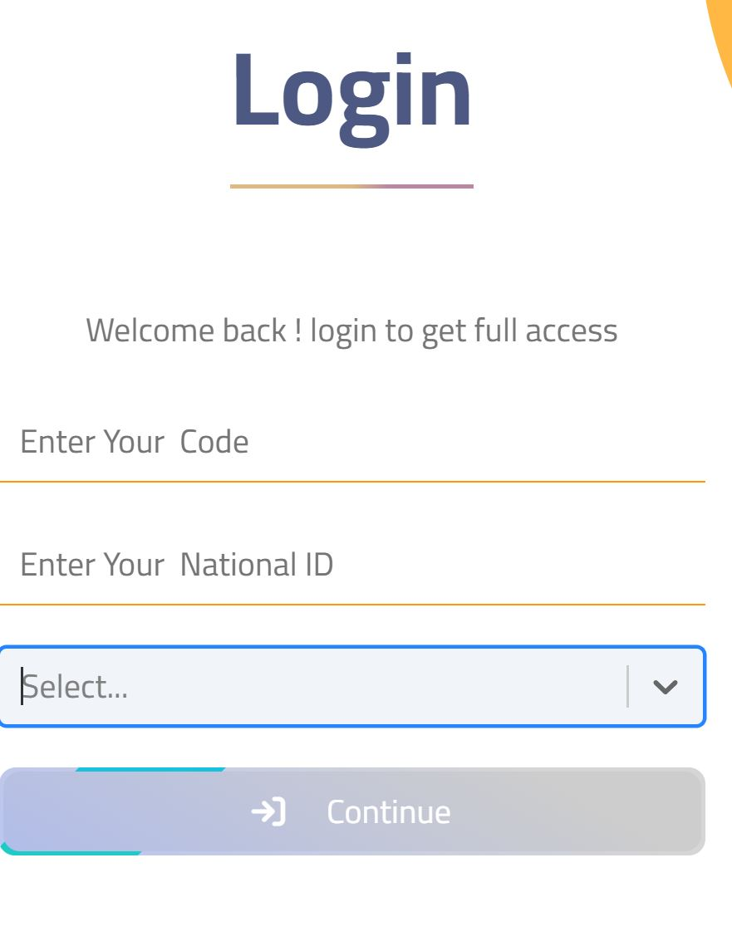

**Code of logging into the system:**

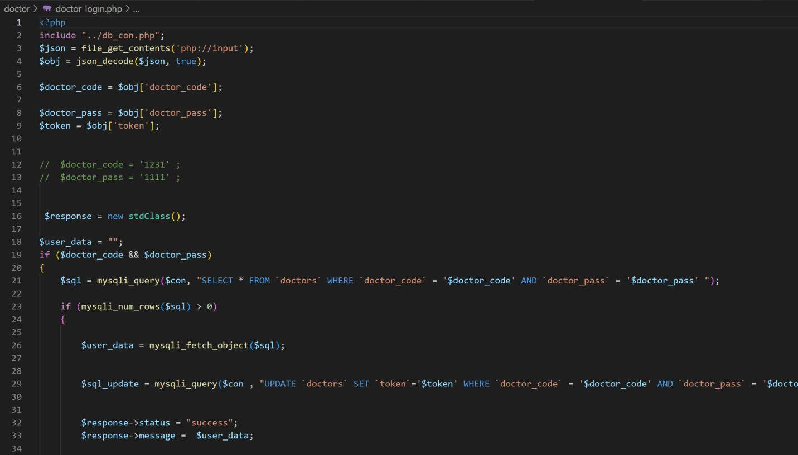Every Doctor has his own code and id saved in the database when he writes them and chooses Doctor from the select list it will automatically take him to his page that he can use all the previous features in.

* 1. **Database analysis:**

*ــــــــــــــــــــــــــــــــــــــــــــــــــــــــــ*

This part of the chapter will talk about our system database as its design, diagrams, and schema to illustrate how our system store user data and handles relations among these data. We have three points to illustrate:

1. 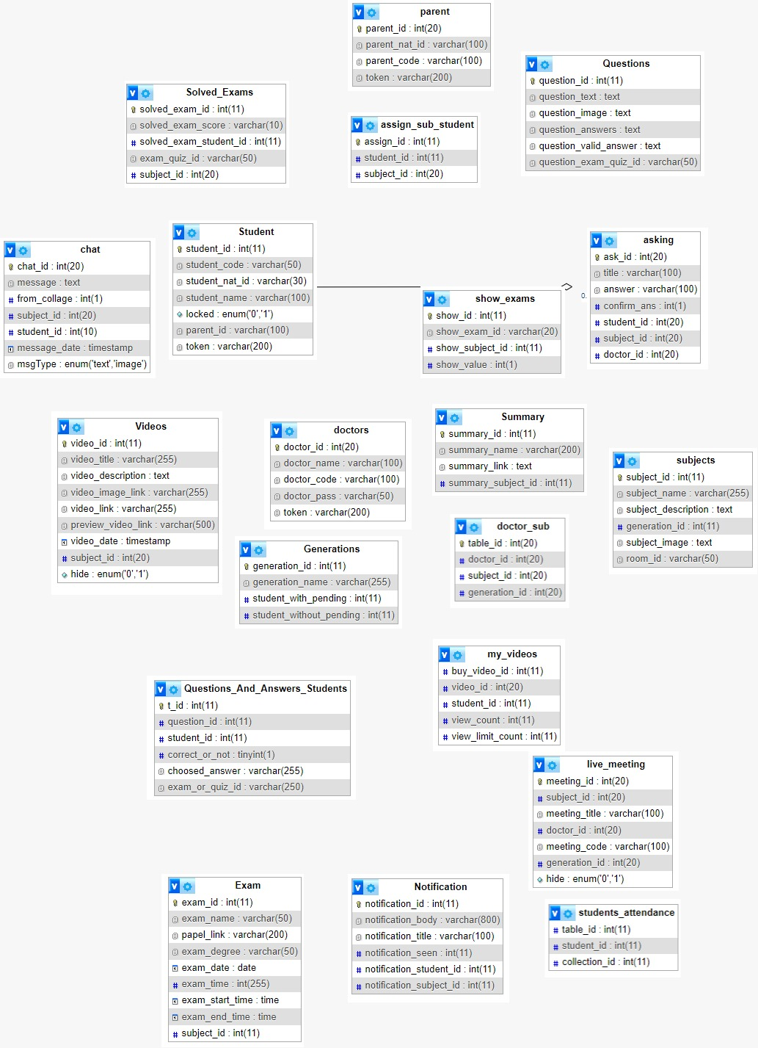**Database Diagram:**

As figure shows the Database diagram. There are 20 tables in our database:

1. Student
2. Parent
3. Doctor
4. Subjects
5. Generations
6. LiveMeeting
7. Videos
8. Chat
9. Notification
10. Asking
11. Exam
12. Summary
13. Questions
14. Solved Exams
15. Assign_sub_student
16. Show Exams
17. Doctor Sub
18. Questions_And_Answers_Students
19. My Videos
20. Students Attendance
21. **Explaining Data storing in each table**

In this section of our chapter, we will illustrate basic tables with their content.

1. 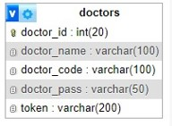**Doctors:**

This table store doctor personal information as the name and log in information as the code, password, and token for allowing log in through web or the mobile application.

1. 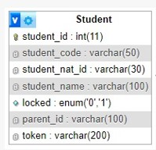**Students**

This table store student personal information as name and national ID and log in information as code and token for log in through web or mobile app. the locked feature is set to know if the account is active in another device or not using (0 = not active, 1 = active). the parent ID is for relation between student and parent tables.

1. 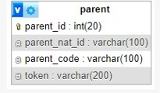**Parent:**

Parent table simply stores parent personal information as national ID and log in information as code and store token.

1. 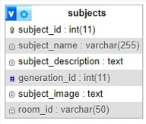**Subjects**

Subject table store subject name, description about it and image to illustrate it. Generation ID for relation withGenerations also table room ID for relation with live meeting table.

1. 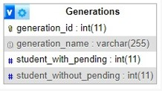**Generations:**

Generation table store name of generation, number of pending students and number of students without pending.

1. 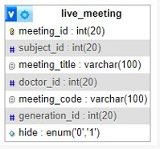**Live meeting:**

Meeting table store title, code and hidden status for the meeting. Subject ID is for relation between subject and meeting tables and the same for Doctor ID or generation ID also for relation with doctors and generation tables.

1. 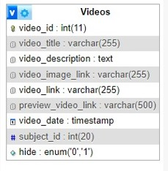**Videos:**

Videos table store video information title, description, video link, date, image link, preview video link and hidden status. subject ID is for relation between videos and subject’s table.

1. 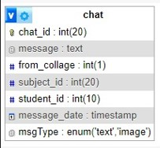**Chat:**

Chat table store message information as the message content, date and type. Subject ID and student ID also for relations with student and subject tables.

1. 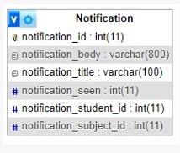**Notifications:**

Notification table store content or body of notification, title for it and seen status which give several people see this notification. Notification student and notification subject IDs are for relation with subject and student’s table.

1. 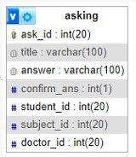 **Asking:**

This table is for the asking part between doctor and student, so it store title, answer and confirmation. Student, subject and doctor IDs also for relations with student, subject and doctor tables.

1. 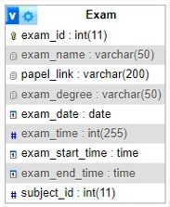**Exam:**

The exam table store all information about exams as name, link, date, time, start time, end time and degree of the exam. Subject ID for relation with subject’s table.

1. 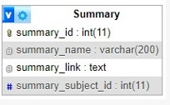**Summary:**

Summary table simply store summary name and link and as summary for subjects, summary subject ID is for relation with subjects’ table.

1. 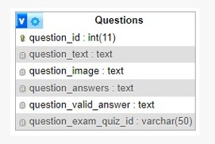**Questions:**

Questions is near to exam table as it has the question that exam use so this table store question text, image of question, answer and valid answer to the question. Question exam quiz ID is for relation with exams table.

1. **Explaining relations among database tables**

After knowing the basic tables content, now in the next section of our chapter

We will illustrate the relation between the basic tables through the secondary tables.

This can be considered more important for organizing relations between basic tables to give the desired data flow in the system database.

1. 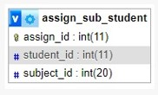**Assign Subject Student:**

This table is for organizing relations between students and subjects’ tables. The relation between these two is many to many relations as many students can have many subjects and vice versa.

1. 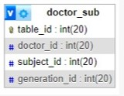**Doctor subject:**

This table to handle relation between doctors and subjects’ tables. And the relation between them is one to one as each doctor has one subject to teach. There is also generation ID for relation with generation table and it is also one to many as each generation take the subject with one doctor.

1. 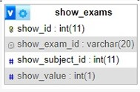**Show exam:**

This table to handle relation between exams and the subject’s table. And the relation between them is one to many as each subject has many exams. Also, the table store value for each exam this table will help in displaying all exams of certain subject.

1. 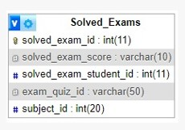**Solved Exams**

This table for identifying number of solved exams for each student so it handles relation between exams and students’ tables which a one to many relation. This table also store exam degree.

1. 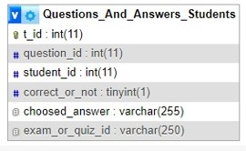**Question And Answers:**

This table handles the relation between the students table and questions table to identify chosen answer and if it is correct or not.

1. 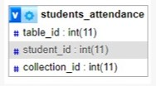**Student Attendance:**

This table identify number of students attend specific collection to allow the doctor to display and record attendance of each collection.

1. 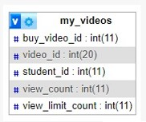**My videos:**

This table handles relation between students and videos tables to identify number of uploaded videos and number of students view these videos and limit of views allowed.

Chapter 5

Results.

* 1. **Introduction**

*ــــــــــــــــــــــــــــــــــــــــــــ*

In this chapter, we will present the results that we have reached through the mobile application and review all the features and how to use each feature in the application.

There are features in the mobile application that are not present in the web application, as well as in relation to the web, but the basic features are found in both applications. You will view all the features with pictures from the application.

* 1. **Mobile application**

*ــــــــــــــــــــــــــــــــــــــــــــــــــــــــ*

* **There are three ways for registration:**

1. Student registration
2. faculty member registration
3. 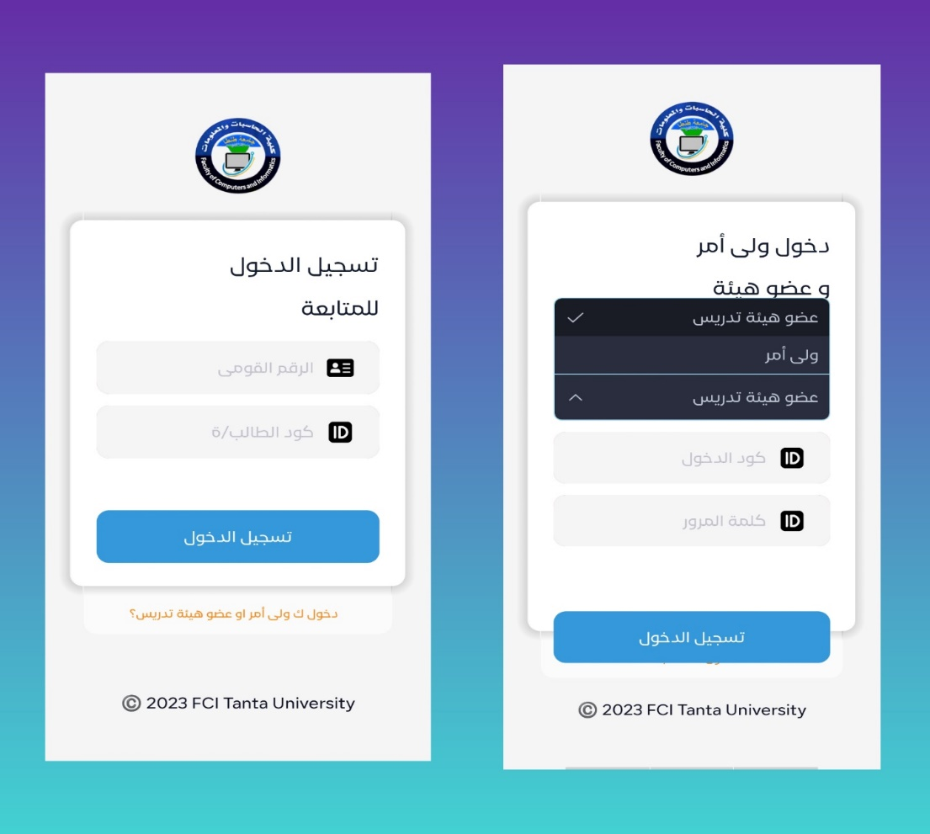parent registration

* **Before registration, there is an introduction to the application:**

The introduction to the program is a brief introduction to the Faculty of Computers and Information, Tanta University. It also talks about the college's mission and college goals. You can skip intro by clicking on " تخطي" or read intro to know about our application.

Introduction goal:

1. Make users know about applications.
2. Make use of application more comfortable
3. Make tour in application.

All of this makes the use of application more comfortable.

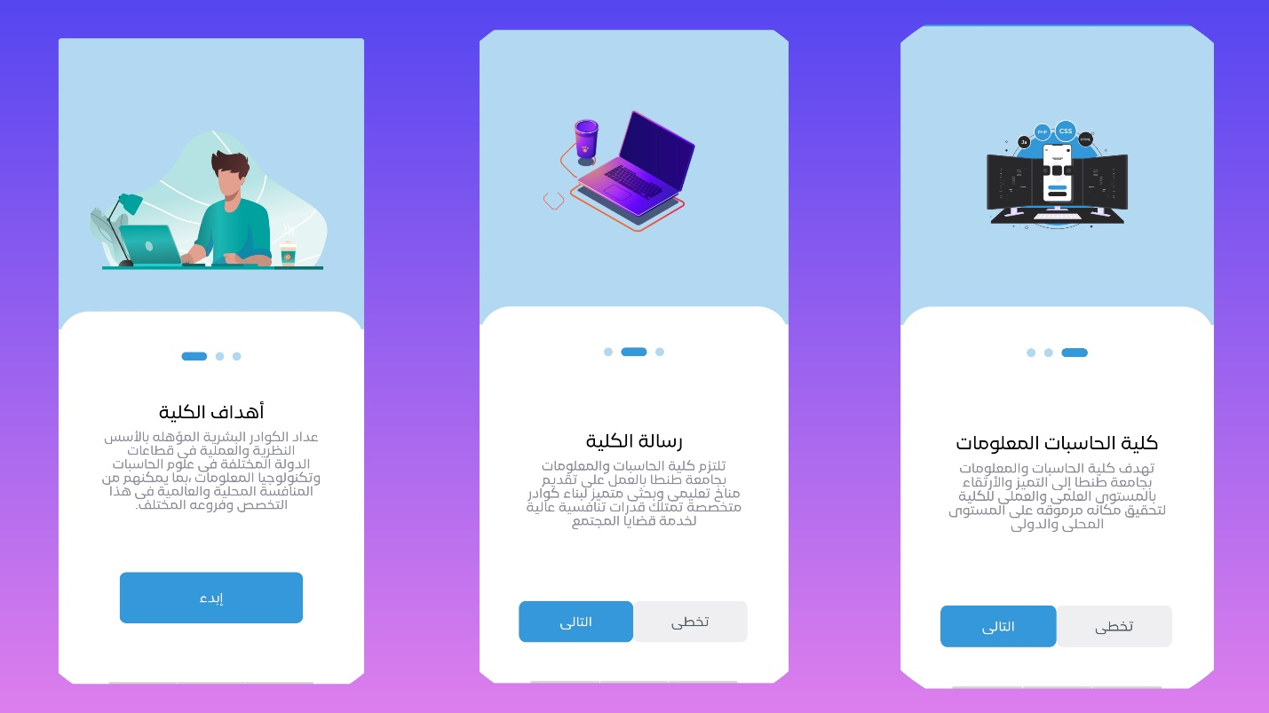

* + - 1. **Student registration:**

When the student logs in, there are payments on the main interface, through which the student can enter his current batch and view the materials registered for this student. There is also a list of notifications through which the student is alerted of everything new and everything that is required of him.

There is also a list of settings, which contains the student's name, national number, and student code, through which it is possible to log out of the application.

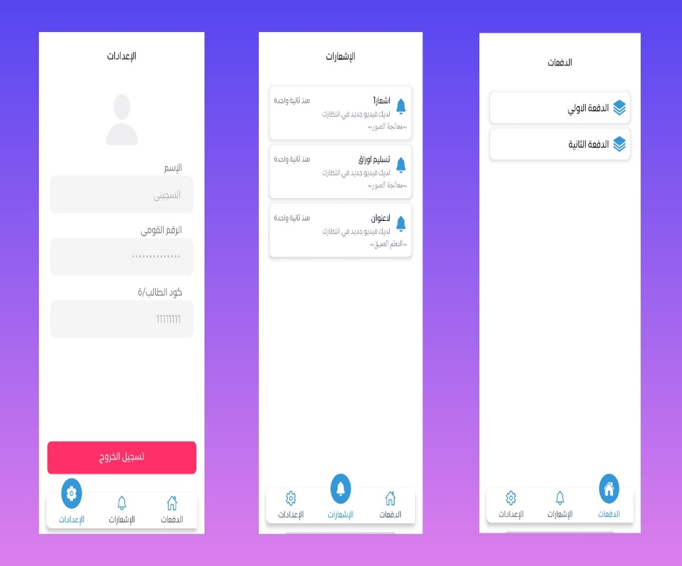

Upon entering the batches, the student can view the courses registered for him and the academic schedule, and he can enter each course and see the available features such as:

* + - 1. Summaries:

which contains all the summaries and books related to this course.

* + - 1. Tasks:

In which there are all the tasks that the teacher shows to the student for this course through the copy assigned to the teacher

* + - 1. Videos:

That the teacher also uploads to the students so that the students can view these videos

* + - 1. Inquiries:

In which the student sends a specific inquiry and shows it to the teacher, and the teacher responds to the inquiry and then presents the inquiry and response to all students.

* + - 1. VideoStreaming:

Through which the teacher can create a communication channel between him and the students.

* + - 1. Chat:

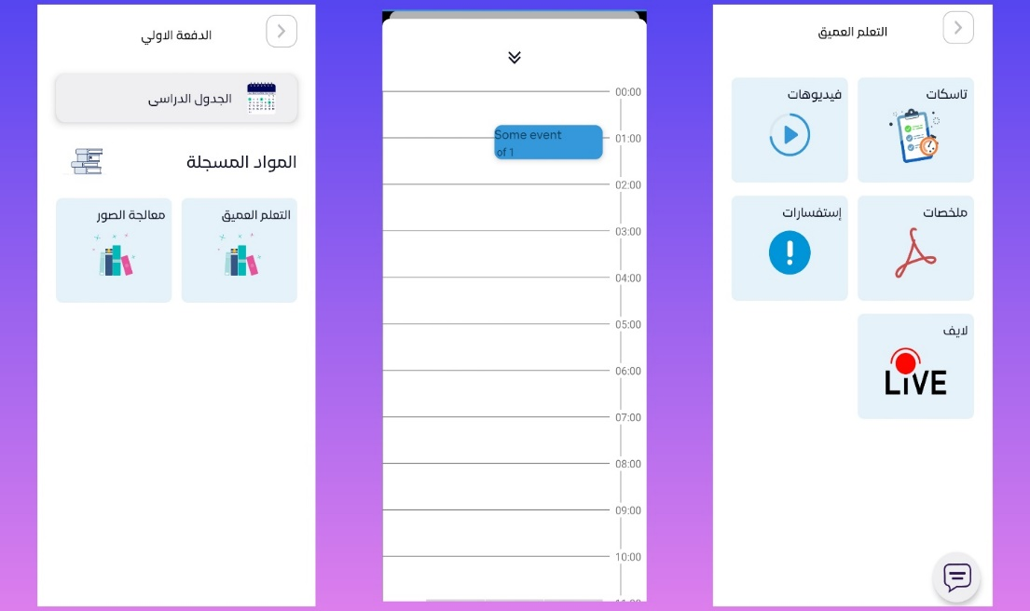Through the chat, all students can send messages to the doctor, and the doctor can also send a response.

* + - 1. **Faculty member registration:**

When the teacher logs in, the subjects he teaches are displayed. When entering a particular course, the features within the course are displayed, which are:

1. Summaries:

Which contains all the summaries and books related to this course.

1. Tasks:

In which there are all the tasks that the teacher shows to the student for this course through the copy assigned to the teacher.

1. Videos:

That the teacher also uploads to the students so that the students can view these videos.

1. Inquiries:

In which the student sends a specific inquiry and shows it to the teacher, and the teacher responds to the inquiry and then presents the inquiry and response to all students.

1. VideoStreaming:

Through which the teacher can create a communication channel between him and the students.

1. Chat:

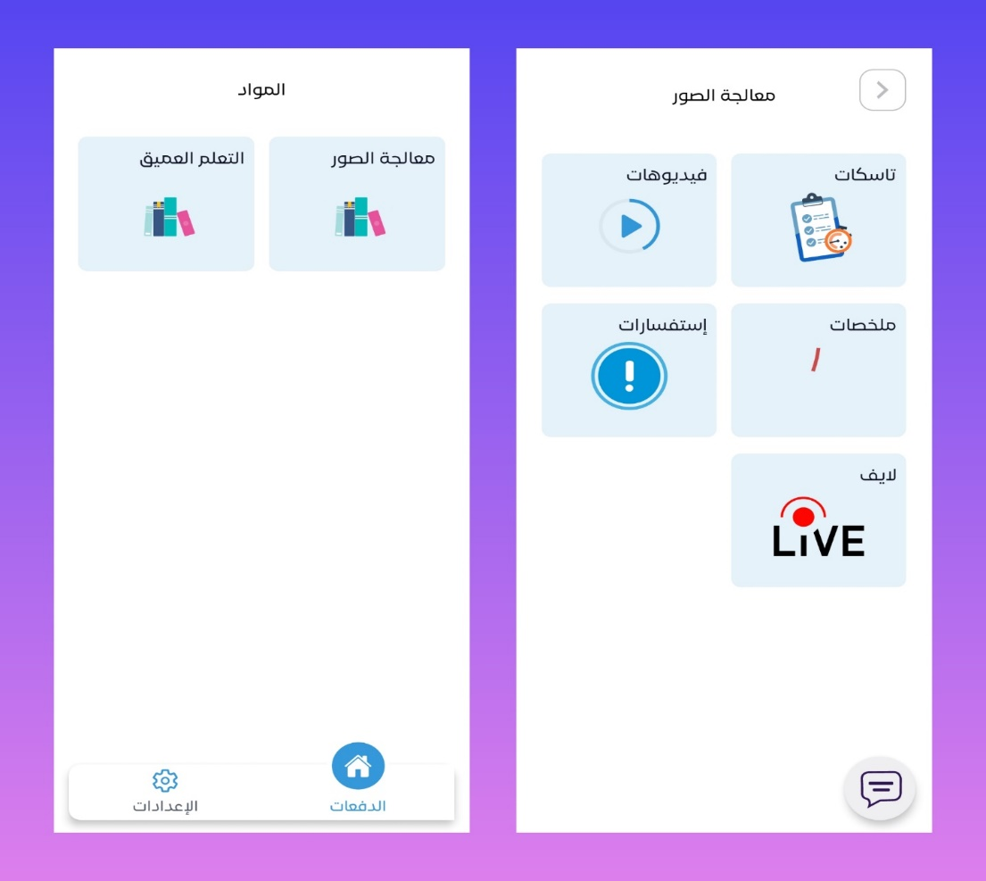Through the chat, all students can send messages to the doctor, and the doctor can also send a response.

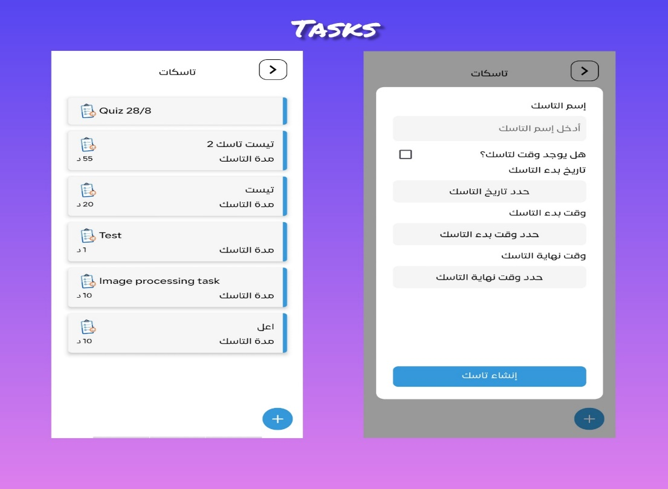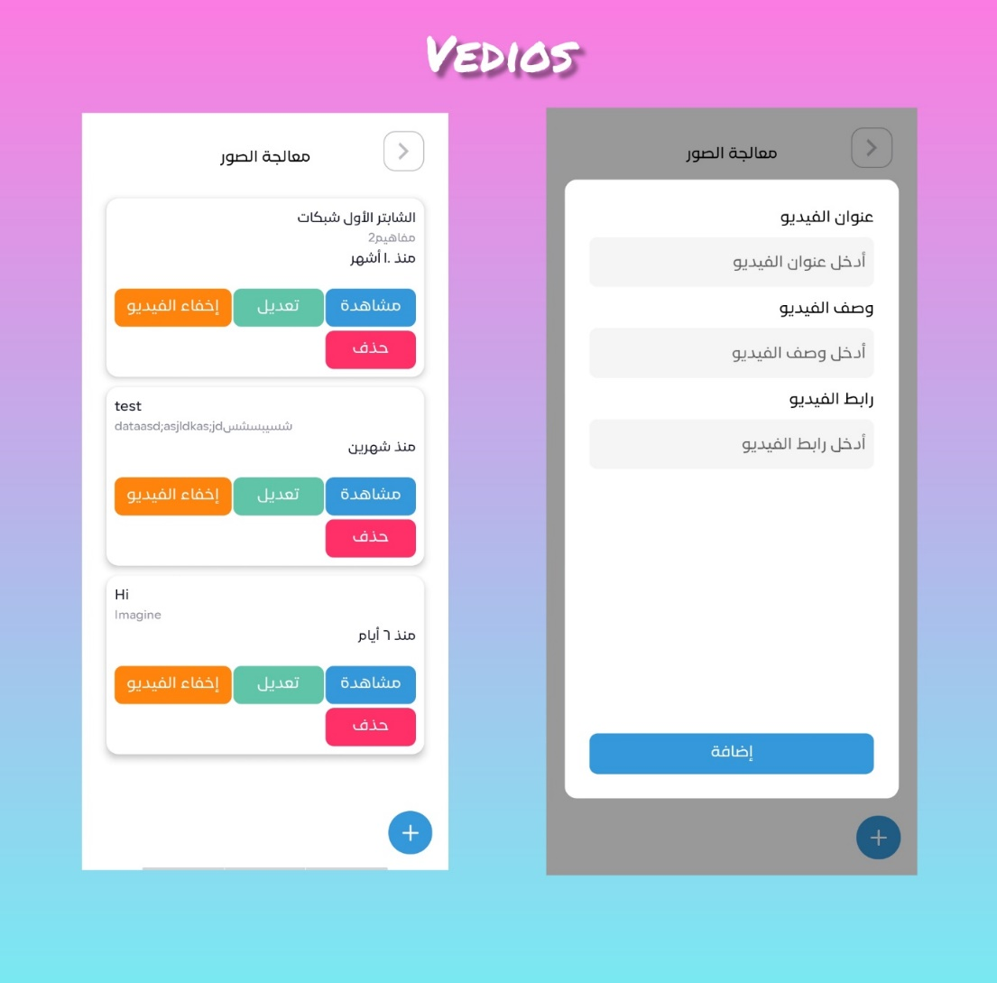

* + - 1. **Parent registration:**

When logging in as a parent, the parent is given some privileges, including:

1. View all his children If he has more than one son, all his children are shown as shown.
2. He can log in to one of his children and see the success and failure rates.
3. 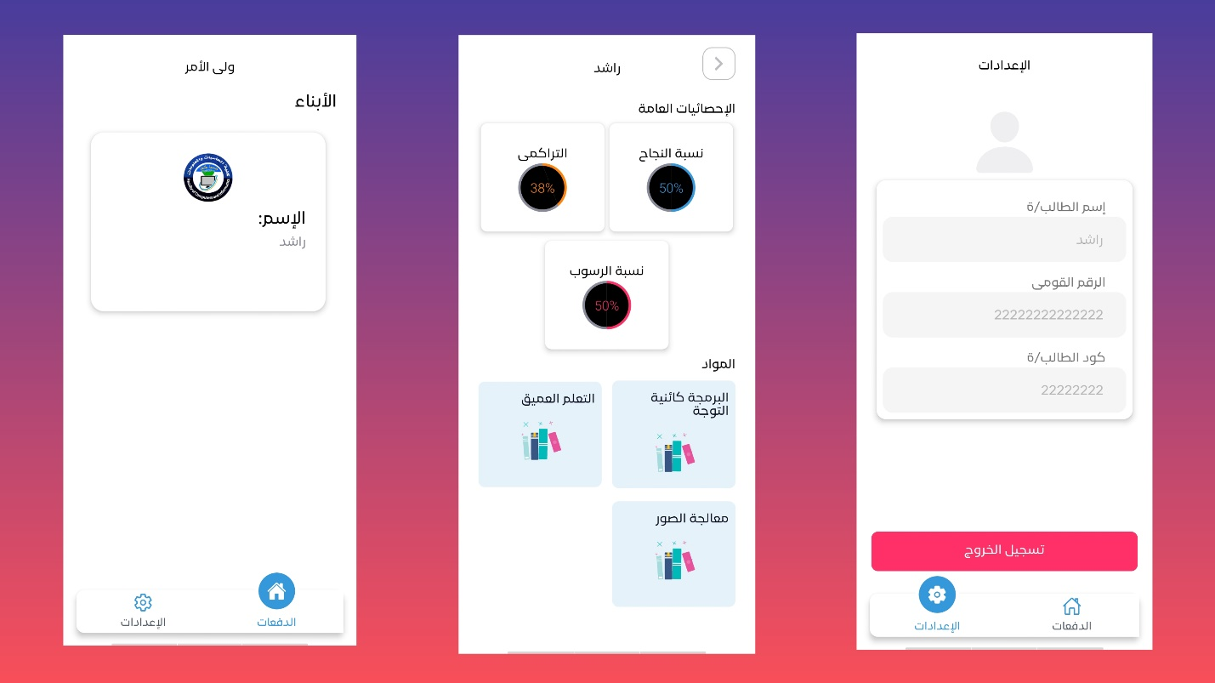He can also see all the grades of the subjects separately and the grades of the tasks and exams.
   1. **Website**

*ــــــــــــــــــــــــــــــ*

* **There are three ways for registration:**

1. Student registration.
2. Doctor registration.
3. Parent registration.

* On the web, there are the same features as on the mobile, in addition to some other advantages, including the

1. To do list
2. notes
3. Libraries
4. But the web and mobile are completely dependent on the basic features that were mentioned later.
5. **Student registration:**

Before you can log in to the system as a student you can see some information about the academy or just log in to the system.

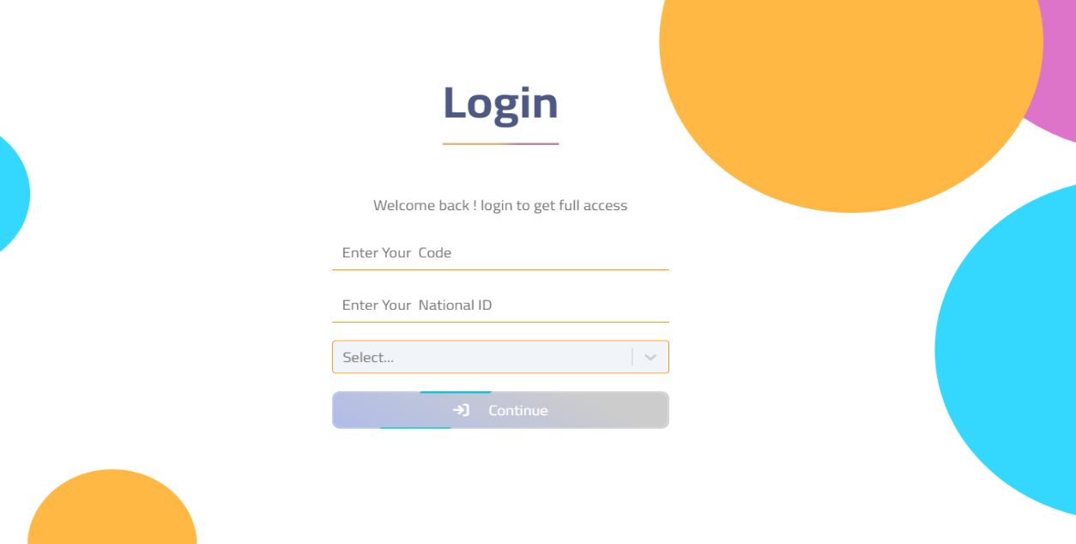

After the student has logged into the system, he can see his teams, subjects, videos, tasks, quizes, and chatbot to ask questions. He can also write down what he wants to do in “Todo list” or play in entertainment section. He can also gain more information by reading books from online library.



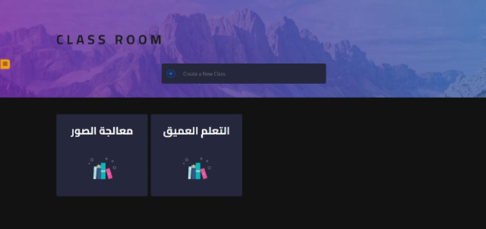

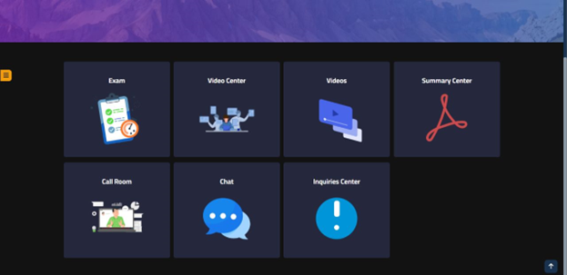

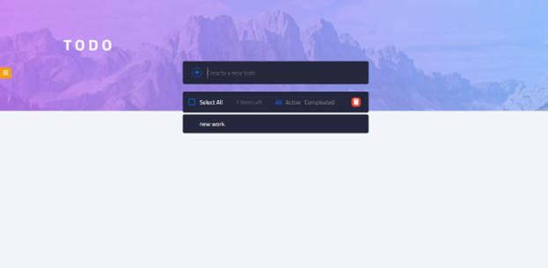

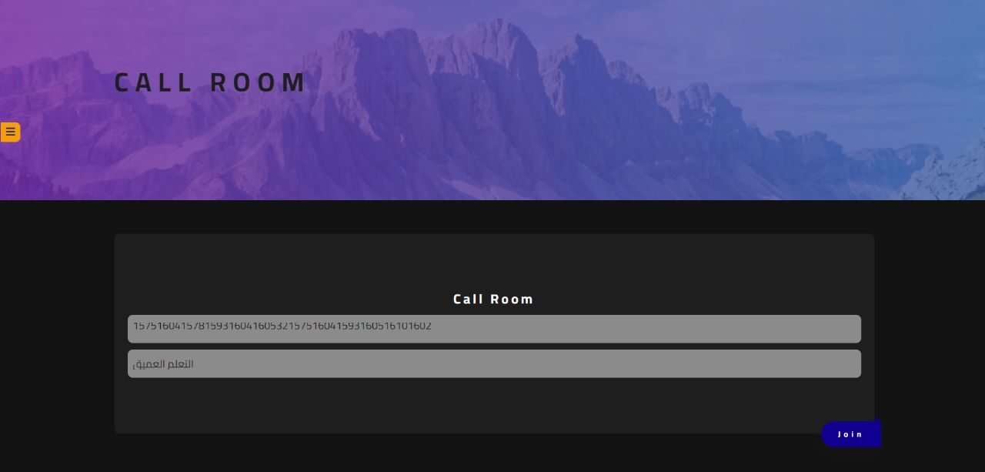

1. **Doctor registration:**

Before you can log in to the system as a doctor you can see some information about the academy or just log in to the system.



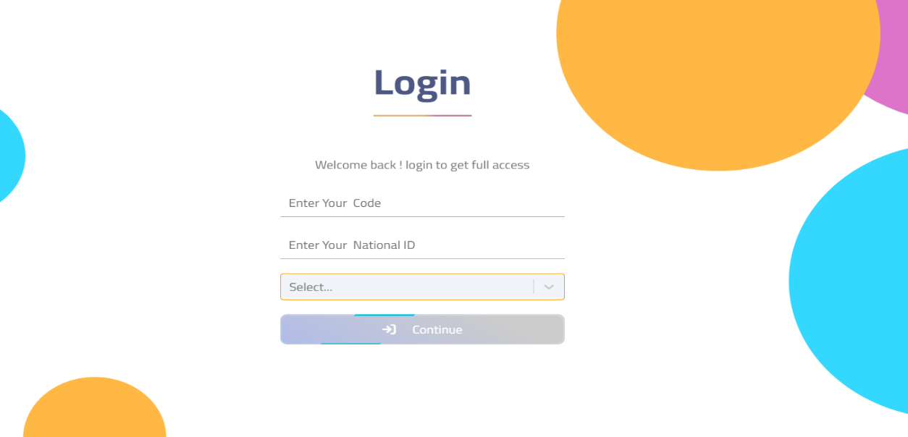

After the doctor has logged into the system, he can add, remove, or edit:

1. Team
2. Subject
3. Student
4. Video
5. Task
6. Exam
7. quiz
8. 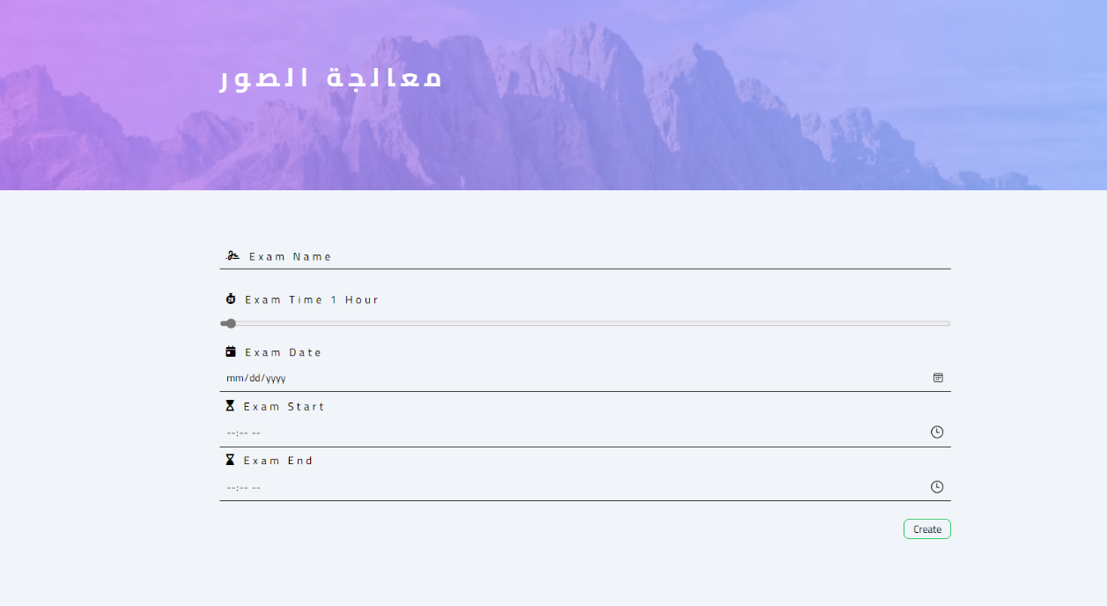summary data

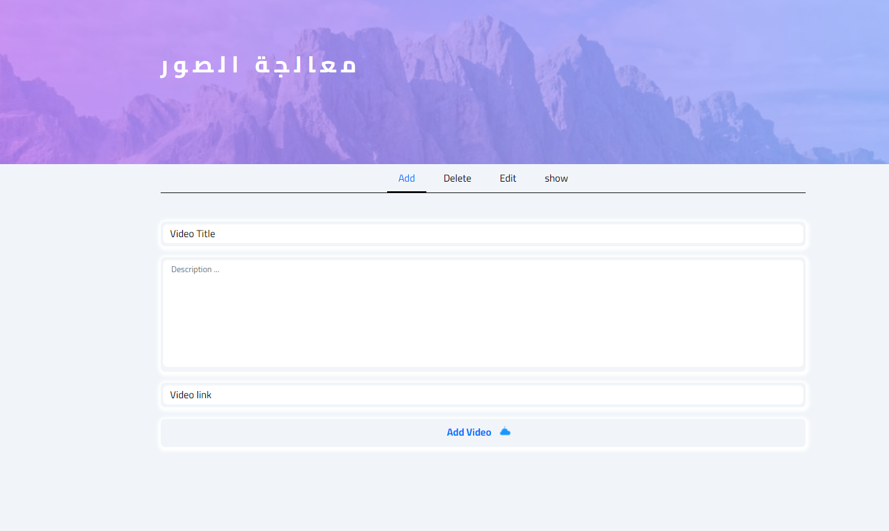

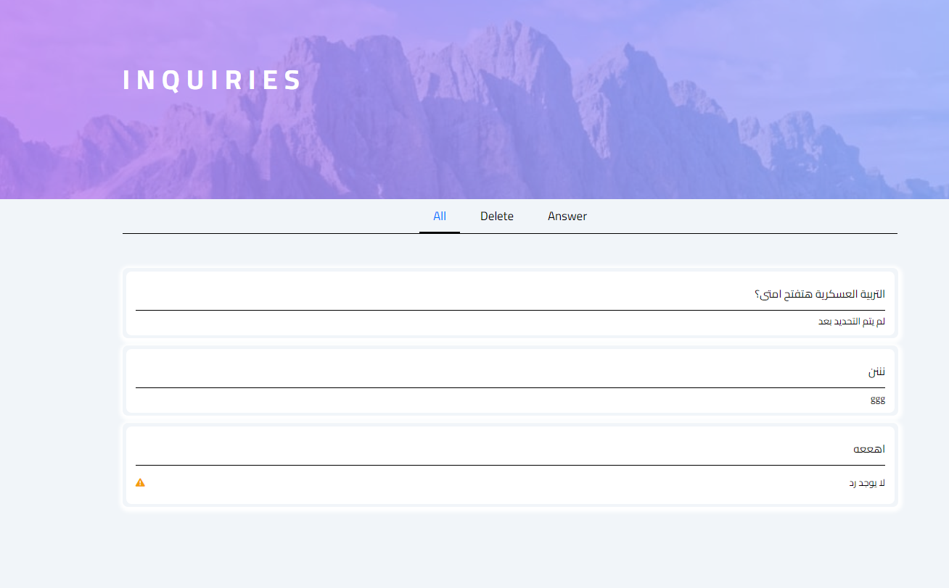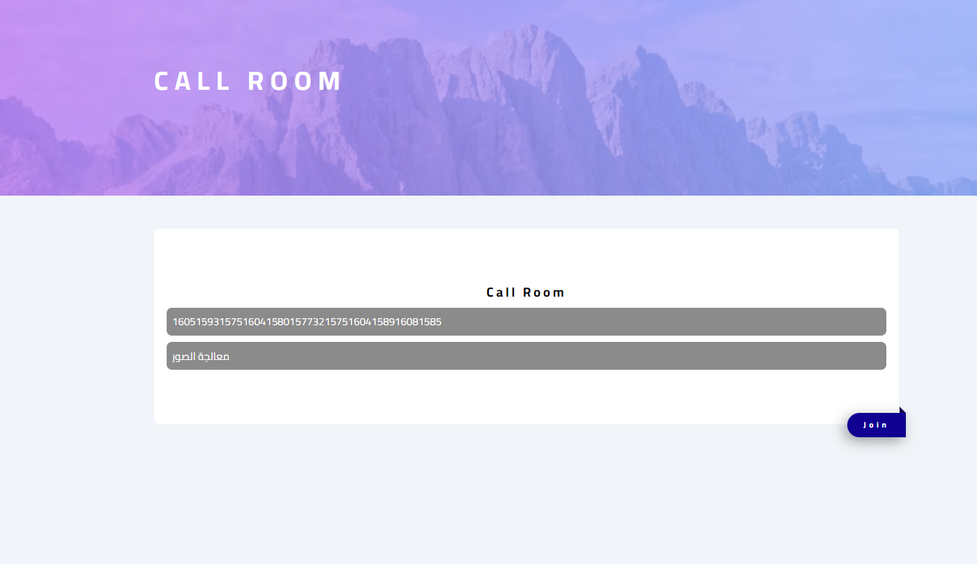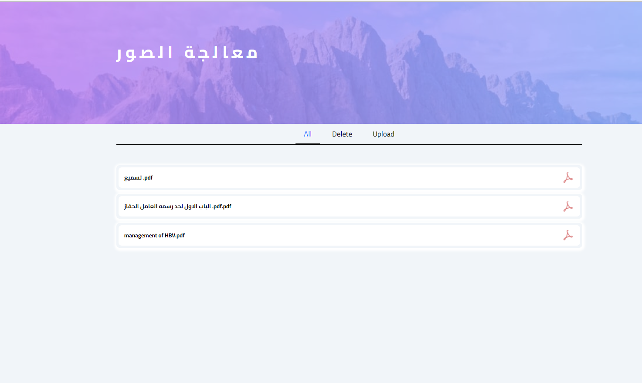

1. **Parent registration:**

Parents can log in to the system to follow up the student’s level and GPA.

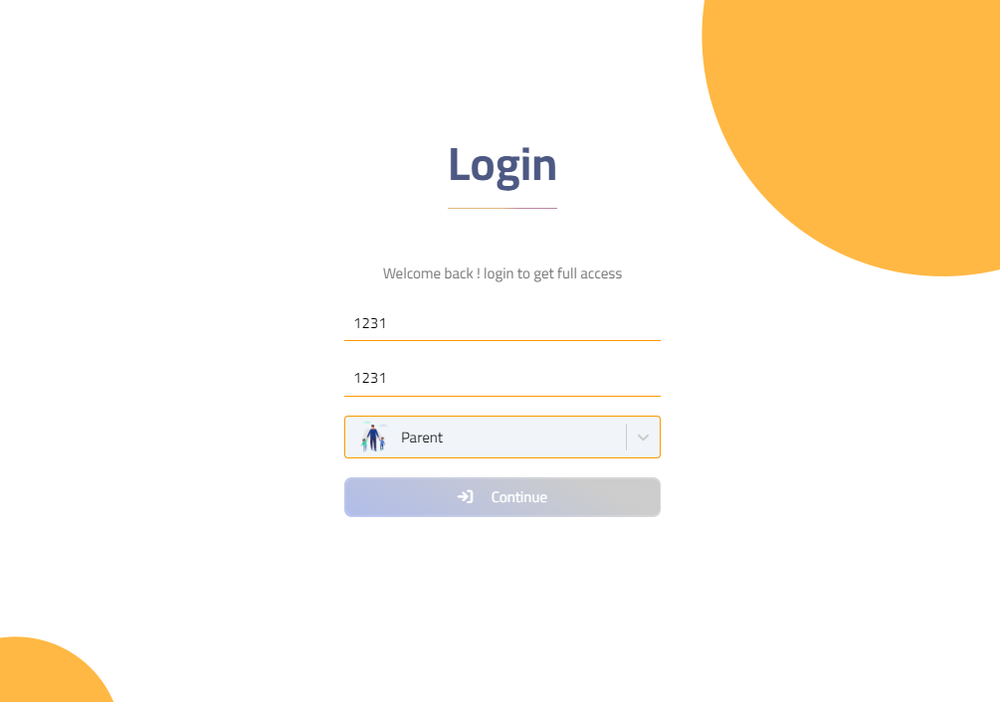

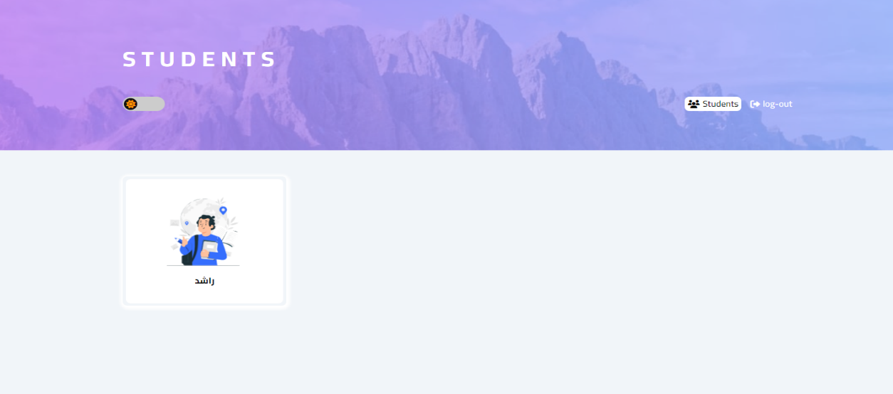

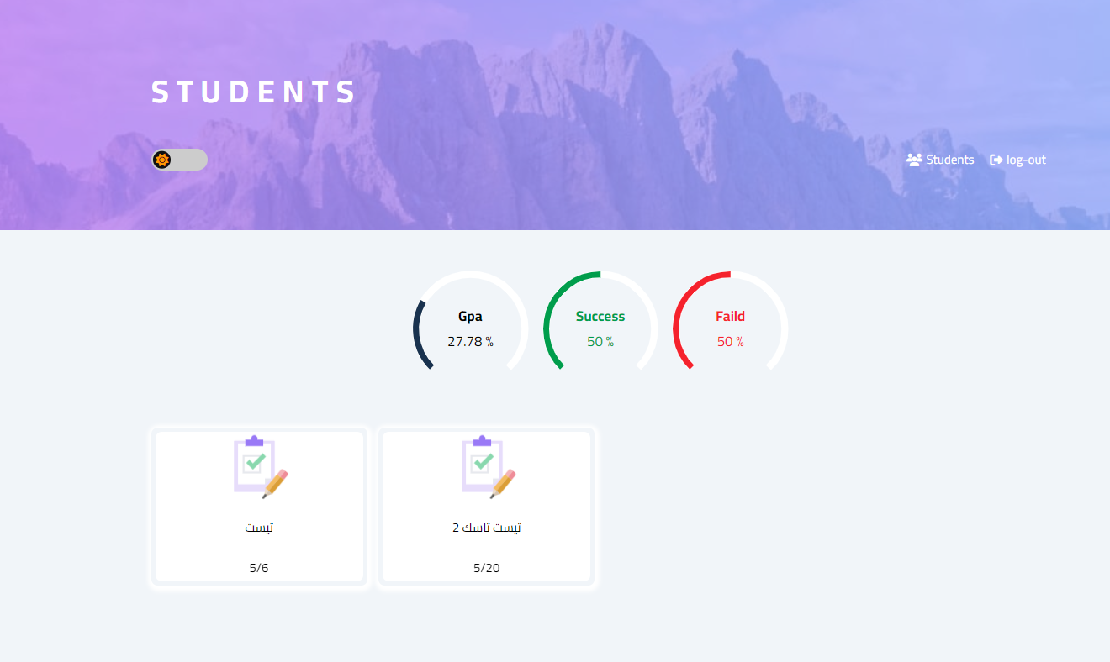

**Chapter 6**

**Conclusions**

* 1. **Introduction**

*ــــــــــــــــــــــــــــــــــــــــــــ*

In this chapter we will talk quickly about our system then discuss the future improvements and updates to our system and the user can use the system (website and application).

* 1. **Our system**

*ــــــــــــــــــــــــــــــــــــــــ*

Academic management system is an online software system created to help teaching and studying in a learning environment. Online instruction is not all that unlike classroom instruction. As the instructor, you are still forming a learning community and educating students with various learning preferences. The system can be used in different places such as schools, academic systems like courses, and can be used in universities.

Academic management system is a trusted software that have some advantages:

1. Maintainability:

I can customize the software so that I can add features that are suitable to the company using the system.

1. Dependability:

The system can work alone without any dependence on other systems or applications.

1. Security:

No one can use the system or access the data except authorized people.

1. Efficiency and acceptability:

The most efficient advantage of the system is that the system is fast and easy to use, anyone can use the system without any difficulties.

There are 3 authorized partitions can use the system:

1. Student:

Students can use the system in education (watching videos, tasks, quizes, online lectures). The student can also communicate directly with the doctor or with his friends or college mates. The system provides a chatbot to the system so that he can find all information he searches for and a library that can help him to gain more information. Academic management system is not only an education system because it provides some entertainment games to the student like memory games and drawing games.

1. Doctor:

Doctor can use the system so the can follow the educational process easily, he can add/remove students to any subject or class, can create new class, create or edit exams, quizes, or tasks, add summary data that can help students to revised what they had before, and the most important feature is online lectures that he can communicate with his students easily or answer their questions.

1. Parent:

Parents can follow up the student’s level so that they can know the level of the students by GPA that is calculated according to the quizes and the tasks.

* 1. **Feature improvements**

*ـــــــــــــــــــــــــــــــــــــــــــــــــــــــــــــــــــ*

Some important future features:

1. Calculate attendance during online lectures and report it to the doctor and the parent.
2. Calculate attendance during offline lectures using QR code and report it to the doctor and the parent.
3. Direct chat between doctor and parent.
4. Calculate GPA.
5. Online payment
6. Add new access modifier ‘IT unit’ that is responsible to deal with database to help doctors.
7. Students can create chat groups to help them working on customized task or project.

**References**

* [Edmodo - Chrome Web Store (google.com)](https://chrome.google.com/webstore/detail/edmodo/ohpppancgeopfjndlaodikbinmkepfml)
* [Log In | Microsoft Teams](https://www.microsoft.com/en-us/microsoft-teams/log-in)
* [Literature review | The University of Edinburgh](https://www.ed.ac.uk/institute-academic-development/study-hub/learning-resources/literature-review)
* [Get started with Adobe XD](https://helpx.adobe.com/in/xd/get-started.html)
* [Figma: The Collaborative Interface Design Tool](https://www.figma.com/)
* [React](https://react.dev/)
* [Visual Studio Code - Code Editing. Redefined](https://code.visualstudio.com/)